Developing and Managing a Music Program (DAMAMP)
2019-2020
Instructors: Tony McDonald and Catherine Massey
Tuesday 7/23/19 from 9:00-12:30 am MT
COURSE GOALS:
To explore the practical aspects of developing and managing a dynamic music ministry program. Students will identify, assess, and discuss the various components that contribute to the formation and maintenance of a successful music program.

COURSE CONTENT:
Stage 1 – Looking at the Present
- Assessing the status/health of your current program
- Assessing the culture of your congregation
- Building community – with staff, with musicians, with congregants, with the wider community
- Collaborating with ministry team and congregation
- Recruiting and retaining volunteer musicians
Stage 2 – Visioning for What’s Next
- Visioning your ensembles
- Determining what the next music element should be: accompanist, chamber choir, bell choir additional octave, etc.
- Creating job descriptions and review procedures
- Managing paid and volunteer staff.
  - Developing management procedures: communication networks, absence policies, etc.
  - Recruitment and retention of volunteers
- Research the resources at hand to help fulfill your next goal
- Developing a music budget
Stage 3 – Harmony in the Beloved Community
- ARAOMC/Working to dismantle white supremacy culture
- Creative interchange with ministry team and congregation
  - How does the music ministry interact with RE?
  - What is the role of the music committee?
- Advocating for your Ministry: with clergy, with board, with congregation.
- Transforming conflict: with clergy, with board, with musicians.
- Resource list: copyright issues, music borrowing programs, repertoire lists, technology

PRE-COURSE ASSIGNMENTS: Create a draft ‘Profile of Music in Your Congregation’ by June 15th and post it in the shared google folder

Candidates should read all submissions before coming to the summer conference. Submissions should be no more than 4500 words (roughly 9 pages) and include:
- Describe the music program you inherited.
- Describe your current program (may use chart or paragraph form)
- Describe your current music budget (may use chart or paragraph form). Include the total amount of your church budget.
- What is the size of your congregation?
- How long have you been at your current church? Have you served other churches, and if so, for how long?
- Describe in 1-2 paragraphs any challenges you’ve experienced and how you handled them.
- Describe in 1-2 paragraphs a success you’ve had in your music program.
- What special concerns would you like to be addressed in this class?

AND
Before the class on 7/23, please review the UUA’s Dismantle White Supremacy web page (https://www.uua.org/justice/dismantle-white-supremacy) and read the article on White Supremacy Culture found here: http://www.cwsworkshop.org/PARC_site_B/dr-culture.html

POST-COURSE ASSIGNMENTS:
Post all submissions in the shared google folder by the dates below (early submissions are welcome!) so that everyone can read.

  - Due October 31, 2019:
- Perform a self-assessment of your program and select 1-2 short-range goals to accomplish this year (these should relate to the goals you set with your Advisor and Sponsor in your Fall Triad meeting)
- Describe how your music program supports/enhances the spiritual life of your church.
- Identify a long-term vision/goal for your program and describe measurable steps for its implementation.

  - Due March 1, 2020
- Report on the 1-2 short-range goals you chose to accomplish this year, as well as any progress made toward your long-term goal. Describe your choices and how you met your goal(s).
- Develop a budget for the coming year. How is the budget developed in your congregation? How did you arrive at the numbers? How will you advocate for it? Did you include a budget for professional development, and if so, how will you advocate for that? If music is not part of your church budget, describe how you will advocate for resources. It is not necessary for you to send us your music budget; however, we would like for you to discuss (in no more than 1-2 paragraphs) the questions asked.
- Describe your current system of managing printed and recorded music and identify any areas for improvement. This may be done in paragraph form (no more than 2 paragraphs) or as a list.
- Describe your current situation regarding job description, covenant/contract and review process. If none exists, work with your church to develop at least one of these. Please write a concise description of your current situation, which of these you chose to develop and if your efforts were successful (should be no more than 2-3 paragraphs). If they do exist, are there any areas of change that you recommend? This can be answered in a paragraph or as a list.
- Create and implement an assessment tool [e.g., survey – samples are in the shared folder] for soliciting input on your program. Please send a copy of your assessment tool and indicate when and how it was implemented.
- Describe how you will create vitality in your program this year. This may be written in paragraph form (should be no more than 2-3 paragraphs) or as a list.

Evaluation
Course Instructors will read and respond to post-course assignments by April 1, 2020.

ABOUT THE INSTRUCTORS

Catherine Massey has been Director of Music at the UU Church of Las Cruces since 1998, and a member of AUUMM since 2000. In 2009 she was in the first group of musicians to become UU Credentialed Music Leaders. She served on the Board of Trustees for Association of UU Music Ministries (AUUMM) for eight years in the roles of At-Large Member, Secretary, and Moderator (two terms). Currently she serves as Co-Director of AUUMM’s Good Offices program. cmasseyuu@live.com

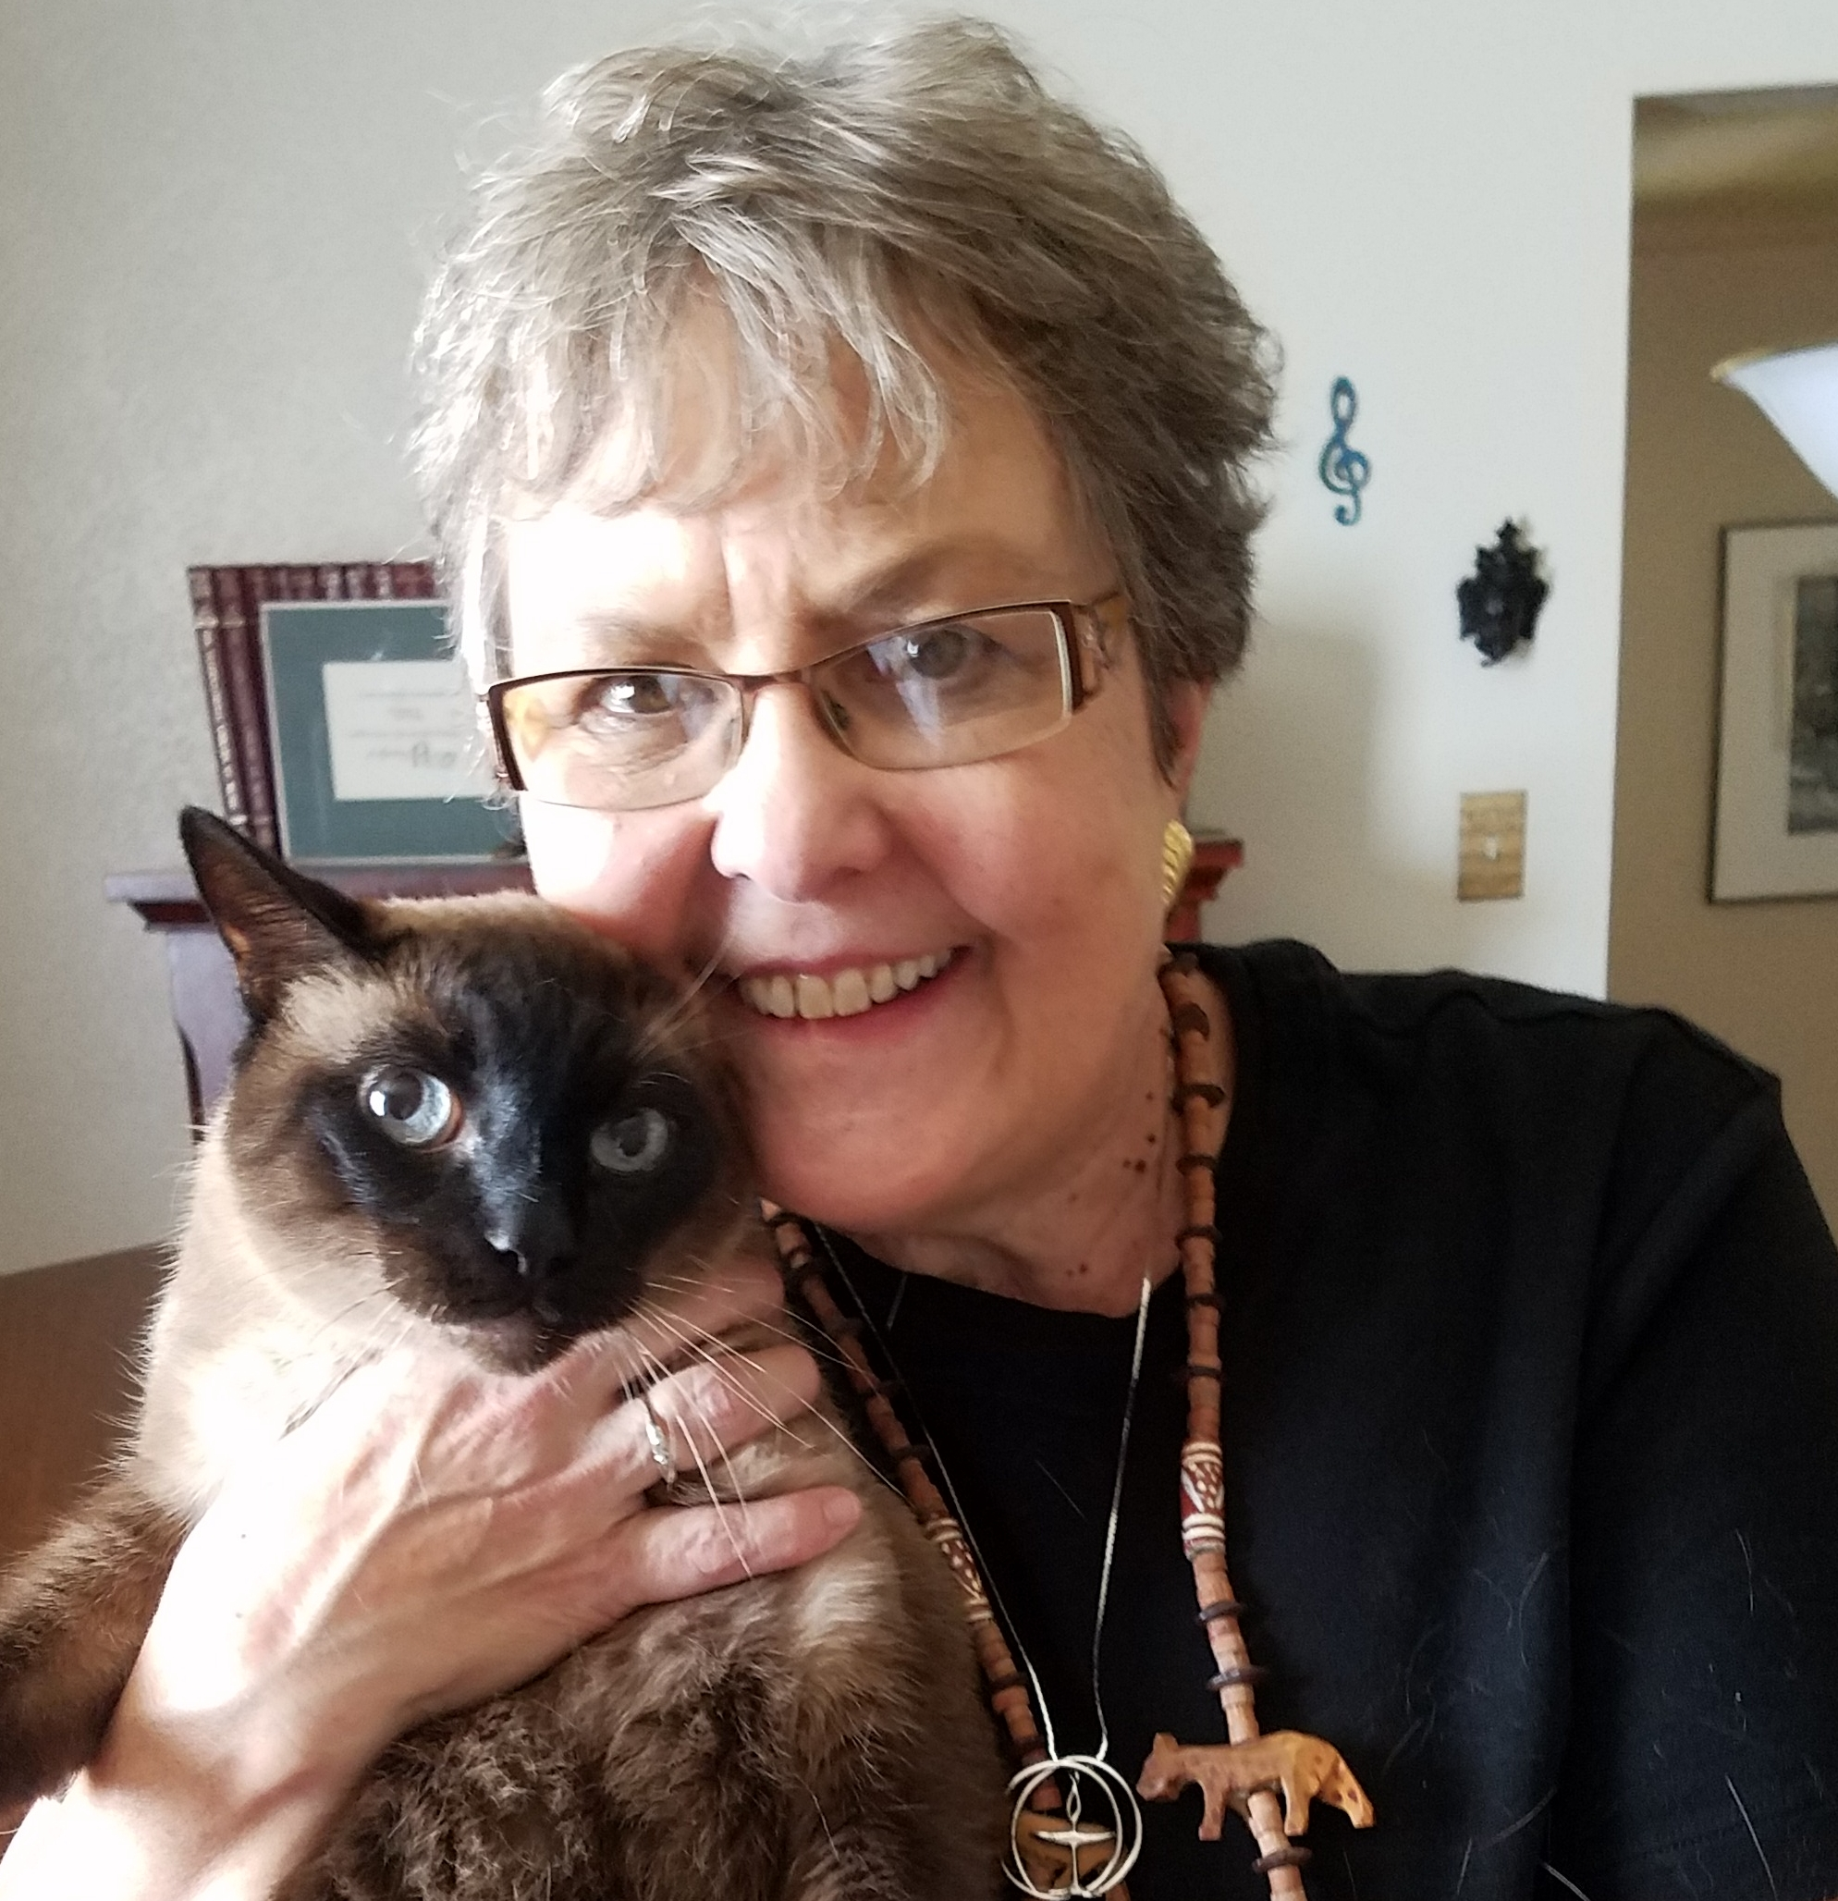

Tony McDonald has been Music Director at the First Unitarian Universalist Church of Columbus, Ohio, since 2007. He will retire (retired) from that position in May 2019 and is now emeritus. Not the choir director, he oversees the music program which includes four choirs plus the many other music activities at First UU. Tony joined the AUUMM in 2010 and in 2012 gave a class on his new publication A Catalog of Music Written in Honor of Martin Luther King, Jr. at the annual conference. He holds his Masters and Doctorate degrees in orchestral conducting from Stanford University, and is the father of UUA Executive Vice-president Carey McDonald. tonymcdonald@att.net

