UUA General Assembly: our annual meeting
General Assembly is more than the annual business meeting of the Association. The myriad of programs, worship events, witness and service opportunities, and exhibits not only provide a rich experience to the thousands of UUs who attend each year, they also give participants a renewed sense of energy, up-to-date information, inspiration, and innovative ideas to take back to their congregations and communities.
“It felt like we were part of a living faith - it gave me
energy to keep going in my own community.”
The votes that GA delegates cast have a huge impact on Unitarian Universalism. They determine our elected leaders, amend the bylaws and rules that govern our Association, and shape the justice work that we do as a movement.
“I was able to grasp the scope of the UUA - there is so
much possibility when we are part of the whole!”

Theme for 2017: Resist and Rejoice!
We will gather in New Orleans, Louisiana for a General Assembly experience focused on solidarity with the movements for racial, economic and climate justice. We will invite the culture, history, geography, and people of New Orleans to be our teachers.
uua.org/ga
UUA General Assembly: our annual meeting
General Assembly is more than the annual business meeting of the Association. The myriad of programs, worship events, witness and service opportunities, and exhibits not only provide a rich experience to the thousands of UUs who attend each year, they also give participants a renewed sense of energy, up-to-date information, inspiration, and innovative ideas to take back to their congregations and communities.
“It felt like we were part of a living faith - it gave me
energy to keep going in my own community.”
The votes that GA delegates cast have a huge impact on Unitarian Universalism. They determine our elected leaders, amend the bylaws and rules that govern our Association, and shape the justice work that we do as a movement.
“I was able to grasp the scope of the UUA - there is so
much possibility when we are part of the whole!”

Theme for 2017: Resist and Rejoice!
We will gather in New Orleans, Louisiana for a General Assembly experience focused on solidarity with the movements for racial, economic and climate justice. We will invite the culture, history, geography, and people of New Orleans to be our teachers.
uua.org/ga
Social Justice Process and General Assembly
One way to engage in Unitarian Universalist social justice work and further promote liberal religious values is to participate in the Statement of Conscience process. This process was created to uphold our principles and to engage Unitarian Universalists in pressing social justice issues.
“I love feeling the energy, knowing that our efforts to do
social justice work are part of something larger.”
Together, as congregations and at General Assembly, we articulate and adopt positions on social justice issues such as:
- Reproductive Justice
- Immigration as a Moral Issue
- Ethical Eating: Food & Environmental Justice
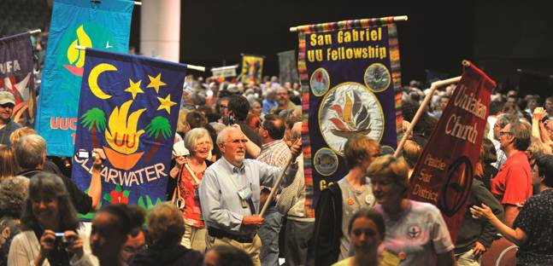
The Opening Celebration at General Assembly starts with a joyful parade of hundreds of UUs carrying congregational banners.
Hundreds of youth turn out for GA each year (about 8% of the total GA population), due in large part to the efforts of religious educators, youth advisors, and congregational lay leaders who believe in the influence of the GA experience on youth faith development. GA is a wonderful way to experience the power inherent in intentional multigenerational communities. Financial aid and childcare are available.
The dollars that congregations contribute support the infrastructure that makes GA planning possible year after year. The work of our UUA is made possible by the generosity of individual donors and gifts to the Annual Program Fund. Please consider making a contribution today to continue this important work: www.uua.org/giving
Social Justice Process and General Assembly
One way to engage in Unitarian Universalist social justice work and further promote liberal religious values is to participate in the Statement of Conscience process. This process was created to uphold our principles and to engage Unitarian Universalists in pressing social justice issues.
“I love feeling the energy, knowing that our efforts to do
social justice work are part of something larger.”
Together, as congregations and at General Assembly, we articulate and adopt positions on social justice issues such as:
- Reproductive Justice
- Immigration as a Moral Issue
- Ethical Eating: Food & Environmental Justice
The Opening Celebration at General Assembly starts with a joyful parade of hundreds of UUs carrying congregational banners.
Hundreds of youth turn out for GA each year (about 8% of the total GA population), due in large part to the efforts of religious educators, youth advisors, and congregational lay leaders who believe in the influence of the GA experience on youth faith development. GA is a wonderful way to experience the power inherent in intentional multigenerational communities. Financial aid and childcare are available.
The dollars that congregations contribute support the infrastructure that makes GA planning possible year after year. The work of our UUA is made possible by the generosity of individual donors and gifts to the Annual Program Fund. Please consider making a contribution today to continue this important work: www.uua.org/giving

