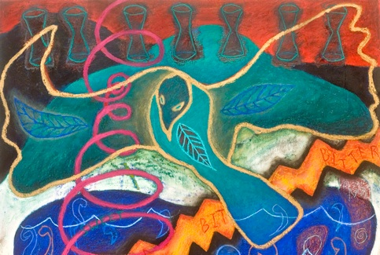
Art as Worship, Worship as Art
Sat. Dec. 1 - Workshops
Sun. Dec. 2 - Service (Optional)

J.Axtmann, "Natural Inheritance", detail

Paint Branch Unitarian Universalist Church
3215 Powder Mill Road | Adelphi, Maryland

Are you a singer, dancer or visual artist or want to explore one or more of these art forms…

We invite you to join us to restore and renew your spirit through
Workshops in Visual, Choral and Movement Arts
Inspired by John Lennon’s song Imagine

VISUAL: What do YOU imagine?  Come together to explore your imaginings in pictures, words  and color!  Led by Joanna Axtmann | CHORAL: Reimagine Imagine.  Sing together and reinvent a classic song for current times  Led by Allison Hughes | MOVEMENT: You may say I’m a dancer, and I’m not the only one  Led by Peggy Hoffman &  Sharon Werth

Workshop Leaders Bios on Back

Saturday, December 1, 9:00 am – 4:00 pm
Option for choice of 2 workshops/Lunch & snacks will be served (vegetarian option available)
Children age 10 and older are welcome

Sunday, December 2, 10:00 am Worship Service - Optional
Workshop participants are invited to attend and participate

Workshop Fee (includes lunch & childcare):
$50 – Adults * $30 - PBUUC Members * $20 – Seniors/Students/Youth
Registration/Payment information on back of flyer
Sponsored by The Chalice Dancers and Arts Council of Paint Branch UU Church

About the Workshop Leaders
Joanna Axtmann Artist, Instructor. “Making art is my consistent passion and a means for survival. Vision and experience builds up an energy within that needs physical, visual release/expression.” Joanna makes images in a variety of media – mixed media on paper, sculptural installations, assemblage and printmaking. She leads workshops in Washington DC & California, teaches at University of DC and previously at University of Iowa, Montana State University, State University of Puebla, Mexico and she holds a MA & MFA degrees in Painting, Drawing & Sculpture. See her art at joannaaxtmann.com.
Peggy Hoffman & Sharon Werth/The Erika Thimey Dance & Theater Co. - "Modern dance was an attempt to frame the human experience in a different light, and Erika represented that first impulse, first energy." The dance company, inspired by Ms. Thimey’s 60-year legacy, shares dance as an art form and expression of the spirit. The workshops will draw on modern and sacred dance, and the dance within us all.
Allison Hughes – “Sing freely, listen deeply, breath together, hear one another.” Allison is a singer, choir director and voice teacher in College Park, MD. She has performed locally and in exciting venues including Kennedy Center, Wolf Trap, Carnegie Hall, Prague’s Rudolphinum, and the Liszt Academy in Budapest. She directs the College Park Chorale and founded and leads the fun and unusual (un)choir, a pop-up community sing. She is also a member of Paint Branch Creek, a folk music group performing acoustic americana in the DC area.
Learn more www.allisonsings.com.
_ _ _ _ _ _ _ _ _ _ _ _ _ _ _ _ _ _ _ _ _ _ _ _ _ _ _ _ _ _ _ _ _ _ _ _ _ _ _ _ _ _ _ _ _ _ _ _ _ _ _ _ _ _ _ _ _ _ _ _ _

REGISTER NOW:
NAME(S): _____________________________________
ADDRESS: ___________________________________________________________
EMAIL: ___________________________________ PHONE: __________________
# Adults _____ # PBUUC Member _____ # Senior/Student/Youth _____
Childcare needed for _____ children (Ages?) _______
REGISTRATION
Online: ArtAsWorship@pbuuc.org
Mail: Chalice Dancers, Paint Branch UU Church, 3215 Powder Mill Road, Adelphi, MD 20783.

PAYMENT
Online: https://pbuuc.breezechms.com/form/373f59
Mail: Chalice Dancers, Paint Branch UU Church, 3215 Powder Mill Road, Adelphi, MD 20783 Make check payable to PBUUC with “Art As Worship” on memo line.

