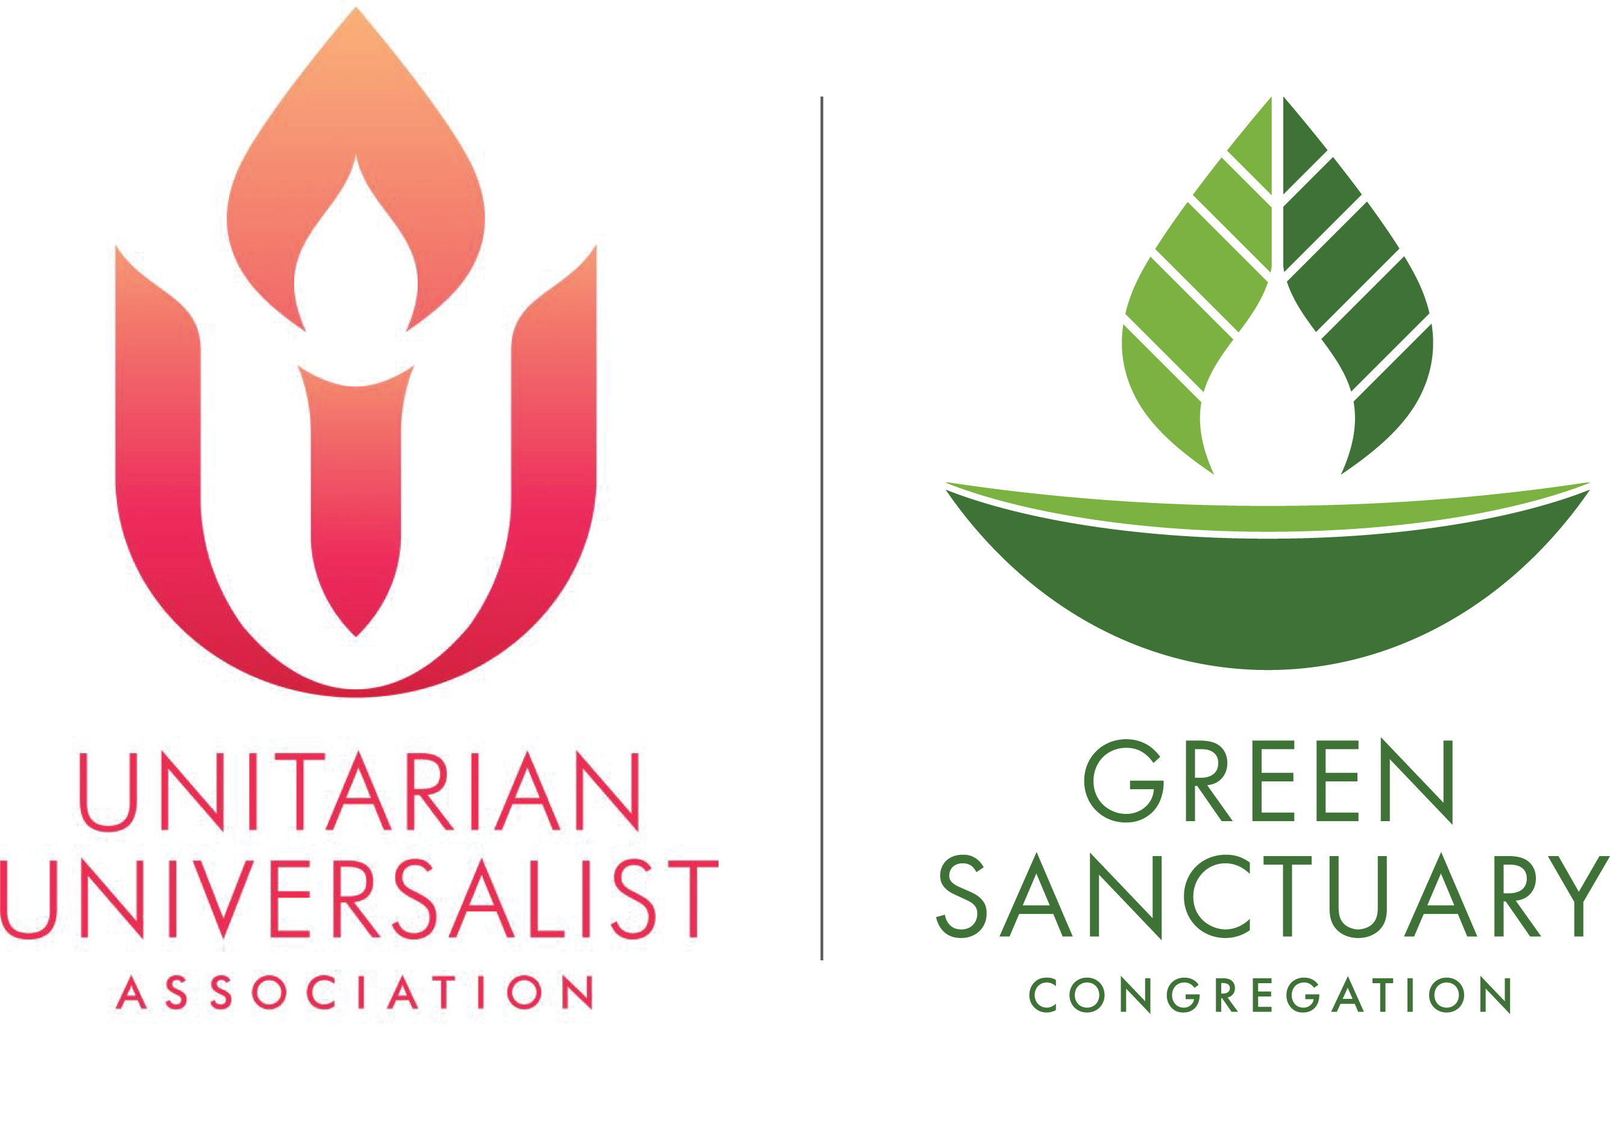
Checklist for Team Building and Congregational Education

STEP  Briefly state type of activity | HOW YOU CAN TRACK OR MEASURE IMPACT OF THIS STEP  Some of this may be numbers, but also stories about people’s energy, particular responses, etc. | DATE ACCOMPLISHED OR LAUNCHED
LEARN
How does learning happen? Is it ongoing?
BUILD TEAM
Who? Sense of energy level...
EDUCATE LEADERSHIP
Reports, Presentations, Worship, RE, Group Conversations...
EDUCATE CONGREGATION
Newsletter, Presentations, Worship, RE, Group Conversations...

