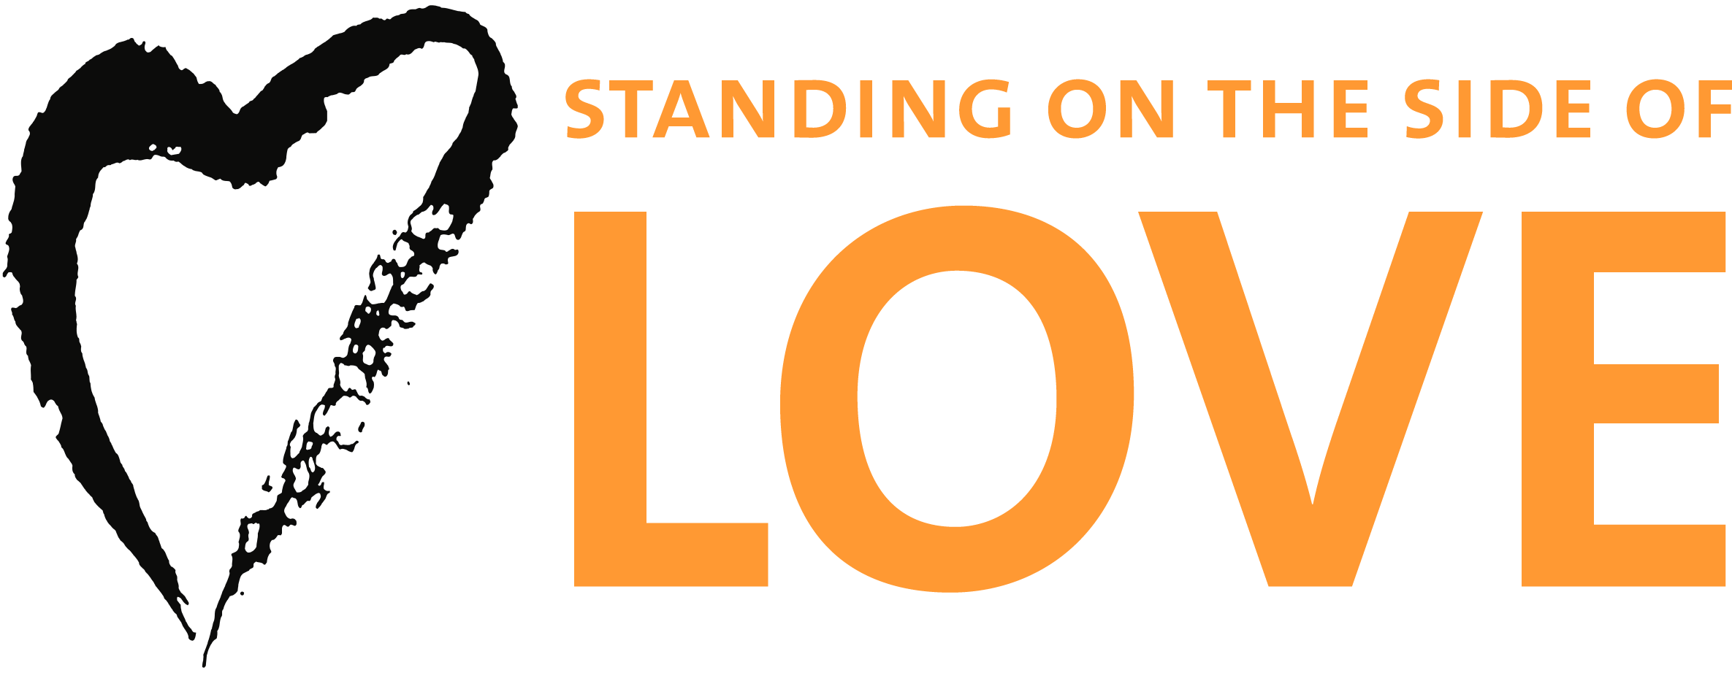 30 Days of Love Activity Calendar for Families

Week One – Living the Dream
Week Two – Sharing our Stories
Week Three – Building Bridges of Love
Week Four – Pause, Reflect, Celebrate!

Saturday | Sunday | Monday | Tuesday | Wednesday | Thursday | Friday
Jan. 18  Make a "30 days of love" journal with your child. Repurpose a composition notebook or staple 30 sheets of paper together.  Print out the Standing on  The Side of Love logo for the cover. Decorate it! | Jan.19  Ask your child to define these two words: “love” and “justice”. Write the definitions down in your journal, and see if they change over the month. | Jan. 20  Together, watch MLK's "I Have a Dream" speech at www.youtube.com/  watch?v=gdTpU5WZHHM  Help your child write the words that seem most important in your journal. | Jan. 21  Read one of your child's favorite picture books with your child. Ask your child to draw the main character. What would the story be like if it were told by one of the other characters? | Jan. 22  Help your child make a list of the adults your child knows in the congregation. Are any of them involved in making our congregation a friendly and welcoming place? How? | Jan. 23  What is our fifth UU principle? Write it in your journal.  Add a list of things that are important for people to be able to vote on. | Jan. 24  Find the SSL channel on youtube. Find a 3-4 minute video to watch together.  For older children: find out about the "Moral Mondays" movement in N. Carolina. Would this work in Texas?
Jan. 25  Make a poster with your child about Unitarian Universalism and being able to vote. Display it where other people can see it! | Jan. 26  Have a family story-telling time. Ask each family member to tell a story about something they did that was hard for them. Doodle in the journal while you listen! | Jan. 27  Find a family photograph that tells a story about your family's history. Share the story. Ask your child to find a favorite photo and share the story with you. | Jan. 28  Make a word cloud about spiritual practices you do. Write the words in different sizes and colors. Or fingerpaint it in a mound of shaving cream in the tub! | Jan. 29  Create a people collage with your child. Use pictures of different ages, cultures, genders, and family relationships. Is this what our church looks like? | Jan. 30  Help your child interview someone who has moved to the United States from another country, or someone who has lived in another country. | Jan. 31  Help your child make a list of people you know who go to different churches. Ask your child to circle the churches they'd like to visit.
Feb. 1  Ask your child to draw a picture or write a story about something they learned this week that they would like to make sure *their* children know. | Feb. 2  Help your child think of someone they know who has exhibited "courageous love" and made a difference in someone's life. Make a certificate and give it to them! | Feb. 3  Challenge your child to do something nice for every person you meet today, whether it’s smiling at them and saying hello, telling them something you like about them, or giving out cookies or love notes. | Feb. 4  Draw a family spiral. Write the name of the city you live in. Now begin to form a spiral around that city by writing the last city you lived in, and then the cities your parents lived in, etc. How far back can you go? | Feb. 5  Is there someone in your family or circle of friends who has served in the military? Help your child interview them. One question to ask: "Why did you join the military?" | Feb. 6  Borrow a wheelchair or a pair of crutches. Use them to go into every room in your house or your church. Write down the things that the wheelchair or crutches make harder. How can these things be changed? | Feb. 7  Use the internet to help your child find out what rights and privileges are taken away when someone is convicted of a felony. How hard would it be to live your current lifestyle if those were taken away?
Feb. 8  Find a Muslim mosque, Islamic Center or Muslim community center in your city and drive past it with your child. Ask your child, "how does it look like our church? " | Feb. 9  With your child, write a prayer, mantra, meditation or poem about how love connects us to other people and to the earth. | Feb. 10  For both you and your child: Practice mindfulness today. Take a deep breath and pause before you say anything, all day long. At the end of the day, share how this made you feel. | Feb. 11  Get a piece of fat sidewalk chalk for each family member. Go outside. How many hearts can you draw with one piece of chalk? Add messages about love in a different color chalk. | Feb. 12  Make a piece of art that celebrates love from a Unitarian Universalist perspective. It can be drawing, painting, playdough, sculpey, word art or music. Have fun! | Feb. 13  Have your child draw or color a valentine for the workers at their favorite restaurant. Take it to the restaurant and wish them a Happy Valentine's Day! | Feb. 14  How many pictures of love will you or your child see today? Find a way to record them so you can keep count of them. Celebrate all kinds of love, not just romantic love!
Feb. 15  Look through your journal. Talk about how one of the activities changed the way you think, even just a little. | Feb. 16  Did you and your child do any of these activities? Find the DRE and get a sticker for your nametags!
For daily inspirational email messages, go to www.standingonthesideoflove.org and “sign the pledge” for Thirty Days of Love!

