Our Whole Lives Brand Guidelines
Version 1.0
Last Updated April 2025 | Designed by Palmetta

Table of Contents
- Logos & Marks
- Color
- Type
- Application

How to Use
These brand guidelines serve as a structured framework of rules and standards, aimed to ensure consistent representation of the Our Whole Lives brand everywhere it’s displayed. Adhering to these guidelines ensures visual uniformity that reinforces the brand’s aesthetic, purpose, and values.

Consider this document a litmus test for evaluating all branded collateral, guaranteeing brand confidence among consumers across various channels.
If you have any questions regarding how to apply this brand guide effectively, reach out to hello@palmetta.co.

1) Logos & Marks
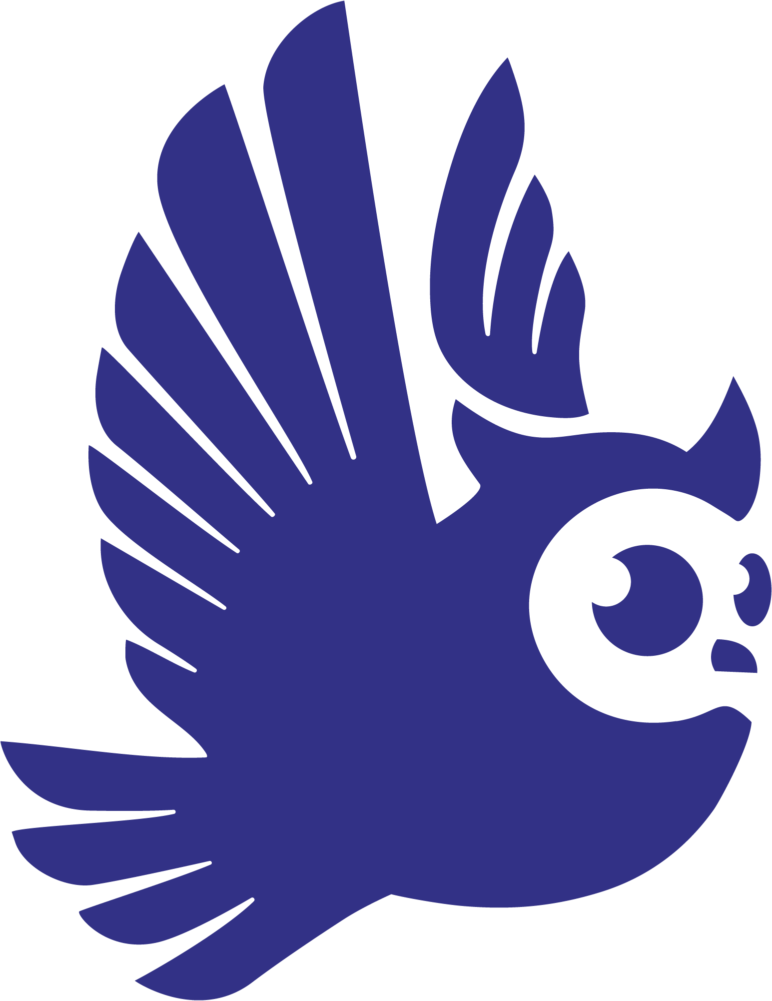 | Brand Mark  The owl icon serves as the heart of the Our Whole Lives identity, a symbol of wisdom, care, and watchfulness. Its forward motion and uplifted wings reflect growth, journey, and support across the lifespan.  The brand mark stands confidently on its own and is ideal for use in small-scale applications, such as social media avatars, favicons, or embroidery, where the full logotype may not be practical. It can also be used as a subtle watermark or graphic accent to reinforce the brand without overtaking the layout.
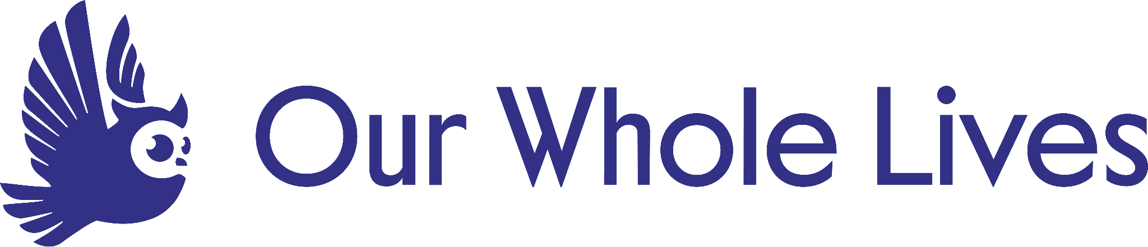 | Horizontal  The horizontal lockup combines the owl and wordmark in a side-by-side arrangement that provides balance and legibility across wide-format uses.  This version is ideal for website headers, navigation bars, slide footers, signage, or sponsorship layouts where a compact vertical format would feel constrained or visually off-balance. It’s a go-to choice for moments where width is more available than height.
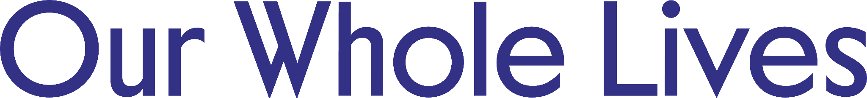 | Wordmark  The standalone wordmark offers a simple and flexible typographic treatment of the brand. While it does not include the owl, it retains a recognizable and consistent presence that allows for versatility across applications.  It’s useful in layouts where space is limited or where the icon may be redundant, such as email signatures, footers, or collaborative materials shared with partner organizations.
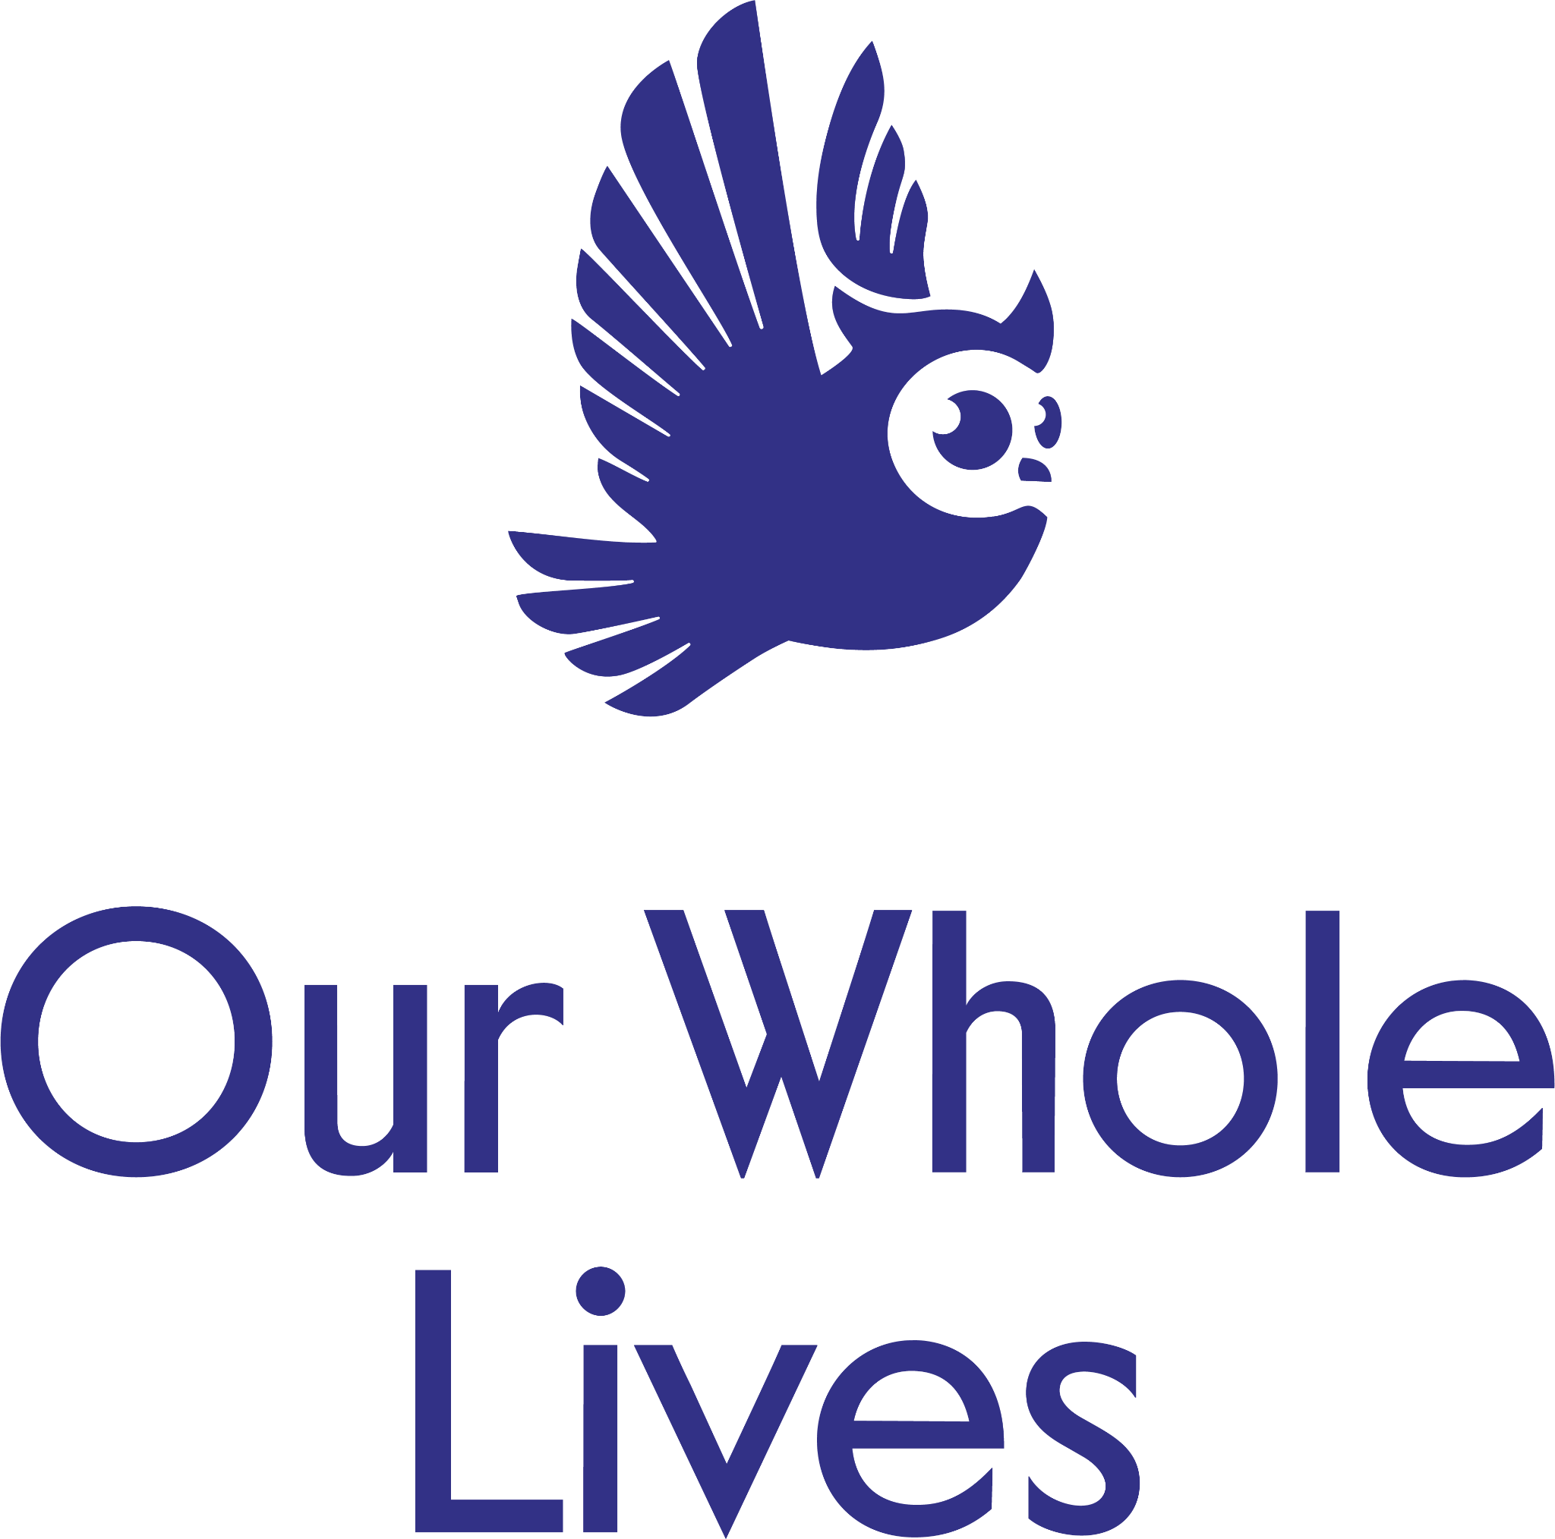 | Compact  The compact logo combines the owl mark with the wordmark in a vertically stacked configuration, offering a clean and cohesive expression of the brand.  This version works beautifully when a strong, centered presence is desired, and it serves well as a primary logo on web, print, and merchandise. It’s especially effective in spaces like the front cover of a brochure, a presentation title slide, or promotional items like tote bags and apparel.
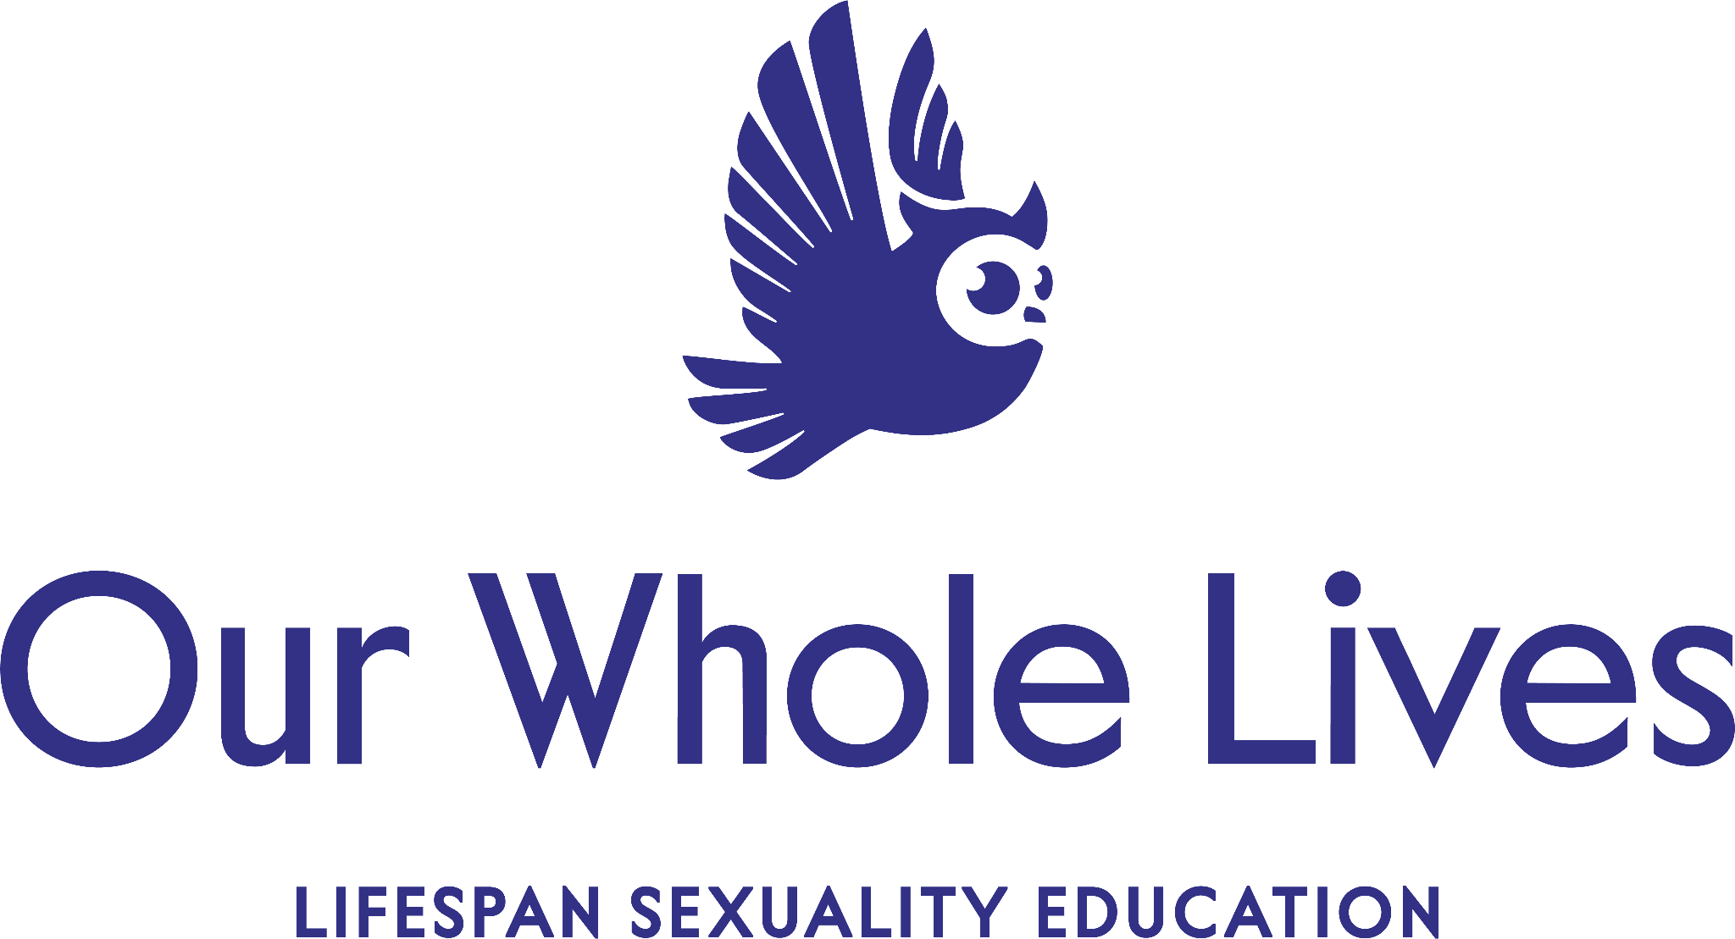 | Tagline  The tagline lockup pairs the owl and wordmark with the full program descriptor: “Lifespan Sexuality Education.”  This version emphasizes clarity of mission and is well-suited for educational or outreach materials where it's important to quickly communicate the program’s purpose. It works well in brochures, orientation packets, welcome slides, and any place where a first impression of the brand is being made.
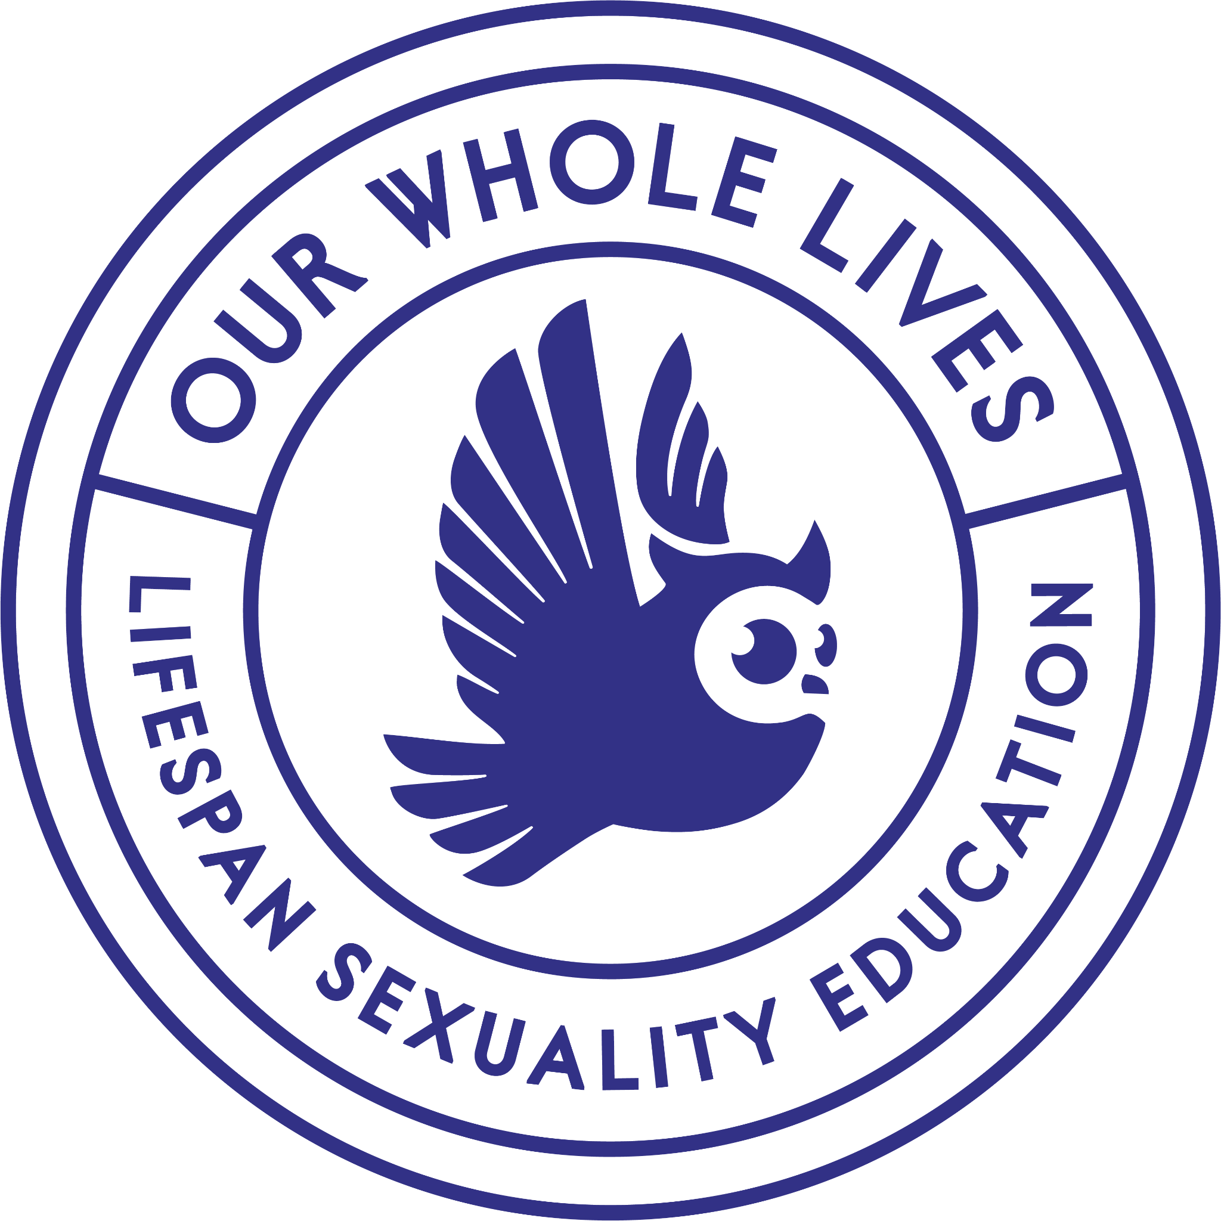 | Emblem  The Our Whole Lives emblem offers a seal-like expression of the brand, incorporating the owl, program name, and tagline within a circular layout. It provides a sense of trust, authority, and timelessness, making it especially appropriate for formal or official contexts.  Use this version on certificates, facilitator credentials, letterhead, and any communications that benefit from a sense of endorsement or gravitas.
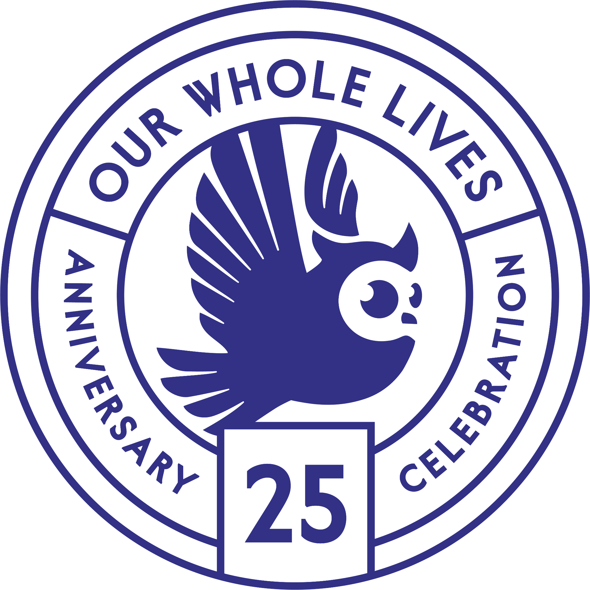 | Anniversary Mark  The anniversary mark was created to honor the 25th anniversary of Our Whole Lives. It uses a circular badge-style format to highlight the milestone while staying true to the program’s visual language.  This special-edition mark is designed for limited-time use in celebration materials, including digital campaigns, email newsletters, printed programs, event signage, and commemorative items.

Logo Misuse
Do NOT skew, rotate, recolor, slant, recreate, alter, recolor, mar, combine, re-do, or otherwise change the logo. To maintain the integrity of the brand, no logo should undergo any un-approved alterations or modifications.
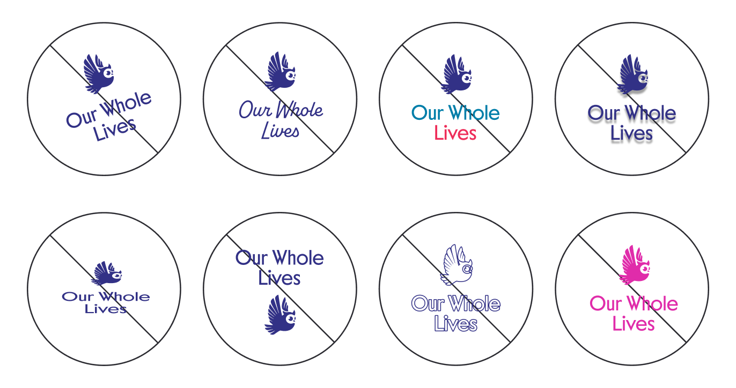

Clear Space
To maintain consistent and appropriate treatment of the logo suite, it's crucial to ensure no mark is positioned too closely to other visual elements on any collateral. This means avoiding proximity to other brand logos, images, typography, or other graphics.
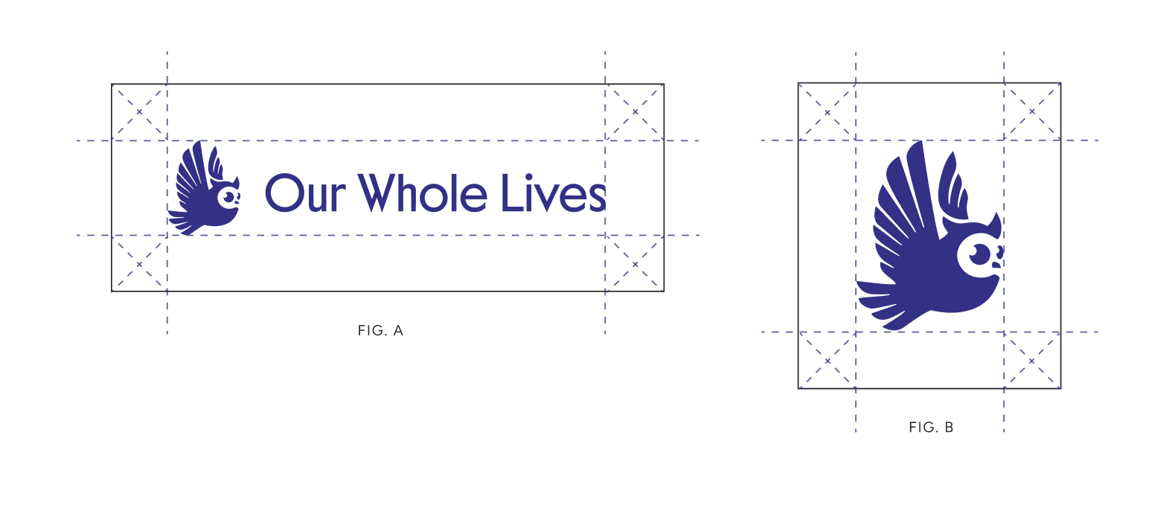

2) Color

Color Palette
The color palette features a vibrant mix of bright and grounded hues, crafted to inspire a sense of comfort, approachability, and harmony. Each color has been thoughtfully chosen to reflect the warmth, wisdom, and inclusivity at the heart of the program.

The four primary colors (Wisdom, Butter, White, and Shadow) serve as the foundation of the brand, providing contrast and structure for text, logos, and key brand elements.

The secondary colors (Orange, Red, Mist, and Blue) introduce complementary tones that create balance and enhance visual interest across brand applications.

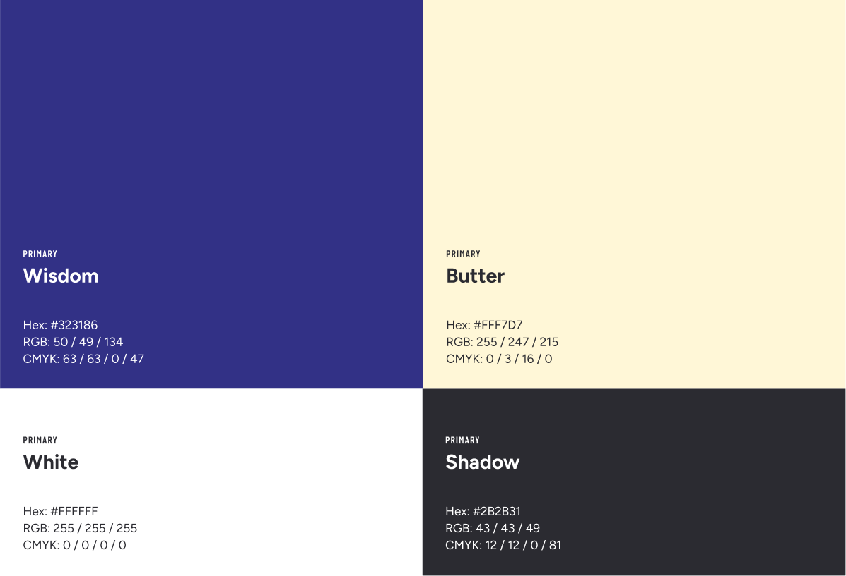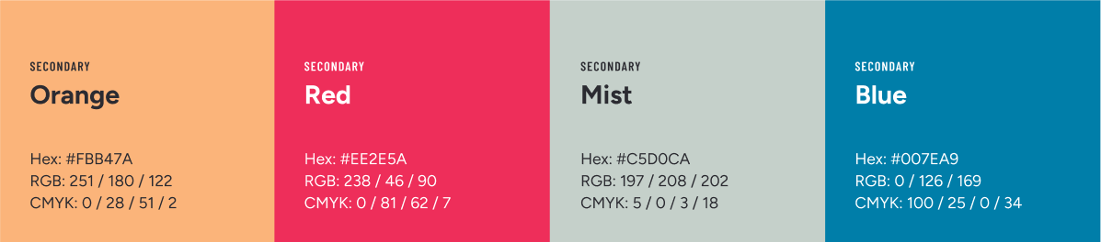

Inverted Logo Usage
The Our Whole Lives logo is designed to maintain clarity, contrast, and brand integrity across a range of background colors. To support this, an inverted version of the logo is available for use on dark backgrounds.

When placed on dark or saturated backgrounds (such as Wisdom or deep photographic imagery), the logo should appear in its inverted form, with the owl and wordmark rendered in a light color like Butter or White. This ensures optimal legibility and visual balance.
On light or neutral backgrounds (such as Butter, White, or Mist), the standard logo should be used, with the owl and wordmark in the core brand color, typically Wisdom.

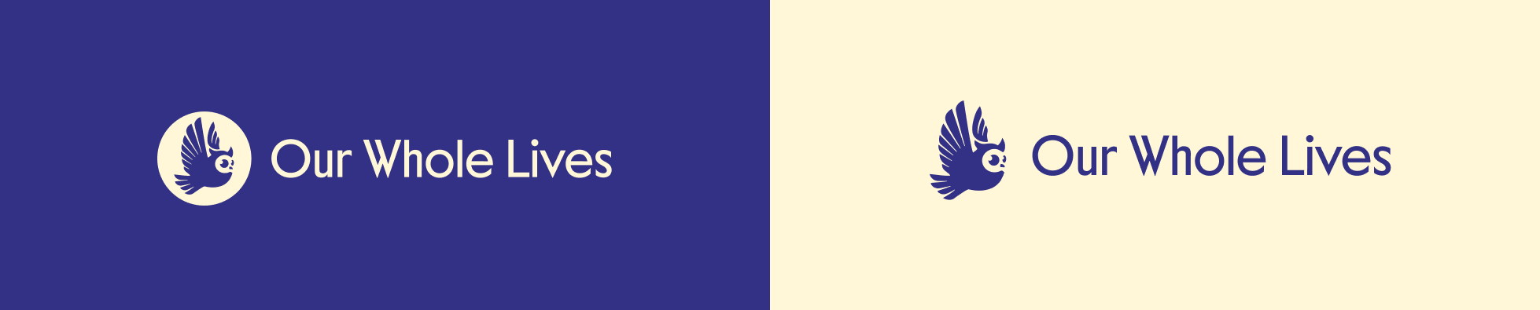

Color Contrast Key
To maintain accessibility, legibility, and visual consistency across brand applications, the Our Whole Lives logo should always be used in combinations that provide sufficient contrast between the logo and its background.

This contrast key serves as a guide for determining which logo color treatments are appropriate with each brand color. Diagonal lines indicate inappropriate pairings that compromise readability or fail to meet accessibility standards.

Use this key to guide your logo selection in digital and print materials. When in doubt, prioritize legibility and follow ADA-compliant contrast standards to ensure the brand is inclusive and easy to engage with for all audiences.

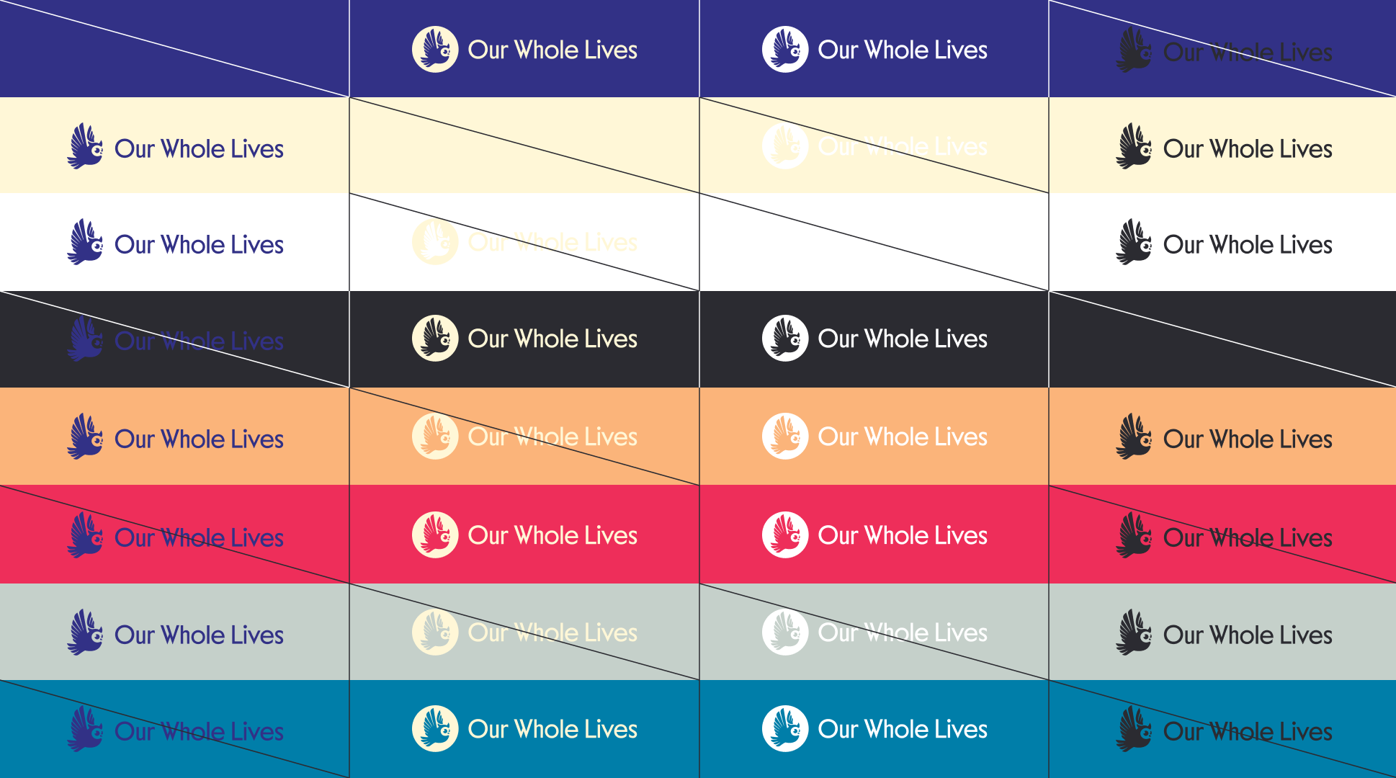

3) Type

Type Stack
The type stack establishes a clear hierarchy that ensures consistency across all materials.
Figtree Bold serves as the primary display font, used for headings to convey a sense of clarity. Tenor Sans Regular adds variability and a sense of quiet sophistication to the stack.

For body copy, Figtree Regular creates a seamless reading experience whereas Barlow Condensed Semibold is incorporated for pre-headers and buttons to enhance visual interest and create distinction in high-traffic areas.

- Heading & Display: Figtree Bold
- Heading & Accents: Tenor Sans Regular
- Body Copy & Paragraphs: Figtree Regular
- Pre-Headers & Buttons: Barlow Condensed Semibold

Heading & Display
Figtree Bold is a clean sans serif font that brings clarity and approachability to headlines and display text. It can be used in title or sentence case, with sentence case preferred for longer headlines to enhance readability and maintain a refined look.

Italic styles may be used sparingly to emphasize key phrases. Proper letter spacing and line height should be maintained, as outlined below, to ensure visual consistency across applications.

Figtree Bold
ABCDEFGHIJKLMNOPQRSTUVWXYZ
abcdefghijklmnopqrstuvwxyz

Case: Title or Sentence
Letter Spacing: 0%; 0px
Line Height: 100-120%; 1.0-1.2pt

Heading & Accents
Tenor Sans is a humanist sans serif font that adds a sense of quiet sophistication and personality to the brand’s type stack.

Proper letter spacing and line height should be maintained, as outlined below, to ensure visual consistency across applications.

Tenor Sans
ABCDEFGHIJKLMNOPQRSTUVWXYZ
abcdefghijklmnopqrstuvwxyz

Case: Title or Sentence
Letter Spacing: 0%; 0px
Line Height: 100-120%; 1.0-1.2pt

Body & Paragraphs
Figtree Regular is a clean sans serif font used for body copy, offering excellent readability for paragraphs and smaller text elements. For optimal clarity, use italics or bold weights depending on the level of emphasis required within the text.

Proper letter spacing and line height should be maintained, as outlined below, to ensure visual consistency across applications.

Figtree Regular
ABCDEFGHIJKLMNOPQRSTUVWXYZ
abcdefghijklmnopqrstuvwxyz

Case: Sentence
Letter Spacing: 0%; 0px
Line Height: 150-170%; 1.5-1.7pt

Pre-Headers & Buttons
Barlow Condensed Semibold is a condensed sans serif font that adds a bit of visual interest and personality to the brand, used explicitly for pre-headers, buttons, and accents.

When using Barlow Condensed Semibold, opt for uppercase to ensure clarity and visual impact. Avoid using it for long paragraphs, as it is intended to enhance key elements and provide a polished contrast to a composition.

Proper letter spacing and line height should be maintained, as outlined to the right, to ensure visual consistency across applications.

Case: Upper
Letter Spacing: 8%; 80px
Line Height: 100-120%; 1.0-1.2pt

Type Stack
Web hierarchy is crucial for creating a clear, organized structure that guides users through content seamlessly.

Headings H1, H2, and H4 are set in Figtree Bold, while H3 is set in Tenor Sans for visual contrast. Paragraph text is styled in Figtree Regular for clean, approachable readability, while pre-headers and buttons use Barlow Condensed Semibold to create impactful, attention-grabbing elements.

The visual on the right provides the exact sizes for consistent application across the Our Whole Lives site, ensuring a polished experience across pages.

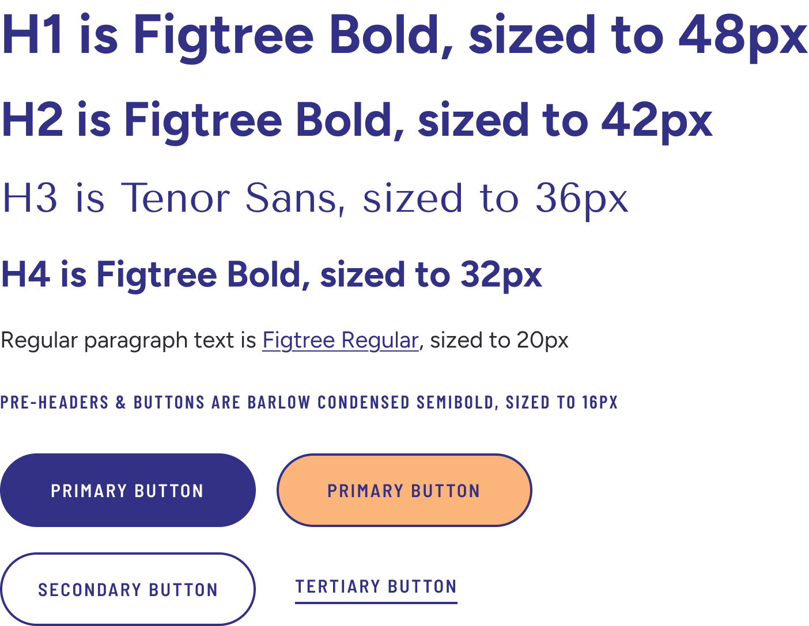

4) Application

