Philosophy of Religious Education Sparks Module
HANDOUTS


© 2002, 2020, 2022 by the Faith Development Office of the UUA, Boston, MA

List of Handouts
1 Introduction to Sparks and RE Credentialing 3
2 Preparation for Module Evaluation 4
3 Creating Covenant 5
4 Religious Education Philosophy Module 7
5 Session Topics 8
6 Religious Education as Relationship Building 9
7 Constructivist Learning Theories 10
8 Faith Stages According to Fowler 11
9 Criticisms of Fowler’s Theory 15
10 Other Perspectives on Developmental Stages 17
11 Wrought Faith: Minding What We’ve Missed in Faith Development 23
12 Dewey and Progressive Education 25
13 Fahs and MacLean 28
14 The Great End in Religious Instruction 34
15 John Westerhoff: Modes/Dimensions of Consciousness 36
16 Head and Heart Activity 37
17 Paulo Freire, “The Banking Method of Education” 38
18 bell hooks, “Paulo Friere” 46
19 Taking a Special Education Approach 53
20 Tough Terms 67
21 More Tough Terms 71
22 Unitarian Universalist Principles & Sources 73
23 Online Resources for Religious Education 74
24 For Further Reading 77

Handout 1: Introduction to Sparks and RE Credentialing
The Sparks Program has a distinguished history of providing standardized training on topics useful to religious educators, as well as parish ministers, seminarians and lay leaders. The Sparks program is a major component of the Unitarian Universalist Association (UUA) Religious Education (RE) Credentialing program. These modules are throughout the year online by the UUA Lifespan Faith Engagement office or may be “face to face” trainings:
- Administration as Leadership
- Adult Faith Formation Online
- Beloved Conversations (in partnership with the Fahs Collaborative)
- Curriculum Planning
- Family Ministry Training
- Leading UU Culture Change
- Philosophy of Religious Education
- Teacher Development
- Unitarian Universalist Identity
- Unitarian Universalist History
- Unitarian Universalist Theology
- Worship for All Ages

For more information, visit the Sparks program page of the UUA website:
https://www.uua.org/careers/re/sparks
The Religious Education Credentialing Program is a program for religious education professionals intended to nurture the call to religious education as a profession, to provide a comprehensive path for professional development, and to articulate and uphold professional standards and guidelines in religious education leadership. For more information, visit the RE Credentialing page of the UUA website:
http://www.uua.org/careers/re/index.shtml

Handout 2: Preparation for Module Evaluation
Locate the Sparks Program Participant Online Evaluation Form.
Please complete and submit it within one week of completion of this module. The official Sparks Certificate will be sent to you within two weeks of receipt of evaluation. All feedback is confidential and is seen only by Sparks staff; feedback to leaders is shared only in the aggregate. Your candid comments are very helpful in developing strong leaders and a strong Sparks program.
There are three areas for which you will be asked to provide feedback:

I. Module Leadership – consider each leader separately
Group facilitation skills
Knowledge of content area
Sensitivity to different learning styles
Teamwork with other leader
Organization/communication
Other comments or suggestions for leaders
II. The Learning Experience
What was most valuable for you?
Please share at least five significant learnings from the module:
What expectations did you bring to the module? Did the module meet your expectations?
Please explain.
In what ways will you use the learnings from this module?
How will you share your learnings in the congregation or with peers?
Other comments or suggestions about the learning experience III. The Reader
I read: all/most/some/none of the reader
I found the reader: very useful/somewhat useful/not useful Comments on the reader

Handout 3: Creating Covenant

The 8 Guidelines for Equity and Inclusion–Visions, Inc.1.
- “Try on” is an invitation to be open-minded to others’ ideas, feelings, world views and ways of doing things so that greater exploration and understanding are possible. The invitation also includes feeling free to take those things that “fit” and to leave or file away those things that don’t fit.

- “It's OK to disagree” assumes that disagreement is not only inevitable but can help individuals and groups produce better outcomes. By acknowledging what we have in common and by recognizing, understanding, and appreciating what is different between us, individuals and groups can shift the pressure to “be”, “think”, or “act” the same into permission to generate all possible ideas and strategies. This guideline assumes we can disagree and still stay connected and do great work.

- “It's not OK to blame, shame or attack ourselves or others” assumes that most of us have learned well how to show our disagreement by making the other person wrong. This happens in direct, indirect, verbal and non-verbal ways. When we attack, shame, or blame ourselves and others, we are less likely to take in what others are sharing and less likely to problem-solve across our differences.

- “Practice self-focus” assumes that our learning about differences can be accelerated and maximized when we listen to our internal thoughts, feelings and reactions. When we find ourselves getting irritated with someone about cultural differences, we can blame or shame them or ourselves, or we can figure out internally what is causing our irritation. An effective tool for practicing self-focus is using “I”, rather than “we”, “you”, or “one” statements. When we intend to refer to others, be specific about who those others are --by name or group. In addition, when speaking about our own experience or opinion, use "I have found..." or, " I think, I feel, I believe..." and include feeling words, e.g. mad, sad, scared, happy, relieved, etc.
- “Notice both the process and content” means notice both, “what we say”, “how “and “why” we say or do something and how the members of the group react. For example, notice who's active and who's not, who's comfortable and who's not, who's interested and who's not, including ourselves. Ask about both the process and content and share our own thoughts and feelings too.
- “Practice "both/and" thinking” invites us to see that more than one reality or perspective can be true at the same time (diunital thinking) rather than seeing reality as strictly either/or, right or wrong, good or bad, this or that (dichotomous thinking).Using "both/and thinking" can be very helpful in reconciling differences and conflicts that do not present easy solutions.
- “Be aware of both the intent and impact of your actions” invites us to consider that in cross cultural interactions, our intent might not match our impact. When we have a negative impact on others across culture, ensuring a successful outcome requires changing that negative impact. This guideline requires a willingness to take risks and to exchange and receive honest feedback about the impact of our words and actions on others. It is possible to be well-intentioned AND still say and do hurtful things. To be successful across differences, we must be willing to shift our behaviors and actions such that people who are different from us feel fully valued and included.
- “Confidentiality” invites us to honor personal sharing and to not repeat personal details outside of the group. Confidentiality assumes that feeling free to share in one setting, does not translate into comfort in other settings. So, if we want to bring up information related to a person’s sharing in other settings, we need to privately ask the person if it is acceptable to do so. Confidentiality also assumes that we will not use something someone has shared to hurt them, get them, or punish them later. This is especially important for work groups or teams involving multiple staff or organizational levels. Participants are encouraged to freely share their learnings about theory, practice and themselves in any setting of their choice.

VISIONS Study Guide for COIC. https://www.edomi.org/wp-content/uploads/2020/02/8-Guidelines-for-Equity-and-Inclusion.pdf

Once we have affirmed the covenant, we will place it into the shared Google Docs Folder

Handout 4: The Religious Education Philosophy Module

Rationale
Unitarian Universalist religious education needs to be re-invented afresh for every era. This workshop is based on the belief that we need to re-examine the philosophies that served us well in the past and incorporate new research and new philosophies of religious education that expand and deepen our understanding.
A changing world affects the lives of us all, especially our children and youth. Changing theories of human development suggest that there may be new considerations and ways of meeting spiritual, ethical, and educational needs.
Philosophizing about religious education is something that needs to be done, not just by a few experts, but by everyone who wishes to participate in religious education. Each person operates on some de facto religious education philosophy. By becoming aware of it and examining it in light of others' views the hope is that we will become empowered to do the kind of thinking that leads to an intentional philosophy of religious education.
This workshop will provide some experiences in thinking about basic questions that are posed by theologians and educators. But it is just a beginning and leaders and participants are invited to return often to the basic philosophical questions and to re-examine and revise their individual and our collective philosophy of Unitarian Universalist religious education.

Learning Objectives:
- Increased ability in articulating one's own religious education philosophy
- Increased clarity about the purposes of lifespan religious education
- Increased comfort and competence in sharing a philosophy of religious education
- Increased understanding of learning and faith development theories.

Handout 5: Session Topics
Session 1: The Congregation as a Learning Community (2 hours)
How do the terms we use affect our philosophies of religious education? What makes a religious community a learning community? How important is relationship building for religious education?

Session 2: Learning Theories & Faith Development (2 hours)

How do people learn? What can learning theories can tell us about our philosophies of religious education? Who is Fowler and what is his theory of faith development? What are the criticisms of his theory?

Session 3: Our Religious Education Philosophies of the Past
(2 hours)

Who are the people that have been influential in religious education philosophies of the past? What aspects of past education philosophies are still alive today? Who is Freire and what influence has his Pedagogy of the Oppressed had on Unitarian Universalist religious education philosophy?

Session 4: Liberation Pedagogy (2 hours)

What can we learn from Paulo Freire that is applicable to religious education philosophy? How can we also think critically and use the teachings and writings of others to discern parts of a philosophy that need further work? How does the need for liberation fit into our religious education philosophies?
Session 5: Stretching Ourselves Toward Liberation (2 hours)

Why do Unitarian Universalists still struggle with religious language and how does this affect our religious education philosophy? How do we create religious education philosophies that build strong and radical communities working toward wholeness and liberation?

Session 6: Creating a Philosophy of Religious Education (2 hours)

What are some ways we can use technology and social media in religious education? How do we create a religious education philosophy with all the people who are invested in the process?

Handout 6: Religious Education as Relationship Building


Handout 7: Constructivist Learning Theories
- People learn about the world by acting within their environment
- People are active participants in their learning
- People are active in constructing their own learning
Jean Piaget
- Focused primarily on internal influences
- Language as means of disrupting equilibrium for reconstruction of thought
- Involves series of stages people must progress through in order
- Ignores cultural influences on development and learning
Lev Vygotsky
- Emphasized how external forces shape learning
- Language as means of establishing social relationships conducive for learning
- Continuous and lifelong
- Emphasizes cultural differences

Kurt Fischer
- Lifelong and multidimensional
- Learning and development involve the entire brain
- Learning happens through levels and tiers
- Learning happens through a slow and variable process
- Context is important
- Support is essential

Limitations of Piaget’s Theory
- Research methods
- Stage theories approach not supported by brain research
- Modern research has proven that children possess many of the abilities at an earlier age than predicted by his theories

Handout 8: Faith Stages According to Fowler
Summary, Rev. Lindsay Bates and Cynthia Wade for Sparks Module: Philosophy of Religious Education Expanded by Joy Berry

Pre-stage: Primal Faith
pre-birth to about age 4
For the youngest ones, there is no "other" or external world. "I'm It." This child is his or her feelings, both physical and emotional, and that's the world; other people are not understood as "other people." What the youngest children are going to retain from this time in their lives is how they have felt. The youngest ones don't have any understanding of religious symbols, whether it's of God or Jesus or Torah or Santa Claus. Their experiences at this stage, especially of the nurturing/lack thereof provided by primal others, are apt to surface later in the images of God that begin appearing by about age 4 or 5. Infants form their initial impressions of the world and experience sensations of love, trust and courage (or lack of these) on a body level. The spiritual virtue being instilled is HOPE; the ability is trust through times when that trust is challenged.

Stage One: Intuitive/Projective Faith - Faith is CAUGHT
approximately from ages 4 or 5 to ages 7 or 8
They're learning about how words and symbols work -- which is why this is usually when they're learning to read on their own. Their "cause-and-effect" thinking is still often magical. These children can easily believe, for example, that they are responsible for bad things happening. Under the best of circumstances, a child at this stage is able to trust in the security and "rightness" of the family, and "Because my mommy says so" is an adequate squasher for all challenges. It's important for parents and other authority figures in the child's life to be willing to say that they believe certain definite things, such as that God does not send people to hell, or NO, the baby did NOT die because you were bad or because she was bad. That parental authority can do a lot to ease the fears that arise when their little friends start sharing their Sunday School stories about going to hell if you aren't right with Jesus. A UU parent or RE teacher who will not express a definite opinion at this point in the child's religious growth is not doing the child a favor. The authoritative role of the family and the family's chosen circle (which includes the church) explain why at this stage we talk about our children's religion being "CAUGHT." It's what's around them; it's what the people they trust and care about are doing so they do it too. Spiritually, they're working on the meaning of "Free Will," the inherent worth of each individual, including themselves. They need a lot of encouragement and positive reinforcement for the things they do well and the things they try to do well. They need to know that they are accepted and cared about and loved. This is when our church home needs to be a place of safety and fun and love.

Stage Two: Mythic/Literal Faith - Faith is TAUGHT
approximately from ages 6-8 through ages 10-12
Thought is more complex now, and cause-and-effect thinking passes from the magical to the scientific. Discussion of ideas and of one's own thoughts becomes important. These children are beginning to recognize that they do have their own thoughts, and that other people have other thoughts. How their trusted authority figures handle these differences in thoughts is very important. These children do not want to be thought of as "different." If they know that in their own group different ideas are good, they will be comfortable having ideas that are different. If they are taught that there are absolutely right ideas and absolutely wrong ones, they will feel guilty, inferior, "sinful", if their ideas are not like everybody else's. Children tend at this age to be very concerned with absolute fairness. Morally ambiguous issues are very hard for them. They're often described at this stage as "legalistic." In this stage, the conviction that if you are good, you will be safe and successful and happy, and if you are bad, you will be punished, is normal. But alongside that is the growing awareness of how unfair the real world can be. At this stage, stories are very important. These children want to know the stories that everyone else knows, Bible stories, stories about their own church, stories within the family. Those shared stories are part of what creates the group to which these children belong. That's why we often speak of religious faith at this stage being "TAUGHT." These children want to be told what the trusted adults around them know and value.

Stage Three: Synthetic/Conventional Faith - Faith is BOUGHT
approx. ages 10-12 through adulthood, but not all adults
This stage is one of transition. Many children decide that they are atheists at this point. If there were a God, then things would be fair, but things are not fair, and therefore there can be no God. Many adults also hold this position. Adults in many faith communities, including ours, settle quite happily into this stage. We usually enter it (if we enter it at all) when we begin to recognize how complicated and illogical and unfair life can be. We can't count on "ultimate fairness," so we rearrange our framework of understanding value and worth, and we seek meaning within our own group (realizing that there are others but not necessarily being convinced that those other ways might be as valid as ours). Our group's certainties provide our spiritual and psychological foundations. In this stage, one is "thinking about thinking"; beginning to understand how one develops one's beliefs, how to construct and test hypotheses, now to take another person's perspective while not necessarily agreeing with it. This is a highly relational way of being, and being part of a group is very important. When God is discussed, it's apt to be in relational terms—"God is Love," which makes God a little bit like us, or us a little bit like God, or perhaps in a relationship with God. Important questions become "Who am I?" and "Who are you?" Issues of what we believe and why we believe it become interesting and important. The ideal of relatedness, of belonging, can also create a strong idealism as a member of a group. Ways of being of service become important, in part because how one is regarded by those who are important to us matters a lot. Identity becomes of paramount importance in the face of the many possible conflicting roles they are being invited to fill. Sexual and gender identity are important issues. The spiritual issue is faithfulness—being true to the values, the commitments, and the ideals of one's community. This is what we refer to as faith that is "BOUGHT." The young person wants to be able to buy into what the trusted group values and believes. And it's the task of the adult community to share our beliefs and values with our young people, to be clear about why we believe certain things are right and others are wrong without being wishy-washy or apologetic about it.

Stage Four: Individuative/Reflexive Faith - Faith is SOUGHT - and FOUGHT*
mid-to-late adolescence through adulthood, but not all adults
This stage is reached as the discovery is made that there really are all sorts of people out there who are not like the folks I grew up with. And they have claims to be taken seriously, which can be perceived as very threatening. This is sometimes a retrenching time. Earlier values are clung to with an almost desperate need for that security. At the same time many presuppositions are being challenged. Early in this stage one tends to see everything in terms of "either/or." Either I'm right or you're right, and if I'm right, you're wrong, and if you're right, I'm wrong. There tends to be a loss of patience with lack of clarity or ambiguity, and a strong need for an identity that one can indeed defend as valid against those who are different. There is often a tendency to caricature, discount, or not take seriously the experiences and differences of members of other groups while being in relation with individual members. One does not yet see that your insistence upon being who you are does not diminish who I am, no matter how different we may be. This is a time of intense seeking, which is why this faith is no longer caught, taught, or bought. Now it is actively "SOUGHT." The challenge is to learn to deal with radical differences and ambiguities, to move beyond what's been called a "class-based universalism," in which issues of right and wrong, good and evil are resolved with the conviction that what's right for me and my group is right for everyone.

Stage Five: Conjunctive/Paradoxical/Consolidative Faith - Faith is FRAUGHT*
may begin as early as late teens/early 20s, more commonly in later adulthood - not all adults reach this stage
Fowler suggests that the transition to this stage is apt to be brought about by experiences in adulthood of deep pain, grief, awareness of the reality of death. It is in this stage that we begin to learn to move away from "either/or" and begin living with "both/and." Concepts and experiences of paradox, of multiple layers of meaning and understanding and experience, are now enriching rather than frightening. Truth is understood to be paradoxical, complex, beyond absolute understanding. Symbols become symbols again, vehicles for experiencing and expressing those things for which exact, scientific explanations can never be adequate. Authority is found in the dialectic of critically self-chosen beliefs, norms, and values with those maintained in the reflective claims of other persons and groups and in various expressions of cumulative human wisdom. One becomes deeply appreciative of the stories, myths, rituals, etc., of other groups, coming to see them as being equally legitimate vehicles of truth. In moral judgment, there tends to be an appeal to a principled "Higher Law." Integrating conflicts of law with morality can be a struggle. In this stage, one is apt to be strongly loyal to society and its values while seeing clearly the injustices, pain, etc. within it. One realizes that "seeing what justice requires means doing what justice requires." This is often painful. As such, faith is FRAUGHT.

Stage Six: Universalizing Faith - Faith is OUGHT* (we act as we ought to, without struggling to be good)
Very few people achieve this level. In reaching this level, one has truly transcended one's own particulars (while still valuing them) and become a full member of the "Commonwealth of ALL Being." Authority is built upon all previous sources, now located in the individual judgment purified of egoistic striving, attentive to the requirements of pure Being. Morally, loyalty to Being transcends any and all laws or societal norms. Spiritually, if you get this far, you have achieved Buddhahood. But I do think, while few of us honestly get here, it is a vision of faith and of being to which we aspire -- so maybe it's not as far beyond our reach as Fowler often seems to insist.

*additions of FOUGHT, FRAUGHT and OUGHT as snapshot words for stages 4, 5 and 6 by Joy Berry from “Wrought Faith - Minding the Gaps in Faith Development Theory and Practice”

Handout 9: Criticisms of Fowler’s Theory

Fowler’s theory is based upon the work of Kohlberg and Piaget, who both characterize development as happening in stages which are always experienced in the same order. However, lifespan development is now recognized as complex and uneven, and heavily influenced by a person’s culture and environment. Even Piaget himself in later life moved away from his conception of a rigid, hierarchical structure and considered development more in terms of a spiral than a series of ordered stages.

Fowler’s theory is gender biased and gender binary. Fowler noted that the scale under-scored women and over-scored men and suggested the inclusion of “relational knowing” in the fourth stage. Feminist work on moral development (e.g., Carol Gilligan and Nona Lyons, 1982, 1983) has viewed the stages as fluid, dynamic, non-hierarchical phases or steps shaped by emotion, imagination, relationship, and cognition. By listening to girls and women resolve serious moral dilemmas in their lives, Gilligan traced the development of morality organized around ideas of responsibility and care. This conception of morality contrasted sharply with the morality of rights described by Piaget (1965) and Kohlberg (1981, 1984), who studied the evolution of moral reasoning in boys and men. More recent critiques of Gilligan and Kohlberg cite the complexity of gender as a social construct, which must be considered.

People operating within a rights morality—more commonly men—evoke the metaphor of “blind justice” and rely on abstract laws and universal principles to adjudicate disputes and conflicts impersonally, impartially, and fairly. Those operating within a morality of responsibility and care—primarily women—reject the strategy of blindness and impartiality. They posit that the needs of individuals cannot always be deduced from general rules and principles; rather, moral choice must be determined inductively from the experiences each participant brings to the situation. They believe that effective dispute resolution requires dialogue so each individual is understood on their own terms; in other words, mutual understanding is most likely to lead to creative consensus.

Fowler’s Faith Development theory is culturally specific. He developed his theory within the context of late twentieth century Euro-American intellectual culture. From a Vygotskian perspective, this theory fails to consider the role of engagement in cultural life in forging development. Modern psychology which recognizes the validity and value of a plurality of viewpoints is in conflict with any theory which does not reflect cultural diversity. Furthermore, faith is shaped by the interactions with people and the building of relationships, suggesting a theory that is vertical as well as horizontal in its perspective.

Fowler’s theory is hierarchical in that higher stages are preferential to lower ones, the stages and claims some people never progress to higher levels, implying inferiority. While the earlier stages address advances in children’s thinking and characterize many of their evolving needs for faith development, stages 3, 4 and 5 may be considered instead as different directions as opposed to stages. Since Fowler claims that adults can get “stuck” in any one of these stages, perhaps a view that is less judgmental and recognizes the influences of culture, gender, socio-economic status and a person’s family environment would see these as equal paths to follow or pass into via a sideways motion rather than upwards.

Fowler’s theory overemphasizes cognition and does not address emotional/affective issues such as transition and transformation. Faith development is more than cognitive development; it is full of emotions, pain, healing, fear, courage, rage, as well as love and becoming our best selves. All those aspects of faith formation are absent from this theory.

Handout 10: Other Perspectives on Developmental Stages
Abbreviated Summary: Child Development
Adapted from Nurturing Children and Youth: A Developmental Guidebook, by Dr. Tracey L. Hurd, published by the UUA (Boston, 2005); also “Stages in Children’s Development of Racial/Cultural Identity and Attitudes,” Louise Derman-Sparks (UUA 2012)
 | Preschool Child | Early School Age Child | School Age Child
Physical Development | Body is acquiring gross and fine motor skills  Learns through physical experiences  Needs sensory and tactile experiences  Doesn’t have link between thinking and action refined | Starts coordinating motor skills (rides bike, games)  Uses tools for drawing, writing  Very active; needs physical challenges  Learns through doing  Needs to play | Fine and gross motor skills almost fully developed  Central nervous system primarily fully developed  Needs food, rest, exercise  May enter puberty  Is a top consumer of media images of bodies, ideals, wellness
Cognitive, Intellectual Development | Self is primary reference point: “egocentric”  Obtains Object Permanence  Categorizes & classifies  Dichotomizes  Appearance = reality  Fluid between fantasy & reality  Needs to problem solve | Starts to understand the notion of “Conservation”  Interested in numbers, letters, words, facts  Self is still primary reference point  Enjoys being “correct”  Learns best in the “zone of proximal development” | Engages in logical thinking  Develops hierarchical reasoning  Concrete Operational thinking—based on non-abstract “pieces”  Develops specific learning styles; learning disabilities may become more clear
Social, Affective Development | Social circle of family is primary reference points  Has not acquired race or gender constancy  Starting to learn notion of “friend”  Empathic, but centered on self | Learns through social interaction  Enjoys peers and working together  Has beginning “true” friendships  Often rigid is thinking about gender, race, roles | Peers and friendships are important  Identities navigated through social relationships  Takes perspectives of others  May segregate based on gender, racial, ethnic identities
Moral Development | Categorizes right and wrong- sometimes too rigidly  Needs support linking words to actions & moral issues | Attends to order and authority; uses rules  Develops a sense of industriousness  Starts to understand motive | Uses “Golden Rule  Interested in fairness, justice and care  Aware of moral issues & interesting in helping
Racial / Cultural Identity Development | Developing awareness of self as separate  Beginning to absorb cultural identity through daily interactions  Critical window for becoming skilled in home language(s)  Beginning to identify and “match” people according to “racial” characteristics – often confused about who belongs to which group | May feel a sense of cultural crisis when entering school – may reject either home or school culture, or learn to “code switch”  Aware of and exploring meaning of / cultural messages about various aspects of identity (gender, race, class, etc.)  May use insults related to skin color, but are also interested in how it happens | Begin to establish identity groups with self-made rules  Increased use of name-calling, but also interested in learning science of skin color and history of race and race-relations  Role model of people involved in anti-racism/social justice struggle very important to them
Spiritual, Religious, Faith Development | Learns about religion and faith through experience  Receptive to spirituality  Not afraid of “big questions” – full of wonder  Fowler’s Intuitive Projective stage of faith development | Does religion to know religion  Latter part of Fowler’s Intuitive Project stage of faith development  Needs to have rigidities, and “correct” answers gently challenged | Enjoys membership in faith or denominational communities  “Does” religion & spirituality  Enters Fowler’s Mythical Literal stage of faith
Important Notes:
By age 9, “when faced with counter-stereotypic information, children who showed highly stereotyped attitudes tended to forget that information or even, disturbingly, to distort it in memory to be consistent with their stereotyped beliefs.” ~ Bigler & Liben, 1993, Child Development
“After age 9, racial attitudes tend to stay constant unless the child experiences a life-changing event.” ~ Frances Aboud, 1988, Children and Prejudice
 | Early Adolescence | Middle Adolescence | Late Adolescence
Physical Development | Transitions into adult body  Eats and sleeps more  Demonstrates or does not demonstrate behaviors that may indicate risk for eating disorders or depression  Seeks support for self-esteem and body image | Develops sexuality more fully; feelings of gendered attraction and sexual orientation are often central  Navigates greater risks relating to alcohol, drug use, sexual activity  Peak physical growth stage for male youth | Achieves full physical development  Gains more assurance about body image  Engages in sexual activity; more likely to be partnered  Learns to manage stress and maintain health
Cognitive, Intellectual Development | Concentrates on self and others’ perceptions of self  Engages an “imaginary audience,” a mental idea of others observing  Particular intelligence strengths become evident (linguistic, mathematical, interpersonal, musical, etc.) | Has the ability to think deductively, inductively, conceptually, hypothetically  Engage in practices to celebrate new mindfulness about self (journal writing, reviewing emails, etc.)  Become more critical of the world around them | Particularly open to learning; a time ripe for formal / informal education  Expresses ideas with more linguistic skill  Sees many points of view and may claim multiple realities as the truth
Social, Affective Development | Social relationships with peers are very important  Learns social scripts (embedded in the contexts of race, ethnicity, and class) about what it means to be a sexual person  Expresses criticism of self and others | Tries to claim an identity/ies  Needs to belong and have a sense of self-worth  Struggles with gender and sexual identity – often a time of increased stress for LGBTQIA+ and questioning youth | Increases self-reliance  Develops sense of identity and intimacy  Expresses interest in vocational and personal life choices  Brings to realization sexual identity of self
Moral Development | Demonstrates interest in ethics of care and justice  Respects social order, although sometimes challenges it as well | Thinks conceptually and enjoys moral reasoning  Engages in “principled morality” – principles are more important than laws | Wrestles with personal morality and life choices  Expresses interest in moral and philosophical thinking, for self and wider world
Racial / Cultural Identity Development | Want to learn more about their cultural group and its true identity  Aware of differences between how dominant culture experiences their group and how group experiences itself  Conscious of contradictions between what adults say and what they do | Sense of self and other groups well established, as is sense of justice, though may lie dormant at school  Need opportunities to express true life narratives | Learning accurate history about racial groups plays a crucial role  Active work on social justice increases sense of personal empowerment  Great capacity for anti-racist/social justice organizing
Spiritual, Religious, Faith Development | Enjoys presence or absence of religious creed  Expresses interest in religion that embodies one’s values  Sustains faith development by engaging with a community that allows questioning | Conceptualizes religion as an outside authority that can be questioned  Questions faith, leading to deeper ownership or disenfranchising  Deepens religious or spiritual identity | Claims authority around issues of faith  Further develops spirituality as an important part of self  Engages in “faith” beyond traditional organized religion

Handout 11: Wrought Faith: Minding What We’ve Missed in Faith Development, Joy Berry, Religious Educator
James Fowler's classic theory centers the individual's progress through six stages of faith. The first four have "shorthand" names that make it easy to remember how development happens in each. Faith is caught in stage one, and then it is taught, bought, and sought in stages two through four, Fowler offered.
Yet without a commitment to faith that is wrought - intentionally shared learning in our congregations - the promise of faith development, and indeed the very premise of a "covenantal faith," is in question.
Wrought is an old word that means worked. I use it because it rhymes with those common shorthand versions for Fowler's stages. But also because wrought is a good old word: it describes something strong but flexible, able to be forged, changed, and strengthened, through active work. It's resilient and malleable: it's meant to be shaped with tools, by humans. Its final form is determined by how it is worked.
Fowler believed that individuals move through the stages of faith in a linear process, and that most people never move beyond stage 4, to the "rare" stages 5 and 6.
But why is that? Is there something special in the psyche of those few gurus and transcendentalists? Or is it possible that faith development, like most other kinds of emotional-spiritual-social development, depends on the capacity of the environment to support it?
Fowler wrote that in stage 4, folks begin to question authority and that includes the rules and expectations of faith community. The UUA's handout on faith stages is here: http://www.uua.org/.../wholeness/workshop2/167602.shtml
It reports that stage 4 folks often leave churches when they don't get their way.
What if Fowler's emphasis on the individual made him miss something essential, about how individual development always happens in a context of connection: that our own, and even our congregations' potential faith development is determined by how much of it happens in shared work, learning and growing together across generations?
What if our human blueprint for faith development as individuals depends on the degree to which our communities of faith are engaged in shared faith work? What if our collective learning experiences are the practice and training that determines how whole and strong and complete our faith can eventually become? Does that mean communities, like individuals, can be defined by their collective faith stage?
How much of our faith is shaped in shared work, in our congregations today? And how might doing more of it change the overall faith development stage of our congregations?
Stage four is about the individual journey: asking questions and seeking answers. It's where we become capable of setting aside the opinions of others and making decisions about what's best for us, about what we believe and don't believe, as independent and unique individuals. It's an important stage; but it should be a waystation, not a destination. Is it possible that having congregations with many individuals at stage 4 create challenges to the whole notion of religious education (led by adults from the congregation)?
Is covenantal community possible without a majority of congregants moving on to Fowler's stage five, when the "strong need for individual self-reflection gives way to a sense of the importance of community in faith development" and "a realization that other people's faiths might inform and deepen their own"?
The most compelling question of all, to me, after a decade as a congregational religious educator, is this: Can we expect to develop the faith of our children and youth beyond the faith stage of the adults we recruit to be their teachers and mentors and guides?
Is work toward the Beloved Community, the world we dream about, or missional faith possible in congregations without a commitment to this kind of faith formation?
I believe that unless congregations make a real commitment to wrought faith that is shared, intentional, and collaborative (and throughout the lifespan) we are hard-pressed to succeed in our goals as a faith.
Of course, this puts faith development at the center of church. For THAT to happen, ministers, religious educators, musicians, the board would have to commit to a changed congregational life, RE, worship, and music ministries.
Is that possible?

Handout 12: Dewey and Progressive Education

Dewey, a prolific author whose writings spanned many years, does not readily yield to summary. Yet in possibly his best known work, “The School and Society,” three lectures delivered in 1899, one can see a reflection, a criticism, and a synthesis of American educational thought at the turn of the century.

Dewey’s thinking evidences the democratic faith in common schools as the instrument of reform. According to Dewey, what the best and wisest parents want for their children: “Any other ideal for our school is narrow and unlovely; acted upon, it destroys our democracy.” He envisions schools as the lever of society wherein students are saturated with a spirit of service and provided with the instruments of effective self-direction. Thus he was critical of the standard way of educating, since schools were isolated from the struggle for a better life and dominated by a medieval conception of learning. Instead, he argued, schools should be a genuine form of active community life, not a place set apart for the learning of lessons. To teach merely for the acquisition of information fostered individualism; Dewey passionately believed that schools must be social in orientation so as to teach students the process necessary for the workings of democracy. Schools should not merely reflect society, but improve it. As embryonic forms of community life, they should be permeated with the spirit of art, of history, and of science. If the school were related to life, all of its studies would necessarily be correlated.

Dewey devoted himself to fashioning an alternative form of schooling, one in which passivity, mechanical massing of children, and uniformity of curriculum and method were replaced by activity, group participation, and adaptation to the needs of the student. He acknowledged that his cause was revolutionary—not unlike the case of Copernicus. Only, as Dewey saw it, “the child becomes the sun about which the appliances of education revolve; he [sic] is the center about which they are organized.” Yet Dewey’s methodology also simply recognized what already existed in the child— interest in conversation, inquiry, construction, and artistic expression:

If we seek the kingdom of heaven, educationally, all other things shall be added unto us—which, being interpreted, is that if we identify ourselves with the real instincts and needs of childhood, and ask only after its fullest assertion and growth, the discipline and information and culture of adult like shall all come in their due season.

“My Pedagogic Creed,” written in 1897, encapsulates the principles to which Dewey devoted his education vocation; its very title suggests the religious character education held for Dewey. Education, conceived of as a “continuing reconstruction of experience,” was religious insofar as it provided the “fundamental method of social progress and reform,” the “most perfect and intimate union of science and art conceivable in human experience.” Because it shaped human powers and adapted them to social service, education was the “supreme art.”

Education was the supreme art because Dewey believed that the potential of societal reconstruction made the teacher the “prophet of the true God and usherer in of the kingdom of God.” His view of the exalted vocation of the teacher rested upon a perspective shared with certain other liberals of his time, a naturalistic philosophy that regarded belief in the supernatural as a remnant of a more primitive outlook. His objections to supernaturalism rested on numerous grounds. It ruined religion, since it made religion an absolute in which people settled for security in fixed doctrines rather than risked discovery of truth by way of experimental methods. It distracted people from the realities of life, since it focused on ideal existence; it led to the false dualism of sacred and secular and was all too often grounded in crass ignorance. Moreover, supernaturalism was incompatible with democracy, because it too often legitimized the authoritarian rule of an elite.

Whether or not Dewey was a theist himself is debated. Certainly his 1934 Terry Lectures at Yale, published as A Common Faith, do not reflect traditional theism. Here Dewey used the term God to denote “the unity of all ideal ends arousing us to desire and actions” and ultimately defined God as “this active relation between ideal and actual.” Enamored as he was of scientific method, Dewey could not assent to a transcendent God who could not be empirically verified. Though he continued to use the term and to make frequent reference to the “divine,” his usage evoked images not of a personal Creator, but of the point at which the ideal became present. His profound commitment to education was a religious act, though not in the theistic sense.

Progressivism’s Contribution to Religious Education
Perhaps the contribution of Dewey and other progressives to religious education can be summarized in three points. First, their insistence upon the interrelatedness of doing and knowing engendered a new enthusiasm for “learning by doing,” what a later age has termed “hands-on” education. This recognition of the power of experiential learning was formalized in Dewey’s laboratory school at the University of Chicago and has continued to challenge succeeding generations of educators. Second, their articulation of a child-centered curriculum considerably influenced religious educators who accordingly reworked creed-centered curricula. The assumption that teaching begins with the situation and needs of the learner rather than the content is rooted in the progressive outlook. Third, the progressivist emphasis on the “whole child” and on formation rather than conversion harmonized with Bushnell’s notion of nurture. It provided religious educators with an impetus to use the social sciences and to incorporate psychology into their considerations; it legitimized their awakening sense of the dual character of education as both a political activity and a religious act.

Source: Mary C. Boys. Educating in Faith: Maps and Visions. (San Francisco: Harper & Row Publishers, 1989)

Handout 13: Fahs and MacLean
Fulfilling Channing's Challenge
by Jeanne Nieuwejaar

INTRODUCTION
William Ellery Channing, in his 1837 address to the Unitarian Sunday School Society, outlined much of the essential and enduring philosophy of liberal religious education and presaged the shift from a didactic methodology to a progressive one. Our churches did not implement his philosophy and methodology, however, until a full century later when they flowered in the work of Sophia Fahs and Angus H. MacLean, among others. David Parke has written, "Whereas Channing only announced a revolution, Mrs. Fahs effected one" (Parke, 1965, p. 381).

Many of the same educational theorists influenced MacLean and Fahs while they were working and studying at Teachers College, Columbia throughout the 1920s. The influence of John Dewey, Horace Bushnell, George Coe, Harrison Elliott, and Hugh Hartshorne were important, and led each of these two religious educators to base their work on children's natural capacities for religious and ethical growth and on the pedagogical principle of experiential learning.

FAHS: FOUNDATIONS OF HER PHILOSOPHY
Through her years at Teachers College and the Sunday School there, Fahs underwent a "profound intellectual and religious transformation. . . toward progressive education, and away from a Biblical worldview," writes David Parke. "Her world view shifted from Christ to the child, her premise from conversion to growth, her community from the Church to the family of man [sic]. In short, she became a religious liberal" (Parke, 1965, p.267).

She continued to teach at the Sunday School after receiving her degree, and in her own intense and thorough fashion, she continued her education to continually improve her skills as a religious educator. This self-education intensified over the next twenty years as Fahs's energies were directed primarily to the task of mothering.

Through this task to which she dedicated herself seriously, she learned much about the nature of childhood, the needs and capacities of children, and the impact of traditional religious education upon them.

Over the years another significant influence on Fahs's developing theory was the work of G. Stanley Hall, an educational philosopher and experimental psychologist who also had an interest in religious education. It was through his work that the principle of natural growth, a central concept in Fahs's enduring philosophy, received experimental verification and scientific status. It was his theory of recapitulation, however, that found its way into Fahs' thesis work. This theory stated that the development of the individual organism repeats, or recapitulates, the evolution of the human race. In religious education this would imply that children should be exposed to -- should re-experience, in a sense -- a little bit of every religious expression in the history of humankind in order to develop naturally to religious maturity.

Fahs did not accept all the details of Hall's thinking. She did agree that every child must confront the same elemental forces of nature, of birth and death, of love and conflict; that "modern children must make their peace with the same forces that early man [sic] reacted to in pre-rational and pre-scientific ways" (Hunter, 1966, p 105). Parke, in his thesis on "The Historical and Religious Antecedents of the New Beacon Series in Religious Education," suggests that Fahs' original contribution to the theory of religious education was her blending of Dewey's principle, that learning consists in the reconstruction of experience, and Hall's principle, that individual experience recapitulates racial experience. "Her unique contribution to education, thus understood, is a religious dimension, which infuses the life situation approach of Dewey with drama and purpose, and which ingratiates the iron law of recapitulation of Hall with freedom and joy" (Parke, 1965, P. 282). We find this theory very much in effect in her later work on the New Beacon Series.

Fahs' most comprehensive statement of her philosophy of religious education, Today's Children and Yesterday's Heritage, was published in 1952 - after her formal retirement from editorship of Beacon materials.

In this work she defines religion as the "vital and healthy result of [the child's] own creative thought and feeling and experience as he responds to life in all its fullness. Influences from without and from the past affect the formation of such religion; but the life-giving element is within the child and in his/her [sic] present experiences" (Fahs, 1952, p. 16).

FULFILLING THE PHILOSOPHY
Fahs would make no clear division between secular and religious education, and stressed close cooperation between the Sunday School and the Weekday Schools, hoping that weekday schools, too, would recognize and foster the religious dimensions of the child's experience. Religious experience had a special place in the church school curriculum, she claimed, but not an exclusive place, ". . . since it is the very nature of religious experiences that when they are set off by themselves apart from other experiences of life, they tend to lose their vitality" (Parke, 1965, p.274).

The individual's experiences are meaningless, however, until critically reflected upon, evaluated, and integrated into the whole of life. Teaching thus consists in enriching natural experiences, uncovering and interpreting meanings, and crystallizing learnings into guidelines for the future. The atmosphere and structure must always be democratic, with children free to reach their own conclusions, and must honor the particular developmental levels of the children.

MACLEAN: EXPERIENCE AND EDUCATION
From among a choice of job offers, MacLean chose a professorship at the Theological School of St. Lawrence University, " . . . because of the intimacy, freedom, and natural surroundings promised" (Parke, 1965, p. 203). MacLean spent thirty-two years at this theological school, nine of them as Dean. Although his thinking was entirely compatible with that of the faculty and student body of St. Lawrence, he did not actively embrace Universalism until the 1940s.

MacLean's most comprehensive statement of his philosophy of religious education was published in 1934 as "The New Era in Religious Education." Parke says of it, "The New Era" was the most original work in its field produced by a Universalist or a Unitarian in the twentieth century, perhaps ever" (Parke, 1965, p. 205). In it MacLean affirms, "The good life is the human life" (p. 6). The child's capacity for enjoying the world must be developed, and can be more effectively developed by companions than by books.

The theory of progressive education is pervasive in this work. Children learn what they are ready to learn and what is relevant to their experience; education must begin with present, worthy experiences. "Life is the real school, in the sense that people change and grow where and when they live" (MacLean, 1934, p. 31). MacLean fully realized that learning by doing could easily be simplified into submissive performing of acts suggested by the teacher, and thus merely a gentle form of coercion. "The value of doing depends in part upon the degree of motivation behind it," he wrote (p. 66). Experiences designed to be educational would be effective only when the children's experiences were rich enough to absorb the learning and when their psychological stage enabled them to welcome and/or seek it.

An important dimension of the immediate experience of the children's education, says MacLean, is the modeling of the whole community. The adults, the teachers, must live out their religious ideals; or, as he would later phrase it, the method is the message.

Like Fahs, MacLean insists that one hour in church on Sunday mornings is inadequate for real religious growth. The time spent on religious education must be extended, but there must also be a rich communication and interchange between the religious education program, the church community, and the larger community beyond. In this work, as throughout his whole career, MacLean affirms that the home is the real base of religious growth, and thus must be an integral part of the religious education network. Because of his emphasis on the contextual nature of religious development, he stresses the responsibilities of church adults, especially the teacher, to influence their larger communities. They should do everything possible as citizens to change their communities to make them more religiously nurturing. They should build in their church a community within a community that would provide a place not only for worship and study, but also for "enterprise," the living out of the ideals of their religious convictions.

The children's own experiences are the center of the educational curriculum. Children are confronted with social conflicts, problems, and crises from their very early years, and must have a readiness to respond. Their education, particularly their religious education, should better prepare them for the social realities and ethical responsibilities that are thrust upon them. The personal, experiential approach is the best way to accomplish this preparedness.

The teacher's primary job, in MacLean's thinking, was to shape and supervise positive experiences, and above all else, to give assistance in integrating those experiences into the child's conceptual system and undergirding faith. Positive integration was dependent on the number and consistency of experiences of the good, on habits of mind, and on the opportunity to promote the good life, the opportunity to act upon the new value. "Integration is not merely a gathering together of experiences: It is itself a creative experience. Where integration is in process, conflicts arise, and conflict is an initial step in moral growth" (MacLean, 1934, p. 253).

Faith, MacLean said, is the substance of things hoped for, and hope, in turn, was derived from the substance of experience. If the things hoped for were good, enriching ones, the faith also would be strong and positive. But, again, this faith is a function of experience. "Children cannot be talked into a beautiful faith," he wrote (1934, p. 247) . "Whatever experience contributes to making one love life, anticipates and determines a faith that embodies that love" (p. 251). The basic emphasis in education, therefore, must be on the process itself, on the environment of social harmony.

Source: Liberal Religious Education Journal (Number Four, Spring 1990) Fahs and MacLean A Living Heritage, Excerpts from "Fulfilling Channing's Challenge" by Jeanne Nieuwejaar (pages 7-32)

Handout 14: The Great End in Religious Instruction
by William Ellery Channing

Note the second line of this version has been adapted from the original to omit ableist language.

The great end in religious instruction is not to stamp our minds on the young, but to stir up their own;
Not to make them experience as we experience, but to explore inquiringly and steadily themselves;

Not to give them a definite amount of knowledge, but to inspire a fervent love of truth;
Not to form an outward regularity, but to touch inward springs;
Not to bind them by ineradicable prejudices to our particular sect or peculiar notions,
But to prepare them for impartial, conscientious judging of whatever subjects may be offered to their decision;
Not to burden the memory, but to quicken and strengthen the power of thought;
Not to impose religion upon them in the form of arbitrary rules, but to awaken the conscience, the moral discernment.
In a word, the great end is to awaken the soul; to bring understanding, conscience, and heart into earnest, vigorous action on religious and moral truth, to excite and cherish spiritual life.

Handout 15: John Westerhoff:
Modes/Dimensions of Consciousness
 | Mode of Thinking
Active-Intellectual |  | Responsive-Intuitive
 | Characterized by…
Reflection  Order  Prediction  Logical Analysis  Control | Nurtured by… | Experience  Chaos  Surrender  Mystery  Imagination  Surprise
Sciences  Verbal Expression | Expressed through… | Arts  Non-verbal activities
Signs  Concepts  Reflective action |  | Symbols  Myths  Rituals
Based on John Westerhoff, "Values for Today's Children," from an informal address delivered in 1979, and published in Religious Education, the REA journal, vol. 75, #3, May, June, 1980.

Handout 16: Head & Heart Activity

Spiritual
Intellectual

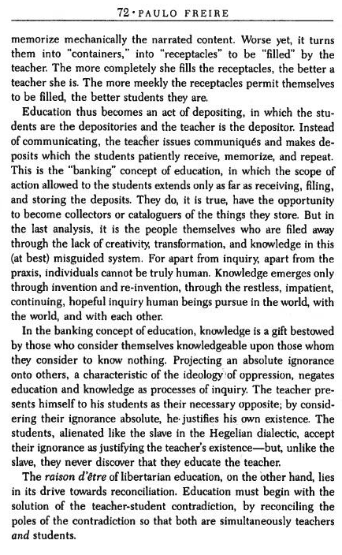
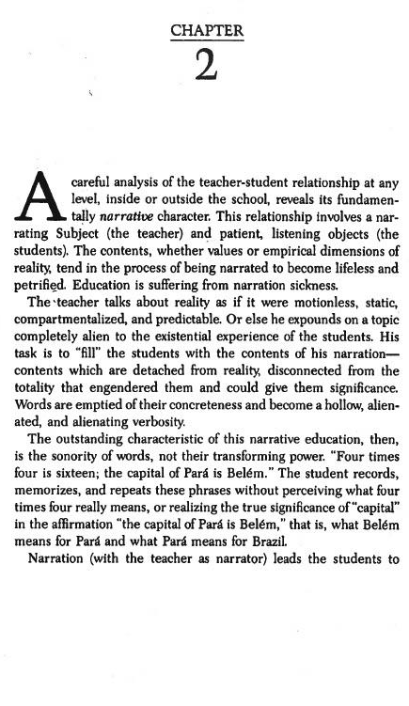
Handout 17: Paulo Freire, “The Banking Method of Education”

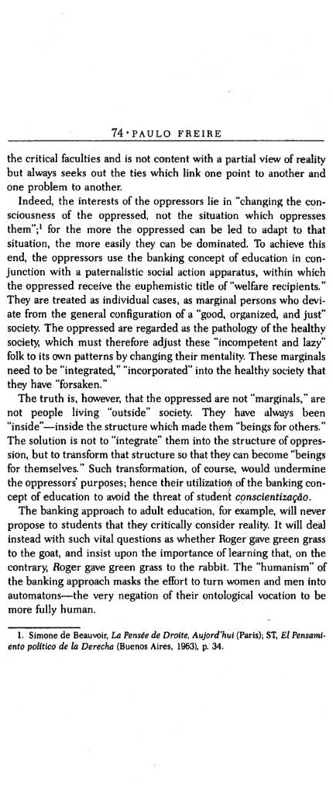
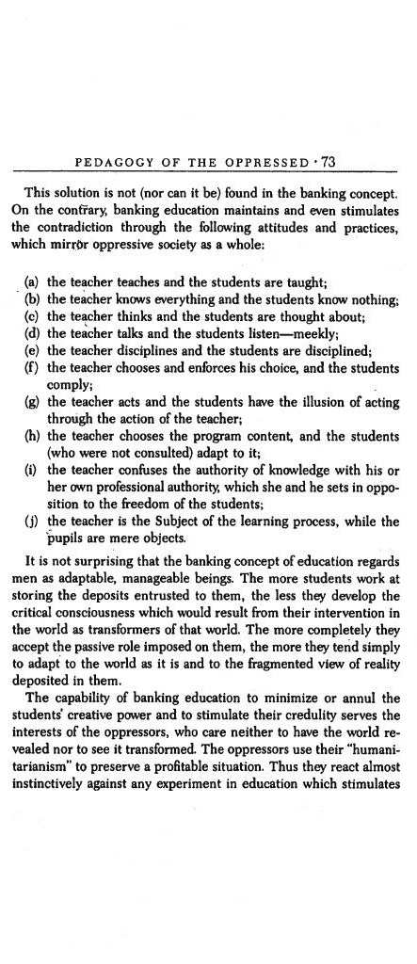
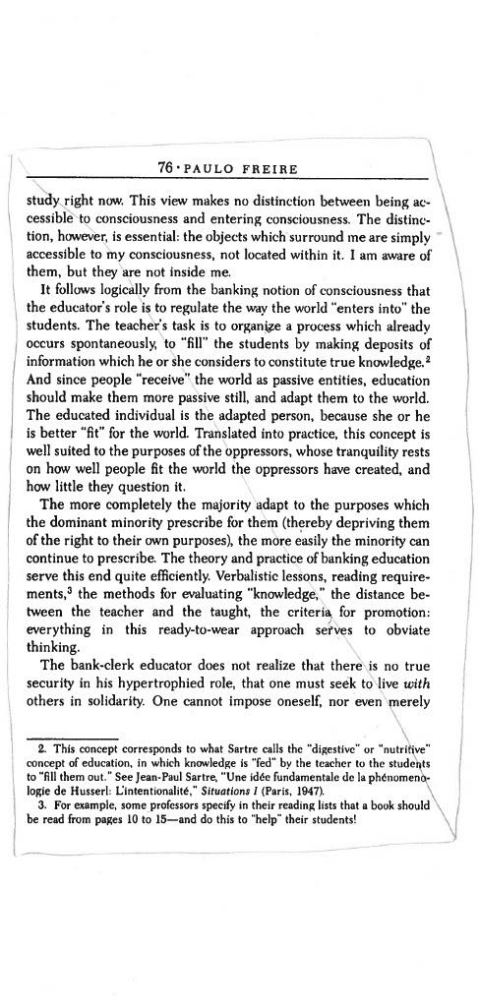
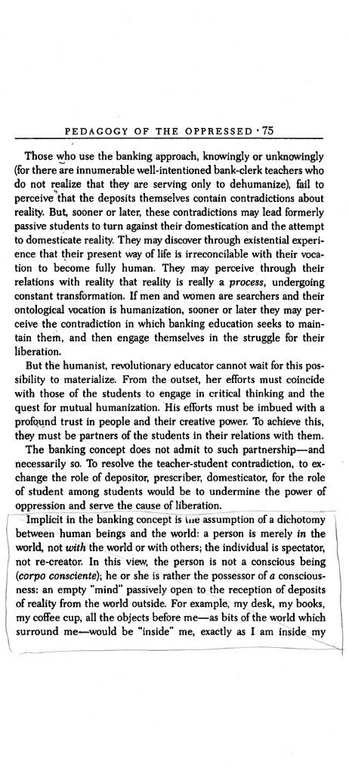
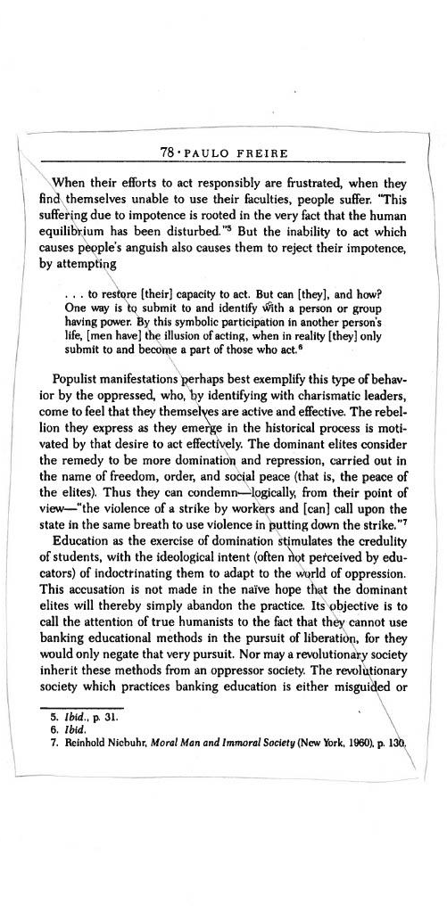
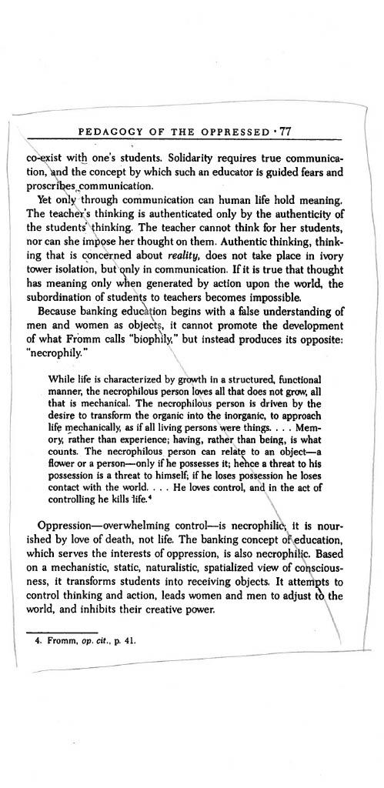

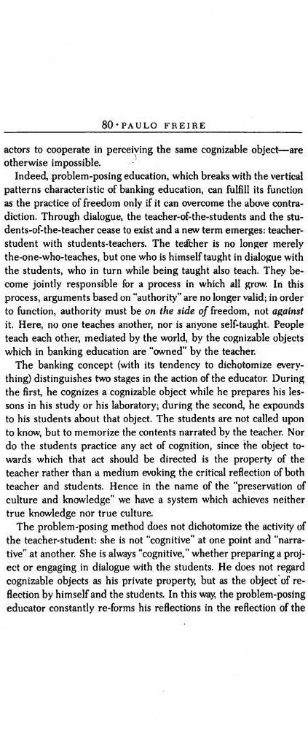
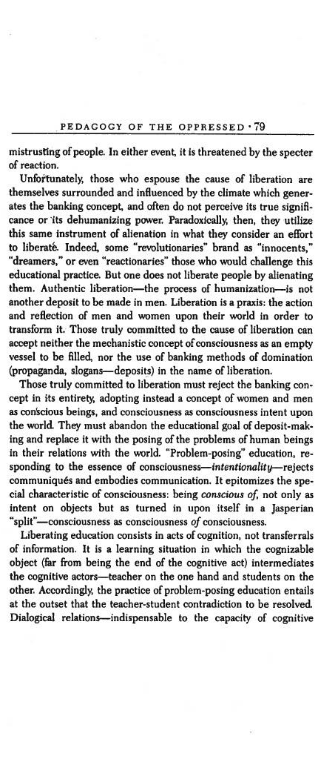
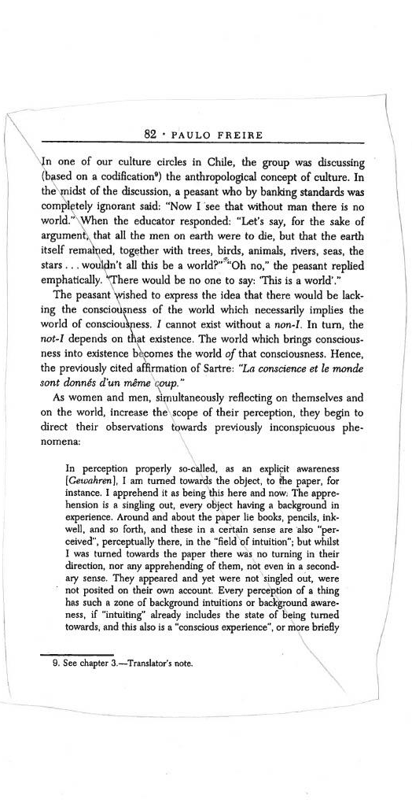
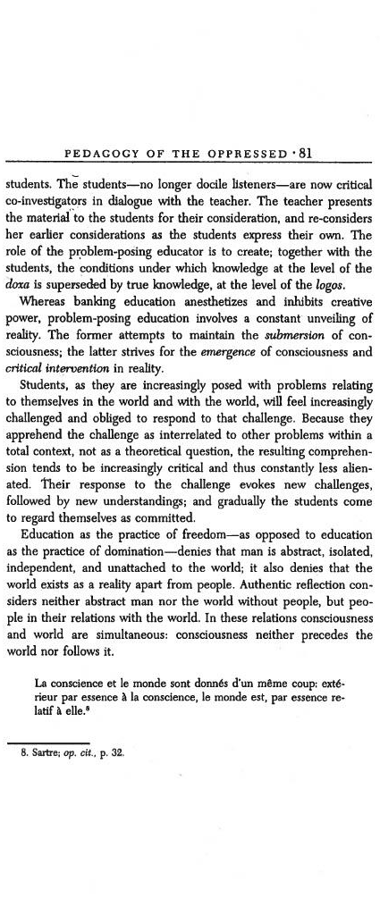
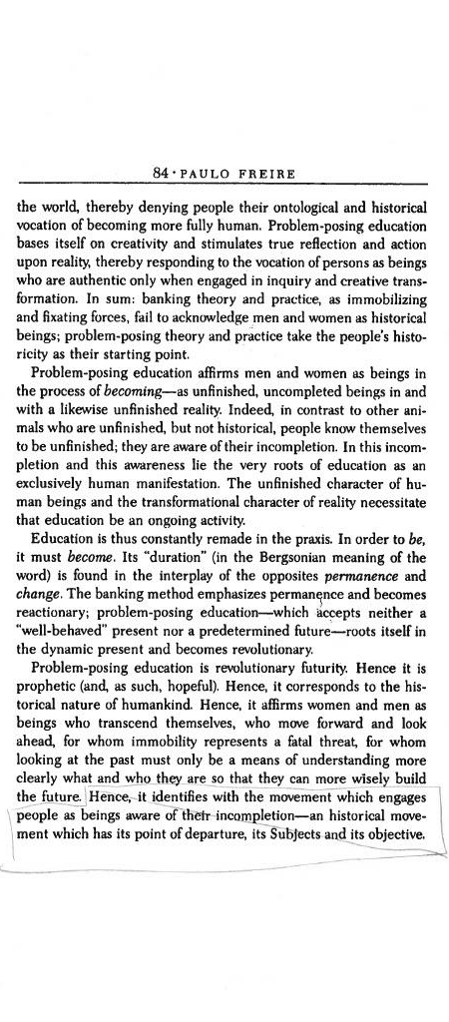
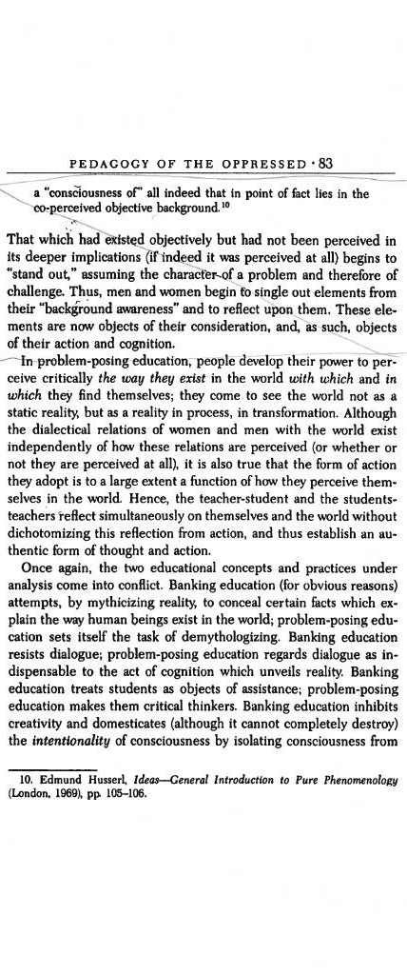
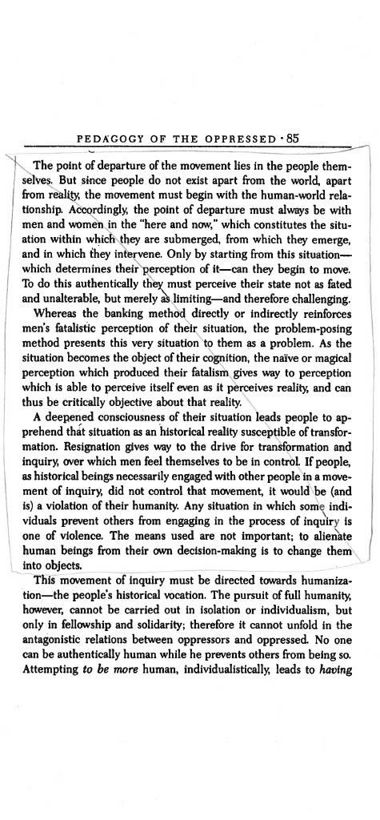
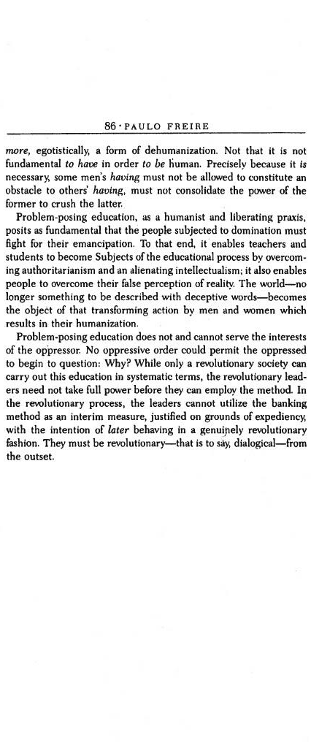

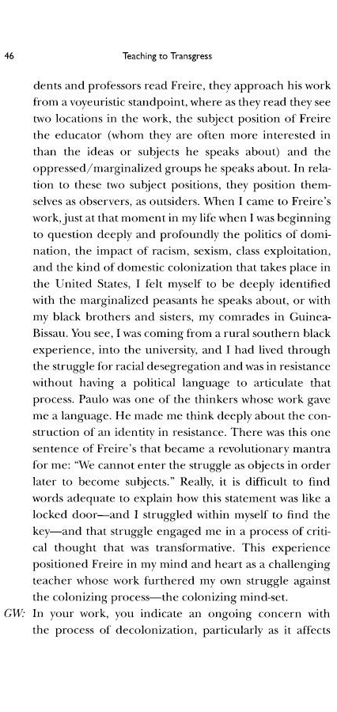
Handout 18: bell hooks, “Paulo Friere”
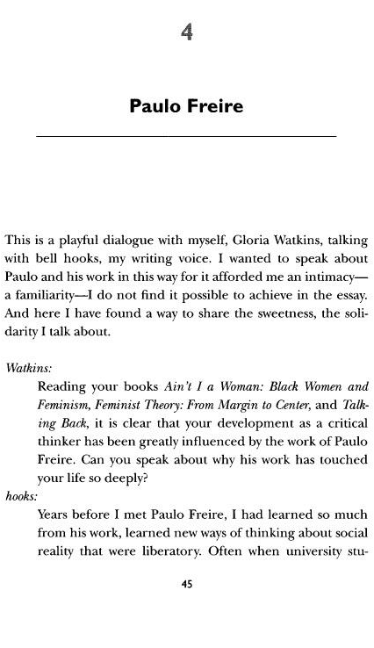
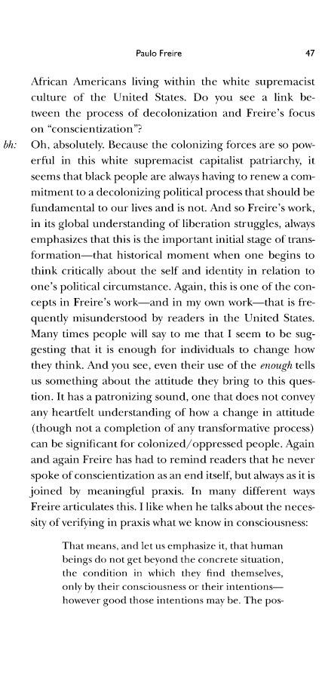
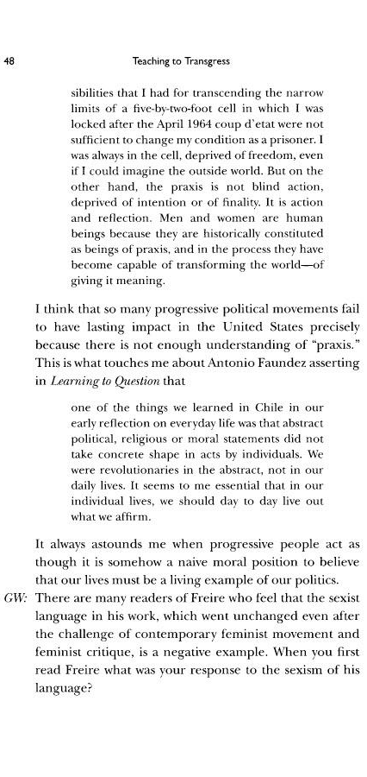

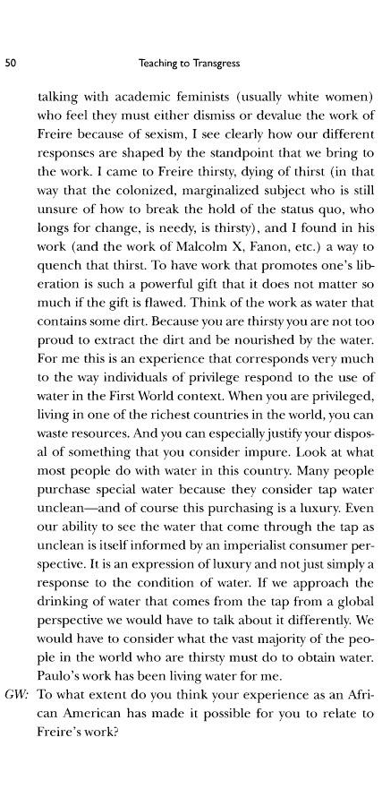
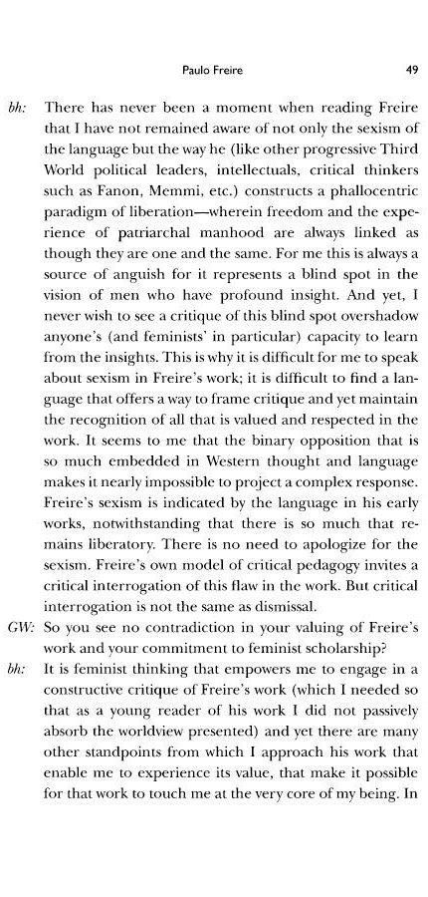
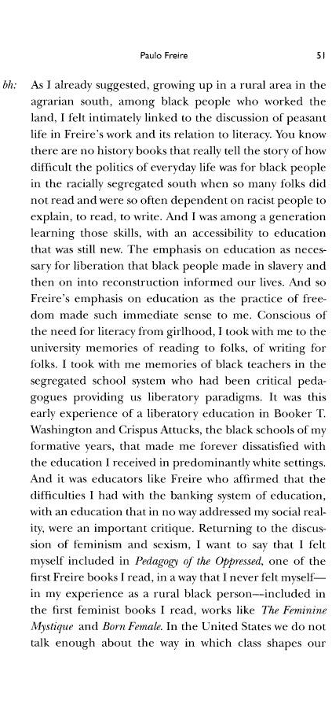
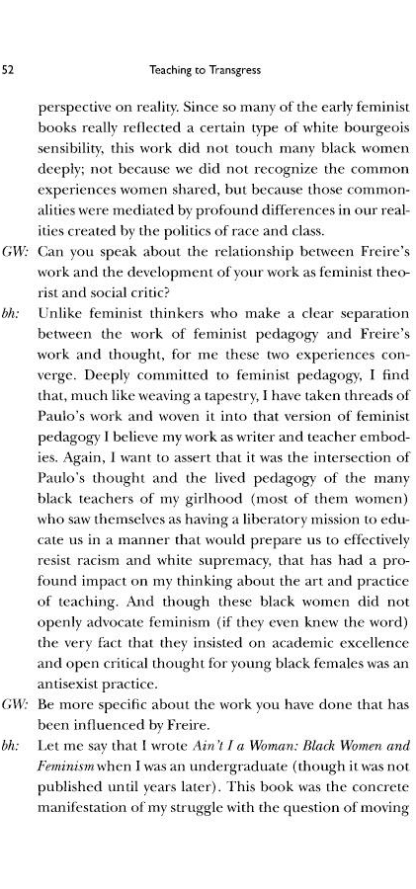
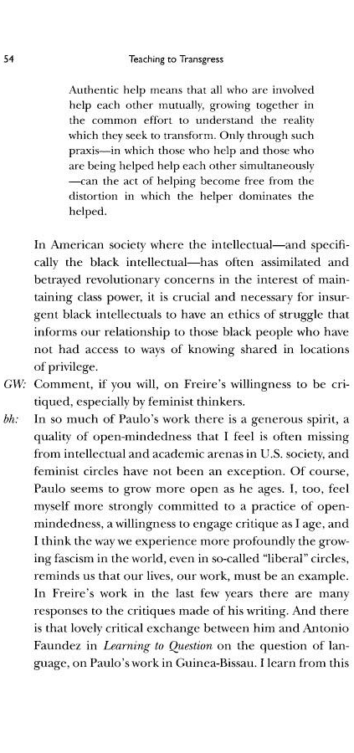
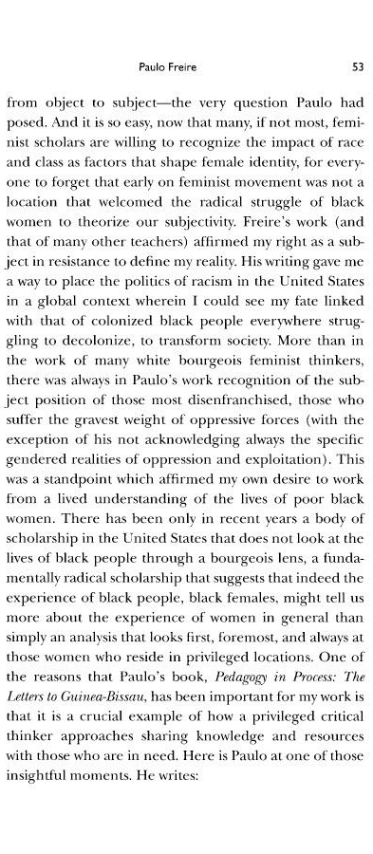
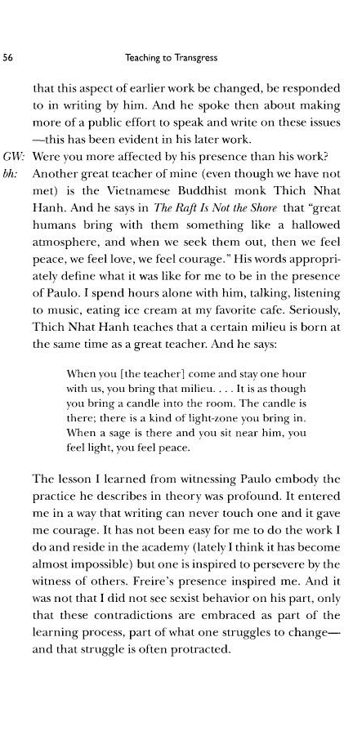
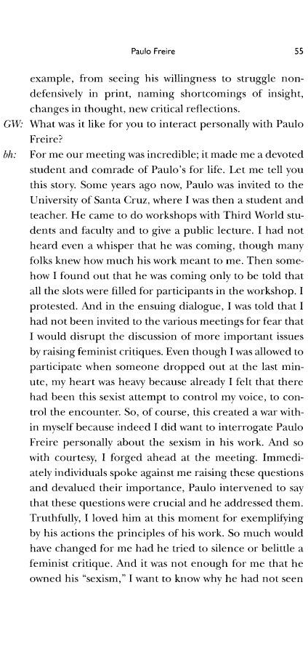
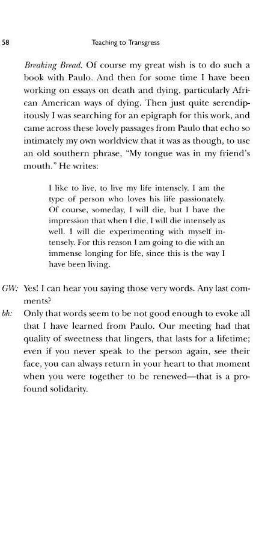
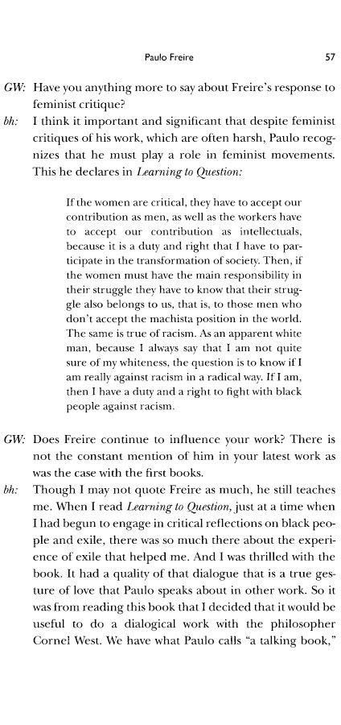

Handout 19: Taking a Special Education Approach
Excerpted and updated from the OWL Taking a Special Education Approach resource for facilitators

BEHAVIORS, CHARACTERISTICS, AND PREVALENCES
ASSOCIATED WITH DISABILITIES

Youth with Attention Deficit Hyperactivity Disorder
Attention deficit hyperactivity disorder (ADHD) is a brain-based condition characterized by inattention, hyperactivity, and impulsivity. The estimated number of children ever diagnosed with ADHD, according to a national 2016 parent survey, is 6.1 million (9.4%). An ADHD diagnosis requires the symptoms to have persisted for at least six months in at least two settings, with greater frequency and severity than their peers evidently experience.
Youth with predominantly inattentive ADHD display six or more of the following traits. They may
• process information more slowly and less accurately
• be forgetful
• become easily distracted, having trouble focusing and maintaining attention during tasks and activities
• fail to pay close attention to details
• make careless mistakes
• give the impression that they are not listening when they are spoken to directly
• have trouble with organization
• lose items needed to complete a task
• avoid, dislike, or quickly lose interest in something, especially if it requires substantial mental effort or is not enjoyable
• not follow instructions or finish a task or activity
• exhibit symptoms of hyperactivity or impulsivity
Youth with hyperactive-impulsive ADHD display six or more of the following traits. They may
• fidget or wriggle around when seated
• get out of their seats when they are expected to remain seated
• become restless and need to move around
• have difficulty playing quietly
• move constantly
• blurt out responses, talk out of turn, or redirect the conversation
• have difficulty waiting for a turn
• show emotions without restraint or expectation of consequences
• handle and play with items around them
• exhibit symptoms of inattention
A youth who displays six or more traits associated with each type of ADHD is diagnosed as having a combined type of ADHD. It is common for youth with ADHD to have other coexisting conditions. Mental health conditions such as depression, anxiety, and bipolar disorder typically accompany ADHD. Symptoms of ADHD can hamper social, academic, and occupational functioning.
Youth with Autism Spectrum Disorder
Autism spectrum disorders (ASDs) include a group of developmental disorders that typically manifest before age three and continue to affect a person throughout life. While individuals exhibit different behaviors and varying severity of symptoms, youth who have an ASD tend to share certain characteristics, including impairments in social interactions, challenges in reciprocal communication, and engagement in repetitive behaviors, interests, or activities. Youth with an ASD may also be hypersensitive to sensory stimuli.
At this writing (2022), according to the Centers for Disease Control, approximately 1 in 44 children has ASD, with boys more than 4 times as likely to be identified with ASD as girls. About one-third of children with ASD also have an intellectual disability. Some youth with high-functioning ASD tend to have a well-developed vocabulary and no cognitive impairments.
Youth with autism spectrum disorder may
• have significant delays in, or complete lack of, speech development
• have poor motor control
• react inconsistently to visual, auditory, or tactile stimulation
• avoid eye contact
• repeat what is said (echolalia)
• become overly preoccupied with or insist upon engaging in repetitive behaviors, interests, activities, or routines and become distressed when unable to do so
• start conversations unrelated to the established topic or setting
• phrase sentences and questions in ways that may be difficult for peers to interpret
• avoid engaging in activities with others
• be unable to understand another person’s thoughts, feelings, or beliefs
• have difficulty initiating, maintaining, or ending conversations
• be unable to recognize, understand, or show nonverbal cues (facial expressions or bodily gestures) that can facilitate or inhibit communication
• use objects in the room, including their own bodies, for stimulation
Youth with a high-functioning ASD may
• exhibit characteristics listed above
• have a well-developed or technical vocabulary but appear to be socially immature
• speak in a monotone
• have difficulty understanding abstract concepts (concrete thinking and literal interpretations are common and sarcasm, jokes, and idioms can be misunderstood or taken literally)
• have difficulty remembering, organizing, and applying information that they just learned
• struggle with redirecting attention to something new
• have difficulty maintaining attention and often become distracted by irrelevant information
• insist on carrying out specific rituals or routines or become distressed when unable to do so
• have poor motor coordination
• enjoy being alone and tend to function better one-to-one than in group settings
• be perceived as egocentric
• dominate or ignore conversations according to their own interest level and not
recognize another person’s level of interest or lack of interest
• not understand the concept of friendships and romantic relationships
• require “friends” to meet certain criteria
• be overly honest and speak their minds regardless of another’s feelings
• have difficulty starting, continuing, or ending conversations (poor impulse control can result in interrupting, making irrelevant comments, or talking over others)
• not exhibit signs (verbal or nonverbal) that confirm they are listening, and thus give the impression that they are not paying attention
• have difficulty identifying and interpreting someone’s thoughts, feelings, knowledge, or beliefs, often because of difficulty recognizing and understanding verbal and nonverbal cues that reveal the other person’s thoughts and feelings
• have unusual interests or priorities that they engage in for longer periods of time than their peers (becoming “experts” in their areas of interest, sometimes acquiring and cataloging facts and objects, and focusing their interactions and conversations with others on these areas of interest to the point that they may come across as monologues)
Youth who exhibit many but not all characteristics above or have mild areas of impairment might be diagnosed with pervasive developmental disorder, not otherwise specified.

Youth with Intellectual Disabilities
Intellectual disability can be the result of a genetic or hereditary condition such as Down syndrome, fragile X syndrome, or phenylketonuria (PKU). Fetal alcohol spectrum disorders caused by prenatal exposure to alcohol and disorders caused by environmental exposure to lead are other causes of intellectual disability. Intellectual disabilities vary in severity (mild, moderate, severe, or profound). Youth with an intellectual disability generally have impairments in cognitive abilities and limitations in conceptual, social, and practical skills. Youth with fragile X syndrome, fetal alcohol spectrum disorders, and Down syndrome may also present with condition-specific symptoms such as hearing problems, hyperactivity, impulsivity, inattention, learning disabilities, and poor coordination. A U.S. Department of Education report noted that 450,000 young people received special education services because of an intellectual disability in 2009.
An intellectual disability is diagnosed on the basis of significantly below average performance in tests of cognitive skills such as learning, reasoning, and problem solving or standardized intelligence tests. Youth with an intellectual disability may have poor conceptual skills such as reading, writing, speech, and self-direction and difficulty understanding concepts of time, money, and number. They may show impaired social skills in the areas of interpersonal communication, ability to follow rules, or interpersonal problem solving; they may exhibit gullibility, naïveté, or a lack of self-esteem. They may be challenged in the areas of personal care, safety, self-help, health care, scheduling, transportation, and using communication devices.
Youth with intellectual disabilities may have impairments in cognition, short term memory, or long term memory. Therefore, they may
• take longer to learn tasks
• be unable to acquire or understand knowledge or skills by observation alone
• lack understanding of abstract concepts, instead thinking concretely and interpreting others’ statements literally
• have trouble applying knowledge or skills in different settings or situations, or
with different people
• have difficulty remembering knowledge, skills, events, or sequences of events
• recall events or information incorrectly, slowly, incompletely, or without sufficient detail
• struggle with interpersonal communication because they have trouble understanding the meaning intended by others or picking up on subtle social cues
• find it hard to initiate contact and develop relationships with others
• take longer than peers to learn and demonstrate modesty
• have difficulty understanding and deciphering social and sexual boundaries
• not know or remember the socially appropriate context (how, when, where,
with whom) of behaviors or interpersonal communication
• become overly compliant, often believing other people know best
• lack opportunities to practice organizing or planning activities because of
restrictions on their leisure time

Youth with Learning Disabilities
A learning disability may not be obvious to others yet may significantly affect the way a youth acquires, understands, and/or utilizes one or more of these skills:
• concentration
• information processing (receiving, storing, recognizing, or recalling information)
• interpersonal communication
• language (verbal or written)
• mathematical conceptualization
• motor skills
In 2009, more than 2.4 million people ages 6 to 21 received special education services for specific learning disabilities, according to the U.S. Department of Education’s Office of Special Education Programs, making learning disabilities the most common reason for youth to receive such services. A 2003 study found that one-third of youth with ADHD had a learning disability as well. However, learning disabilities do not result from a coexisting disability. Instead, learning disabilities are believed to be a result of the way an individual’s brain processes information.
Youth with learning disabilities tend to have typical or above-average intelligence. Depending on their abilities, they respond to various modes of learning.
Common types of learning disability are dyslexia, dysgraphia, dyscalculia, auditory and visual processing disorders, and nonverbal learning disorders.
Youth with dyslexia have difficulty comprehending, recognizing, or using language, particularly when reading. Youth with this type of learning disability may
• read slowly and imprecisely
• have difficulty with reading comprehension
• pronounce words incorrectly
• mix words up
• misspell words
• misunderstand the meanings of words
• struggle with word rhyming
Youth with dysgraphia have difficulty writing or composing words, sometimes within a particular space. Youth with this type of learning disability may
• have poor handwriting
• struggle with writing thoughts down
• write incomplete sentences
• have trouble organizing words or sentences
Youth with dyscalculia have difficulty understanding and applying mathematical concepts. Youth with this type of learning disability may
• have difficulty sequencing information
• have trouble with visual-spatial relationships
• struggle with time-related concepts
• have difficulty reading and recalling numbers
• struggle with numerical estimation
• find it challenging to determine different responses to a problem
Youth with auditory and visual processing disorders have difficulty processing
and understanding visual and auditory information. Youth with this type of
learning disability may
• have difficulty storing and recalling visual and auditory information or instructions
• have trouble recalling the sequence of words or lists that they hear
• have difficulty identifying similar and differently sounding words
• struggle to differentiate objects according to characteristics like size, shape, or
color
• have difficulty recognizing particular objects within a surrounding environment and/or
• find it difficult to glean information from pictures, charts, graphs, or other
visual material
Youth with nonverbal learning disorders have difficulty processing what is seen
and felt, reading nonverbal signs and cues, organizing the visual-spatial field, and
maintaining proper psychomotor coordination. Youth with this type of learning
disability may
• have difficulty processing what they see and feel
• have poor motor skills and/or bodily coordination
• have difficulty getting a sense of self and objects within a particular space
• struggle with adapting to new situations or changes in routine
• process information and interpersonal communication very concretely
• have difficulty organizing thoughts
• have difficulty applying knowledge to new situations
• have trouble interpreting nonverbal communication and tone of voice
• have difficulty determining the intent behind what is said

CREATING AN INCLUSIVE LEARNING ENVIRONMENT
Facilitators can create a welcoming environment for youth with autism spectrum disorders or attention-related, learning, or intellectual disabilities in which they can engage and learn with their peers in their OWL program. This section provides strategies and concrete suggestions grounded in Universal Design for Learning (UDL), an educational framework that aims to maximize learning for all. This section will help you intentionally employ diverse methods for teaching, engaging participants, and helping youth demonstrate knowledge and skills.
It is likely that youth with disabilities who enroll in an OWL program already go through their weekday schooling with a plan that helps their teachers address their learning needs. As early as possible, contact the parent(s)/guardian(s) of youth who are known to have a disability. Meet with them and with the youth as well. Try to get a sense of the youth’s learning style, strengths, and challenges. Ask the parent(s)/guardian(s) and the youth to tell you about attention span, sensory sensitivities, socialization skills, and other relevant aspects of the youth’s disability. Ask about accommodations that have proven helpful to the youth in a school setting. Become familiar with any individualized supports and assistive technology the youth may use, and do this early enough so you will have time to prepare and implement any adaptations. For example, a youth with an autism spectrum disorder may already use an augmentative alternative communication (AAC) device containing words and/or pictures to help the youth communicate. Facilitators will need to familiarize themselves with how the youth uses their AAC device; for example, a youth may need extra time to locate words or icons on the device in order to respond to a question or participate in a discussion. If possible, facilitators should plan to share workshop content with a parent/guardian in advance, so the youth’s AAC device can be programmed with words and/or pictures to help the youth engage and learn. Both facilitators and leaders of the sponsoring organization may benefit from information a parent/guardian offers that will help you plan to address the disability. While the program may not have the capacity to incorporate every learning accommodation that can benefit each youth, the information you gain from parents and caregivers will help you adapt the program and workshops to maximize every participant’s success.
Once you have determined the special needs that are known to be represented in the group and touched base with parents, focus on how you will incorporate the recommended accommodations into the structure, planning, and teaching of your program. Choose an approach that supports all participants’ learning while addressing the special needs of youth in the group who have disabilities. As a general rule, plan to present information in a variety of ways to engage youth interest in a topic. For every topic you cover in Our Whole Lives, offer a variety of opportunities for youth to demonstrate their knowledge and skills.
You may well discover that an alternative learning modality appeals to youth for whom you had not originally incorporated it. Take advantage of the opportunity to deepen inclusion and intensify engagement. For example, if a youth has an item of assistive technology, others may be interested to learn how the device works. When you allow the program to be a place where youth with disabilities can teach their peers about how they learn and how their helpful devices work, you foster a social connection. Always check with the youth with the disability to learn how comfortable they are with sharing.

Structuring the Program
Select an easily accessible location. Choose a meeting space where you can arrange furniture to best suit the group. For example, you will want to allow enough space around tables and chairs for all participants to move freely, and you will want to be able to place youth who struggle to maintain concentration and attention, especially youth with learning disabilities or ADHD, away from potential distractions like windows. If you anticipate a youth will use an assistive technology device that requires an electrical outlet or extra tabletop space, plan accordingly. Consider placing participants who are likely to use alternative multisensory materials, especially youth with intellectual disabilities or autism spectrum disorders, in areas convenient to the materials and away from unnecessary distractions. Other considerations for set-up include sensitivities to sounds, lights, or odors and any participant’s need to get up and move about with minimal distraction to others.
Select a consistent time, duration, and location for the workshops. Plan the calendar for the entire OWL program in as much detail as you can, and try to minimize changes. Youth with learning disabilities and intellectual disabilities often benefit from a structured learning environment. Changes to a routine can be particularly difficult for youth with autism spectrum disorders or nonverbal learning disabilities, while youth with an attention-related or intellectual disability may struggle with remembering inconsistent times or locations for the OWL workshops.
Make sure each workshop includes scheduled breaks for participants to move around. For each workshop, create an agenda using words, pictures, and colors. Refer to it throughout the workshop to keep the youth on task, remind them of what they have already accomplished, and prepare them for what they will do next. Affirm participants’ efforts to achieve an objective or stay on a task.
Youth must do some reading to fully benefit from the program. Yet reading can pose a variety of challenges for many youth, especially those with an intellectual disability or a learning disability such as dyslexia. Plan to read aloud or use other modalities, such as video or role-playing, to reinforce written material. As you plan each workshop, take the time to break down written material into shorter passages for multiple readers to read aloud. Create a print version of every written passage to give participants, so all can follow along as a facilitator or volunteer reads aloud. You may wish to enlarge font size and/or list content items on separate index cards to enable particular youth to participate in reading aloud. Be prepared to summarize the content and purpose of every reading selection. Never assign a youth to read aloud; always ask for volunteers to ensure no one is caught off guard and embarrassed.

Employ Multiple Modalities
Adjust the handouts. Enlarge handouts and add writing space to make it easier for individuals with reading or writing difficulties to read and respond.
Plan to verbally describe the purpose of each handout and to read and review handout instructions aloud. You can affirm understanding by asking participants to explain what they are supposed to do. Provide examples of appropriate responses. Allow alternative ways to provide responses on handouts, such as verbalizing a response, typing it using a cell phone or tablet, drawing it, or role-playing it.
Use videos. Videos appeal to all sorts of learners and can help you teach and reinforce concepts and keep participant attention; many are suggested as part of the Our Whole Lives program. Preview a video to be sure that it explicitly demonstrates content in a way that will serve participant comprehension as well as engagement. Plan to pause and replay segments of the video to review or discuss specific content you wish participants to understand or remember. Since youth with special needs often struggle with social skills, consider using videos that allow youth to practice identifying feelings and practice responding to others. The Multisensory Teaching resources section (page xlvi) suggests sources that may offer useful videos.
Provide teaching tools that can be touched. Tactile items such as anatomy models, dolls, contraceptive products, and hygiene products make abstract concepts of anatomy, pregnancy prevention, and hygiene much more concrete. Use tactile items throughout the program to reinforce knowledge and skills. Invite participants to demonstrate their knowledge or ask their questions using the tactile items during group discussions and interactions and provide responses or complete tasks with them. See the section on Multisensory Teaching resources (page xlvi) for help finding OWL teaching aids.

Pacing, Prompts, and Props
Adjust the pace of instruction. Youth with disabilities may have challenges that affect their ability to receive instructions, understand concepts related to sexuality, and participate in an activity or complete a handout. Adjust the pace of your teaching and instructions, discussion times, and activities to meet participants’ needs.
Prepare to give instructions in multiple ways. Provide directions for activities in oral, written, and picture formats and make sure they are clear and easy to understand. Plan to use positive feedback and frequent updates on time remaining to keep all participants on task and prevent inattention; restate the instructions or ask youth to restate them to be sure they are clear; and give examples of desired responses.
Contextualize the sexuality content. Youth with disabilities like autism spectrum disorders or intellectual disabilities often need explicit instruction on when, where, and with whom sexual expression might appropriately occur. Throughout the workshops, plan to emphasize the importance of being in private to dress, take care of (or receive assistance with) personal hygiene, touch or stimulate the genitals, have sexual intercourse, or engage in other behaviors involving the sexual organs. Discuss ways to manage situations in which privacy is not attainable.
Incorporate movement. Some youth with autism disorder and attention-related disabilities may focus and engage better if they can manually manipulate an object during group time. Provide items for youth to hold if they feel fidgety, like stress balls or pipe cleaners. When possible, incorporate tactile manipulation of objects into learning activities. Some youth may feel a need to move. Schedule stretch-and-move breaks and/or incorporate movement into learning so all participants get physical activity. Designate an area in the room where individuals can stand while content is being taught. Choose volunteers who need movement to help distribute or collect materials.
Use colors. Colored markers and index cards or paper can be useful tools to emphasize particular concepts, keep participants engaged, and provide a visual way for participants to demonstrate knowledge. Apply color to concepts; for example, assign red to represent unhealthy relationship behaviors and green to represent healthy relationship behaviors or use red, yellow, and green to signify high, low, and no risk. For activities in which participants are to move to different positions in the room to indicate different opinions or beliefs, place colored paper at each position to clearly designate its meaning; taking a position by a green paper could indicate agreement with a given proposition, for instance, while standing by the red paper would indicate disagreement. Give youth paper to hold or point to as a means to represent agreement or disagreement, respond with yes or no, or identify a statement as true or false. Print handouts on a variety of colors to help participants organize their materials.
Incorporate images, pictures, and diagrams. Images can be useful to emphasize and concretely display the sexuality content and keep the attention of youth with special needs. Examples may include pictures of the steps for correct condom application, enlarged diagrams of the sexual anatomy, and a pictorial glossary of a workshop’s sexuality vocabulary. Avoid confusing diagrams and pictures. Enlarge visual aids to make them easier to see and understand. Referring to visual aids throughout a workshop as content is taught, reviewed, and discussed will reinforce knowledge and skills. Suggest that participants use the visual aids when they provide responses during group discussions or interactions or when they complete tasks. Sources for obtaining and incorporating multi-modal materials are listed in the section on Multisensory Teaching Resources (page xlvi).
Model the content. Have participants role-play to reinforce knowledge and skills and to facilitate group discussions and interactions. Also invite participants to use role-playing to provide responses and complete tasks.

Strategies to Help Everyone Learn
Keep language simple. Processing difficulties, short attention spans, or impaired cognition can make it hard for youth with disabilities to understand, remember, or recall sexuality-related information. Communicate information in simple, explicit language. Avoid euphemisms and slang. Youth with intellectual disabilities or autism spectrum disorders may interpret what is said in the workshop literally. Check for understanding throughout the workshop.
Build on existing knowledge. Access participants’ prior knowledge related to new topics, to give them a point of reference that will help them grasp and remember new information and stay motivated. Teach or review background information that is necessary to understand the workshop topic.
Repeat, review, reinforce. Youth with autism spectrum disorders or attention-related, intellectual, or learning disabilities have conditions that can hamper their comprehension, retention, and application of information. Repeat sexuality content using multisensory techniques and materials. Refer to content already taught that directly relates to the new workshop topic. Reintroduce relevant examples in different circumstances. Sexuality content can be repeated, reviewed, and reinforced in a variety of ways and at different times throughout a workshop and throughout the curriculum series.
Promote pro-social behaviors. Youth with autism spectrum disorders or attention-related, intellectual, or learning disabilities struggle with social skills, which can make it difficult for them to develop appropriate peer and intimate relationships. Review, model, and post group behavior rules. Find opportunities to explicitly explain, encourage, and model pro-social skills such as distinguishing feelings, deciphering verbal and nonverbal expressions, making eye contact, engaging in reciprocal communication, observing and respecting the personal space of others, recognizing others’ feelings, not interrupting, and expressing socially appropriate behavior or statements. Provide positive feedback for youth as they demonstrate these skills. Encourage group participation and engagement among peers.
Use posters to emphasize important points. Youth with disabilities benefit when key points are reviewed or reinforced. Some struggle with sequencing or recalling information. Make visual aids using newsprint or posterboard. Post images, charts, or word maps for participants to reference throughout the workshop.
Keep it positive! Positive feedback can give youth with disabilities immediate and concrete confirmation of accomplishment, reinforce learning, and help guide behavior such as pro-social interactions. Give positive feedback frequently or to reinforce particular behavior. Clearly highlight the youth’s specific achievement or improvement, such as applying a condom correctly or maintaining personal space with another group member.

Handout 20: Tough Terms

FAITH
- Paul Tillich in his book Dynamics of Faith defines faith as “the state of being ultimately Concerned. The dynamics of faith are the dynamics of a [person’s] ultimate concern.”

- “Faith is often better understood as a verb than a noun, and as a process than as a possession.” — Frederick Buechner

- Faith development theorist James Fowler spoke of faith as a dynamic verb, as an active not static thing. He talked of “faithing”, something we do, a process of wrestling meaning from life and testing it through action and subjecting it again and again to the scrutiny of our minds, to the leap of our hearts, to the reality of action.

- Sam Keen in Life Maps: Conversations on the Journey of Faith looks at the developmental aspect of “faith as trust.”

- John Westerhoff defines faith as an expression of meaning revealed in a person’s life style, or the foundation upon which persons live their lives – that point of centeredness or ultimacy that underlies and is expressed abstractly in a world view and value system…in a person’s thought, feeling, and action.

- Thomas Groome suggests that faith is a lifelong developmental process involving the total person which addresses issues of ultimate concern, such as the meaning of life and death, the nature of being, the existence and nature of deity, and the like.

- Faith can be defined in a three-fold way – as including “belief”—the cognitive (best conclusions of our minds), as “feel—the affective (those allegiances of our hearts), or as “act”—the behavioral (those things we are willing to put our lives on the line for).

- One’s faith is extremely personal and individual, focusing not so much on creeds and doctrines per se, but more on those perceptions and values of an ultimate nature which are a part of that individual’s very being. Faith Development reflects the changing nature of one’s faith perceptions and understanding through the developmental journey of his or her life. It is through Faith Development that maturing adults function in increasingly complex and adequate responses to life’s ultimate questions and issues.

RELIGION
- “The religious way is the deep way, the way with a growing perspective and an expanding view. It is the way that dips into the heart of things, into personal feelings, yearnings, and hostilities that often must be buried and despised and left misunderstood… The religious way is the way that sees what physical eyes along fail to see, the intangibles at the heart of every phenomenon… The religious way is the way that touches universal relationships that goes high, wide and deep, that expands the feelings of kinship… And if God symbolizes or means these larger relationships, the religious way means finding God; but the work in itself is not too important. It is the enlarged and deepening experiences that bring the growing insights and that create the sustaining ambition ‘to find life and find it abundantly… When such a religious quality of exploration is the goal, any subject, any phenomenon, anything, animate or inanimate, human or animal, may be the starting point… Religion is the gestalt of all experiences.” — Sophia Lyon Fahs

- “Religion is that cluster of memories and myths, hopes and images, rites and customs that pulls together the life of a person or group into a meaningful whole… It lends coherence to life, furnishes a fund of meaning, gives unity to human events and guides people in making decisions. Religion, as its Latin root suggests, is what binds things together.” — Harvey Cox

- “Religion at its best is the distillation of images.” — Sharon Parks

- “Religion is the result of the tough and tender experiences of life…” — Richard Gilbert

- “Being religious means asking passionately the questions of the meaning of our existence and being willing to receive answers, even if the answers hurt. Such an idea of religion makes religion universally human, but it certainly differs from what is usually religion. It does not describe religion as the belief in the existence of gods or one God, and as a set of activities and institutions for the sake of relating oneself to these beings in thought, devotion, and obedience. No one can deny that the religions which have appeared in history are religious in this sense. Nevertheless, religion in its innermost nature is more than religion in this narrower sense. It is the state of being concerned about one’s one being and about being universally…Religion is the dimension of depth in all of life experiences…My religion is the answer to the question which I am.” — Paul Tillich

SPIRITUALITY
- Spirituality is the experience of a depth dimension to life, a dimension beyond the physical, the obvious, the provable, the universally shared.

- Spirituality is the inner quickening that comes with a sudden or long sought awareness which touches the core of one’s existence.

- Spirituality is the heightened awareness of oneself in relationship to humankind and the universe.

- Spirituality is the relationship a person experiences with the universe and the meaning that relationship has for how that person orders and lives life. It includes personal experiences of insight and connection, interpretation and sharing of those experiences, and decisions to act in ways that bring one’s life into harmony with the meanings those experiences have evoked.

- Spirituality is at the core of meaning-making—for those who experience it.

- Spirituality involves the relationship between one’s consciousness and one’s soul – and between one’s being and the universe as a whole.

- Spirituality is an evocation of feelings that leads into the spiritual; extrasensory, transcendent experience.

- By spiritual, I mean the ancient and abiding human quest for connectedness with something larger and much more trust-worthy than our egos, with our own selves, with one another, with the worlds of history and nature, with the invisible winds of the spirit, and with the mystery of being alive. — Parker Palmer

ETHICS
- It’s as basic as how people treat each other and it is the choices we make that can affect the course of our lives and the lives of others.

- Ethics refers to standards of conduct, standards that indicate how one should behave based on moral duties and values, which themselves are derived from principles of right and wrong. There are two aspects of ethics: The first involves the ability to discern right from wrong, good from evil, propriety from impropriety. The second involves the commitment to do what is right, good, and proper. Ethics entails action; it is not just a topic to debate.

- There is the “Is” Ethics vs. “Ought” Ethics. Is ethics describes operational standards of behavior – that is, how an individual or group usually behaves, without reference to what should be. It is usually associated with cultural relativism. Ought ethics is prescriptive ethics; it is ethics concerned with discernment of and commitment to principles that establish “standards” of behavior to every person.

- “Ought” ethics prescribe how people should behave, prescribing standards for what “ought” to be without reference to how things actually are. The ideal behavior is based on specific values and principles, which define what is right, good, and proper.

- Ethical development concerns the principles and values about how people interact with other people. Our ethical development depends on our relationships – our relationships with our parents and family, our peer group and their values, and our faith community and living tradition, our world and planet.

- Our values are learned through experience. Our ethics are practiced in our living every day. Our ethical behavior grows out of our religious identity. From our core values and Spirituality, we practice ethical decision-making, and our ethical behavior emerges. - Pat Hoertdoefer

Handout 21: More Tough Terms

PRAYER
- Many of the past generation and many today have found three abiding values in prayer: The quiet meditation on life, The reaching out toward the universal and infinite, and The courageous facing of one’s profoundest wishes. Let parents sense and share with their children the glory and mystery of everyday things. Let them look with sympathy upon humanity’s age-long dilemmas. Let no question be taboo. The next generation can ill afford to have the deeper values deleted from the book of life. — Sophia Lyon Fahs

- Prayer … is an effort to reach deep and to reach out and to become what we would like to be, and need to be, and ought to be. Proper prayer is not a petition to escape realities. It is an effort to face up to realities, to understand them, to deal with them. It is an expression of the desire to grow in spiritual stature, in courage, in strength, and in faith. The purpose of prayer is to transform those doing the praying, to lift them out of fear and selfishness into serenity, patience, determination, belonging. If we being to approach prayer in this manner, it assumes an entirely new significance. — Rev. Jack Mendelsohn

- In rational prayer the soul may be said to accomplish three things important to its welfare: it withdraws within itself and defines its good, it accommodates itself to destiny, and it grows like the ideal which it conceives. — George Santayana

- The word prayer has almost as many meanings as there are people who pray. For some it is a conversation, a speaking to God; for others it is speaking to oneself; and for still others it is speaking aloud – to all who are gathered together, or to no one in particular. — Rev. Patricia Hoertdoerfer

- Prayers offer a skillful means for marrying an inner sense of peace with outer demands of the world. They help us to quiet and focus the agitated mind. They use the words to carry us beyond words…By silencing inner noise and distractions, prayer brings us into the presence of the moment. Its gift is an inner experience of prayerfulness in which the silent center of life’s meaning is revealed. — from Earth Prayers
- The prayer of our souls is a petition for persistence; not for the one good deed, or single thought, but deed on deed, and thought on thought, until day calling unto day shall make a life worth living.

THEOLOGY
- Theology comes from two Greek words: theos, which is commonly interpreted as “God;” and logia, which means “sayings.” Based purely on a linguistic translation then, theology means “the sayings of God”—Who is God? Where is God? What is God? How one might come to know God? In more contemporary terms, we may speak f theology as being in dialogue about that to which we give ultimate value and meaning. Some would add that theology is rational discourse about God, but I would disagree since religion is itself non-rational. It is based strictly in faith.

- Daniel Migliore evokes the classical definition of St. Augustine defining theology as “faith seeking understanding: in relation to ourselves—acknowledging, of course, that we can never completely eliminate our own subjectivity. One would begin with faith statement and then continue to test their beliefs against other faith claims. That’s what theology really is—faith seeking understanding, seeking to understand our own beliefs in relation to other beliefs. It is also critical reflection on the meaning of whatever we understand as ultimate reality; which may or may not include a concept of the divine.

- Theology begins with a question (or more accurately, a series of questions) which we all come to ask at some point in life, even if we don’t articulate them. Theology tries to make sense of the world. The basic question it asks is: why? why? Unitarian Universalists tend to ask that “why” question a lot.

- Why am I here? Why are we here? What is the purpose of life? Is there something more—something beyond all the uncertainty that we feel and see? And when we explore it, we can go further. Why is there suffering? Why is there evil? What will happen to me when I die? — Marjorie Bowens-Wheatley

Handout 22: Unitarian Universalist Principles & Sources

WE, THE MEMBER CONGREGATIONS OF THE UNITARIAN UNIVERSALIST ASSOCIATION, COVENANT TO AFFIRM AND PROMOTE:
- The inherent worth and dignity of every person;
- Justice, equity, and compassion in human relations;
- Acceptance of one another and encouragement to spiritual growth in our congregations;
- A free and responsible search for truth and meaning;
- The right of conscience and the use of the democratic process within our congregations and in society at large;
- The goal of world community with peace, liberty, and justice for all;
- Respect for the interdependent web of all existence of which we are a part.
- Many of our congregations have also adopted Black Lives of UUs’ suggested 8th principle: Journeying toward spiritual wholeness by working to build a diverse multicultural Beloved Community by our actions that accountably dismantle racism and other oppressions in ourselves and our institutions.
THE LIVING TRADITION WE SHARE DRAWS FROM MANY SOURCES:
- Direct experience of that transcending mystery and wonder, affirmed in all cultures, which moves us to a renewal of the spirit and an openness to the forces that create and uphold life;
- Words and deeds of prophetic women and men which challenge us to confront powers and structures of evil with justice, compassion, and the transforming power of love;
- Wisdom from the world’s religions which inspires us in our ethical and spiritual life;
- Jewish and Christian teachings which call us to respond to God’s love by loving our neighbors as ourselves;
- Humanist teachings which counsel us to heed the guidance of reason and the results of science, and warn us against idolatries of the mind and spirit;
- Spiritual teachings of Earth-centered traditions which celebrate the sacred circle of life and instruct us to live in harmony with the rhythms of nature.
Grateful for the religious pluralism which enriches and ennobles our faith, we are inspired to deepen our understanding and expand our vision. As free congregations we enter into this covenant, promising to one another our mutual trust and support.

Handout 23: Online Resources for Religious Education
Timelines:
www.timetoast.com – create timelines which can be shared via the internet site
www.tiki-toki.com – create timelines which can be shared and even created as a group project

Concept Mapping:
www.wordle.net – generates a “word cloud” from text you provide which you can then tweak with different fonts and graphic styles; the word cloud gives prominence to those words used most often in your text
www.tagxedo.com – also allows the creation of word clouds with different fonts and graphic designs
www.bubbl.us – colorful and easy to use concept mapping tool to organize concepts, reinforce information and process ideas through visual “bubbles”

Art/Animations/Video Projects:
http://www.powtoon.com/ -- a Do-It-Yourself animated presentation tool for video presentations, social media clips, and more
www.doink.com – draw or use community-generated art or flash-style animations for presentations
www.makebeliefscomix.com – communicate through comic strip art, including choice of characters and different emotions including some characters with physical disabilities

Charts & Graphs:
www.chartle.net – create charts and graphs
www.popplet.com – collaborative way to explore ideas, record thoughts and collect inspiration from others plus synthesize information through creation of charts and graphs

Collaboration Tools:
www.wallwisher.com – for a different take on discussion boards, wallwisher offers the chance to have discussions via post-it notes on a “wall”
www.storybird.com – allows two (or more) people to create a story in round-robin fashion by writing their own text and inserting pictures; they then have the option of sharing their Storybird privately or publicly on the network
www.popplet.com – collaborative way to explore ideas, record thoughts and collect inspiration from others plus synthesize information through creation of charts and graphs
Zoho Notebook -- online interactive collaborative applications with both audio and video capabilities
Google docs -- online resource for sharing and collaborating on documents
Penzu – create personal journal, online diary or take notes on graphics that look like real notebook paper
Scriblink -- instant notebook for you to share with your friends at home and at school
Webnote -- create an instant web page for class notes. An RSS feed is provided for keeping track of updates. Share the url to allow others to add information and notes.
Skrbl_ -- instant collaboration through web whiteboard
Notesake – create individual and group notes to share which can be revised independently of your own notes
http://www.collba.com/ -- chat with team mates in private rooms, share files, links + code snippets all in real time
www.moodle.com – open source software which allows for creating webinars, podcasts and more
www.pinterest.com – acts like a bulletin board in allowing you to pin items by topic

Interactive Assessments:
www.socrative.com -- smart student response system that empowers teachers to engage their classrooms through a series of educational exercises and games via smartphones, laptops, and tablets
www.jeopardylabs.com – create “Jeopardy” style games easily and share with participants

Videos & Documentaries:
www.snagfilms.com/films/browse -- access to thousands of documentaries and short features on a whole variety of topics
http://documentaryheaven.com/ -- another great source for documentaries and short features on a variety of topics including history, science, politics and more

Educationally-Based Social Media Sites:
www.twiducate.com – a Twitter-style social media and sharing site designed for teachers sharing with their students and for students to share with one another
www.edmoto.com -- social media website for teachers and students that also allows the teacher to post assignments, special notifications, quizzes and polls

Reference Resources:
www.easybib.com – for information on the best way to list citations for different sources
www.creativecommons.org – resource for copyright-free multimedia
www.cooltoolsforschools.wikispaces.com -- links and information comparing different presentation, collaborative, teaching, mapping and audio/video tools available for teaching
www.freetech4teachers.com – an ongoing blog with information and links to free web 2.0 tools for teachers and the great ways to use them

Handout 24: For Further Reading

Class & SocioEconomic Justice
Commission on Appraisal of the Unitarian Universalist Association. Class Action: The Struggle with Class in Unitarian Universalism. Boston, MA: Unitarian Universalist Association, 2017.
Harris, Mark. Elite: Uncovering Classism in Unitarian Universalist History. Boston, MA: Skinner House Books, 2010.
Jayaraman, Saru. Behind the Kitchen Door. Cornell University Press, 2014.
Laru, Annette. Unequal Childhoods: Class, Race, and Family Life. Los Angeles, CA: University of California Press, 2003.
Lugalia-Hollon, Ryan & Cooper, Daniel. The War on Neighborhoods: Policing, Prison & Punishment in a Divided City.​ Boston, MA: Beacon Press, 2019.
Manish Mishra-Marzetti, Jennifer Nordstrom, ed. Justice on Earth: People of Faith Working at the Intersections of Race, Class, and the Environment. Boston, MA: Skinner House Books, 2018.
Newman, Katherine & Chen, Victor tan. The Missing Class: Portraits of the Near Poor in America. Boston, MA: Beacon Press, 2008.
Orleck, Annelise. We Are All Fast Food Workers Now: The Global Uprising Against Poverty Wages. Boston, MA: Beacon Press, 2018.
Winne, Mark. Closing the Food Gap: Resetting the Table in the Land of Plenty. Boston, MA: Beacon Press, 2008.

Human Growth and Development
Dykstra, Craig and Sharon Parks, ed. Faith Development and Fowler. Birmingham, AL: Religious Education Press, 1986.

Ford, Iris M. Life Spirals: A Faith Journey. Burlington, Ontario: Welch Publishing Company, Inc., 1988.

Fowler, James W. Stages of Faith: The Psychology of Human Development and the Quest for Meaning. San Francisco: Harper & Row, 1981.
Gilligan, Carol. In a Different Voice: Psychological Theory and Women's Development. Cambridge, MA: Harvard University Press, 1982.
Hay, David. The Spirit of the Child: Revised Edition. Jessica Kingsley Publishers, 2006.
Kegan, Robert. The Evolving Self: Problem and Process in Human Development. Cambridge, MA: Harvard University Press, 1982.
Noddings, Nel. Caring: A Feminine Approach to Ethics and Moral Education. Berkeley: University of California Press, 1984.
Nye, Rebecca. Children’s Spirituality: What it is and Why it Matters. Church House Publishing, 2009.
Osmer, Richard Robert. Teaching for Faith: A Guide for Teachers of Adult Classes. Louisville, KY: Westminster/John Knox Press, 1992.
Parker, Kayla, Ed. Becoming: A Spiritual Guide for Navigating Adulthood. Boston: Skinner House Books, 2015.
Parks, Sharon. The Critical Years: The Young Adult Search for a Faith to Live By. San Francisco: Harper & Row, 1986.

Multiculturalism
Jones, Paula Cole, ed. Encounters: Poems about Race, Ethnicity & Identity. Boston, MA: Skinner House Books, 2011.
Tatum, Beverly Daniel. Why are All the Black Kids Sitting Together in the Cafeteria and Other Conversations About Race. Basic Books, Revised, Updated Edition, 2017.
Oluo, Ijeoma. So You Want to Talk About Race. Seal Press, Reprint Edition, 2019.
Ortiz, Paul. An African American and Latinx History of the United States. Boston, MA: Beacon Press, 2018.
Takai, Ronald. A Different Mirror: A History of Multicultural America. Back Bay Books; Revised Edition, 2008.

Multiracial/Multi-ethnic Families
Funderburg, Lise. Black, White, Other: Biracial Americans Talk about Race and Identity. Sixth Borough Ink; Anniversary Edition, 2017.
Jackson Nakazawa, Donna. Does Anybody Else Look Like Me? Da Capo Lifelong Books, 2004.
Laszloffy, Tracey. Raising Biracial Children. Alta Mira Press, 2005.
Morrsion-Reed, Mark. In-Between: Memoir of an Integration Baby. Boston, MA: Skinner House Books, 2008.
O’Hearn, Claudine Chiawei, ed. Half and Half: Writers on Growing Up Biracial and Bicultural. Pantheon, 1998.
Wright, Marguerite. I’m Chocolate, You’re Vanilla: Raising Healthy Black and Biracial Children in a Race Conscious World. Jossey-Bass, 2000.
Philosophy of Religious Education
Boys, Mary C. Educating in Faith: Maps and Visions. San Francisco: Harper & Row, 1989.
Coles, Robert. Spiritual Life of Children. Boston: Houghton Mifflin Company, 1990.
Dewey, John. Democracy and Education: An Introduction to the Philosophy of Education. CreateSpace, 2013.
Essex Conversations Coordinating Committee. Essex Conversations: Visions for Lifespan Religious Education. Boston: Skinner House, 2001.
Fahs, Sophia Lyon. Today's Children and Yesterday's Heritage: A Philosophy of Creative Religious Development. Boston, MA: Beacon Press, 1952.

____________. A New Ministry to Children. Boston, MA: Beacon Press, 1952
Freire, Paolo. Pedagogy of the Oppressed: 50th Anniversary Edition. New York: Bloomsbury, 2018.
____________. Education for Critical Consciousness. New York: The Seabury Press.
Gadotti, Moacir. Reading Paulo Freire: His Life and Work. John Milton, TR Albany, NY: State University Press, 1994.
Gilbert, Richard. Growing Up Absorbed: Religious Education among the Unitarian Universalists. Bloomington, IL: IUniverse, 2014.
Groome, Thomas H. Christian Religious Education: Sharing Our Story and Vision. San Francisco: Harper & Row, 1980.
__________. Sharing Faith: A Comprehensive Approach to Religious Education and Pastoral Ministry. San Francisco: Harper & Row, 1991.
__________. Educating for Life: A Spiritual Vision for Every Teacher and Parent. Allen, TX: Thomas Moore, 1998.
Harris, Maria. Fashion Me a People: Curriculum in the Church. Louisville, KY: John Knox Press, 1989.

hooks, bell. Teaching to Transgress: Education as the Practice of Freedom. New York: Routledge, 1994.

Hollerorth, Hugo. Relating to Our World: The Philosophy of Religious Education Undergirding the Multimedia Curriculum Series of the Unitarian Universalist Association. Boston, MA: Unitarian Universalist Association, 1974.

Kushner, Harold. When Children Ask about God: A Guide for Parents Who Don’t Have all the Answers. New York, NY: Schocken Books, 1989.
Middleton, Betty Jo. To Touch Inward Springs: Teaching and Learning for Faith Development. Bloomington, IN: IUniverse, 2015.
MacLean, Angus H. The Method Is the Message. Boston, MA: Unitarian Universalist Association, 1962.
McLaren, Peter and Peter Leonard, Eds. Paulo Freire: A Critical Encounter. New York: Routledge, 1993.
Parke, David. The Children Were My Teachers: The Revolution in Religious Education. Chicago, IL: Meadville Lombard, 2009.
Patton, Sally, Welcoming Children with Special Needs: A Guidebook for Faith Communities. Boston: UUA, 2004.
Prothero, Stephen. Religious Literacy: What Every American Needs to Know and Doesn’t. San Francisco, CA: HarperSanFracisco, 2007.
Strong, Elizabeth. The Larger Message: Universalist Religious Education’s Response to Theological and Cultural Challenges. Chicago, IL: Meadville Lombard. 2004.
Schipani, Daniel S. Religious Education Encounters Liberation Theology. Birmingham, AL: Religious Education Press, 1988.
Shor, Ira and Paulo Freire. A Pedagogy for Liberation: Dialogues on Transforming Education. New York: Bergin and Garvey, 1987.
Stonehouse, Catherine. Joining Children on the Spiritual Journey: Nurturing a Life of Faith. Grand Rapids, MI: Baker Books, 1998

Wertheimer, Linda. Faith Ed: Teaching about Religion in an Age of Intolerance. Boston: Beacon Press. 2015.
Westerhoff, John H. III. Values for Tomorrow's Children: An Alternative Future for Education in the Church. Philadelphia, PA: Pilgrim Press, 1971.
Racial & Ethnic Justice
Alexander, Michelle. The New Jim Crow: Mass Incarceration in the Age of Colorblindness. New York, NY: The New Press, 2012.
Anderson, Carol. White Rage: The Unspoken Truth of our Racial Divide. Bloomsbury USA; Reprint Edition, 2017.
Crass, Chris. Towards the Other America: Anti-Racist Resources for White People Taking Action for Black Lives Matter. St. Louis, MO. Chalice Press, 2015.
Coates, Ta-Nehisi. Between the World & Me. Penguin Random House, 2015.
Dunbar-Ortiz, Roxanne. An Indigenous People’s History of the United States for Young People. Boston, MA: Beacon Press, 2019
Feain, Joe & Sikes, Melvin. Living with Racism: The Black Middle Class Experience. Boston, MA: Beacon Press, 1995.
Fleming, Crystal. How to be Less Stupid About Race: On Racism, White Supremacy and the Racial Divide. Boston, MA: Beacon Press, 2019.
Gates, Henry Louis, Jr. Stony the Road: Reconstruction, White Supremacy and the Rise of Jim Crow. Penguin Books, 2019.
Kendi, Ibram. How to Be Anti-Racist. One World, 2019.
Kivel, Paul. Uprooting Racism: How White People Can Work for Racial Justice. Gabriola Island, BC, Canada: New Society Publishers, 2002.
Laru, Annette. Unequal Childhoods: Class, Race, and Family Life. Los Angeles, CA: University of California Press, 2003.
Marsh, Jason; Mendoza-Denton, Rodolfo & Smith, Jeremy Adam. Are We Born Racist? New Insights from Neuroscience and Positive Psychology. Boston, MA: Beacon Press, 2010.
Ortiz, Paul. An African American and Latinx History of the United States. Boston, MA: Beacon Press, 2018.
Perry, Imani. Breathe: A Letter to My Sons. Boston, MA: Beacon Press, 2019.
Rankine, Claudia. Citizen: An American Lyric. Graywolf Press, 2014.
Theoharis, Jeanne. A More Beautiful and Terrible History: The Uses and Misuses of Civil Rights History. Boston, MA: Beacon Press, 2019.
Traux, Eileen. How Does It Feel to be Unwanted? Stories of Resistance and Resilience from Mexicans Living in the United States. Boston, MA: Beacon Press, 2018.
Walker-Barnes, Chanequa. Too Heavy a Yoke: Black Women and the Burden of Strength. Cascade Books, 2014.

Unitarian Universalism and UU Values
Erslev, Kate Tweedie, Full Circle: Fifteen Ways to Grow Lifelong UUs, Unitarian Universalist Association, 2004 Grille, Robin. Parenting for a Peaceful World. Richmond, VA: Children’s Project, 2008.
McCarty, Marietta. Little Big Minds: Sharing Philosophy with Kids. New York: Penguin, 2006.
Nieuwejaar, Jeanne Harrison. Fluent in Faith: A Unitarian Universalist Embrace of Religious Language. Boston, MA: Skinner House Books, 2012.
Nieuwejaar, Jeanne Harrison. The Gift of Faith: Tending the Spiritual Lives of Children. Boston: Skinner House Books, 2003.
Walker, Nathan. Cultivating Empathy: The Worth & Dignity of Every Person – Without Exception. Boston, MA: Skinner House Books, 2016.

White Privilege
DiAngelo, Robin. White Fragility: Why it’s So Hard For White People to Talk about Racism. Boston, MA: Beacon Press, 2018.
Irving, Debby. Waking Up White and Finding Myself in the Story of Race. Elephant Room Press, 2014.
Thandeka. Learning to Be White. New York, NY: Continuum, 2007

Handout 21: Development of Morality

Children learn the foundations of morality early. As moral development is an essential part of faith development, it is important to recognize that even children as young as preschoolers are already developing a strong foundation of morality as influenced by the important people in their lives.

By the end of early childhood, (children ages 4-6) their personal conscience has already begun to take shape and they already have the abilities to:
• Argue over matters of justice and fairness
• State many moral rules
• Develop compassionate concerns and principles of good conduct

The Pragmatic Approach to Morality:

• Asserts that each person makes moral judgments at varying levels of maturity depending upon the person’s current context and motivations
• Everyday moral judgments are practical tools that people use to achieve their goals
• People often act first and then invoke moral judgments to rationalize their actions
• Sometimes people use moral judgments for immoral purposes
• People frequently rise above self-interest to defend others’ rights

Consider:
🡪 How does this concept of moral development differ from that of Fowler’s Faith Development Stage Theory?
🡪 What are the implications for the development of morality for our religious education/faith development programs?
🡪 How does instilling a sense of what it means to be a Unitarian Universalist fit in with moral development and our religious education philosophies?

