Adult Faith Formation

Renaissance Module Handbook

Session Two Handouts

2.1a: Stories and the Human Brain

2.1b: Reflections on Learning and the Human Story

2.2a: Key Insights from The Power of Stories by the Rev. Dr. Jacqueline J. Lewis

2.2b: Path to Beloved Community

2.3: Including Everyone – Mixing and Huddling

Gail Forsyth-Vail, original author

Judith A. Frediani and Pat Kahn, Developmental Editors

© 2012, 2015 by the Faith Development Office of the UUA, Boston, MA

Redesign for Online Use, January 2021 Gabrielle Farrell and Linnea Nelson

Handout 2.1a: Stories and the Human Brain

Human beings are storytellers. Our evolutionary heritage has left us with brains which are “wired” to make sense of what happens to us and what we encounter and learn by arranging information in narratives. Our brains establish connections that make pieces of what we experience fit together in a coherent narrative.

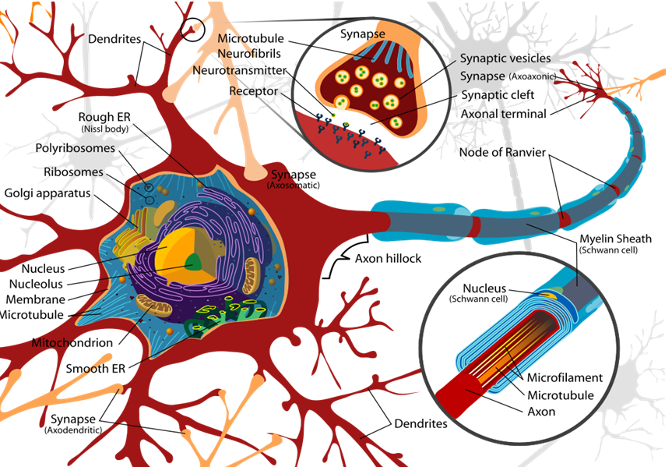
But how does this work on a biological and biochemical level?

Kendall Haven writes:

The typical brain contains 100 billion brain cells (100,000,000,000)- about the same number as the number of stars in the Milky Way…Each cell is linked by synapses to as many as 100,000 others. That means your brain has created over 500 trillion (500,000,000,000,000) wiggling string-like fibers called axons and dendrites that connect with other neurons at junctures called synapses. These synapses are awash with neurotransmitters and hormones that modulate the transmission of electrochemical signals. Synapses constantly form and dissolve, weakening and strengthening in response to new experiences…

A typical brain neuron receives input from thousands of other cells, some of which inhibit rather than encourage the neuron’s firing. The neuron may, in turn, encourage or discourage firing by some of those same cells in complex positive and negative feedback loops. Somehow, through this freeway maze of links, loops, and electric traffic jams, we each manage to think, perceive, consider, imagine, remember, react, and respond…

Haven cites research that shows that humans are not only hardwired for stories due to our evolutionary heritage; we also learn through stories because we are fed a steady diet of stories in childhood, when our brains are far more plastic that those of adults. In other words, we arrive genetically predisposed to learning through stories, and stories told in childhood determine the ways in which our brain synapses develop. This is why dominant cultural narratives, family narratives, and political, ideological, or religious narratives so powerfully shape the ways in which we understand new information. These narratives are wired into our brains due to the synapses that are created as we organize our experiences. Literally, “cells that fire together, wire together.” (Carla Shatz, Stanford University).

That does not mean that our brains do not alter our story maps to accommodate new information. Quite the opposite. Once those story maps are established in our brains, we use them to help us make sense of new information. Our brains work hard to fit that information into stories that we already hold, while, at the same time, those narratives are modified and adapted to accommodate the new information.

Our identity is shaped by the narrative that we hold about our own unfolding life stories. Writing about a narrative approach to adult development, M. Carolyn Clark and Marsha Rossitier state

…construction of an acceptable life narrative is the central process of adult development. The life narrative is repeatedly revised and enlarged throughout one’s life to accommodate new insights, events, and perspectives. Developmental change is experienced and assessed through the process of storying and re-storying one’s life.

References

Haven, Kendall, Story Proof: The Science Behind the Startling Power of Story (Westport, CT, Libraries Unlimited, 2007)

“Narrative Learning in Adulthood,” by Carolyn Clark and Marsha Rossiter, published in Third Update on Adult Learning Theory, Sharan B. Merriam, editor, San Francisco, Wiley Periodicals, 2008

“Neuron cell diagram” image is in the public domain.

Handout 2.1b: Reflections on Learning and the Human Story

Pre-Work

Please respond to these questions prior to the Session

What resonated for you personally, and also professionally, after listening to the video The Relationship Between Neural Pathways and Learning, and reading Handout 2.1a: Stories and the Human Brain? (This question is included in the UUA Discussion Forum)

How do narratives you learned in childhood still shape your thinking? How might these narratives we each hold make it more difficult to build community across difference? How do these stories encourage our community-building?

Where in your congregation have you seen the truth of what you read and heard in these two resources?

What might this mean for your congregational adult faith formation offerings? (This question is included in the UUA Discussion Forum)

Note: During the session, you are invited to ask your partner a question not raised here about the information learned by watching the video and Handout 2.1a: Stories and the Human Brain.

Handout 2.2a: Key Insights from The Power of Stories by the Rev. Dr. Jacqueline J. Lewis

In her book about leading multiracial, multicultural congregations, Jacqui Lewis writes about using the power of story to support, guide, and lead a congregation through the transformative change necessary to create multicultural and multiracial community, where many voices and perspectives are heard (she uses the term ‘multivocal’). Here are some insights that can be applied to adult faith development in our congregations:

People and congregations are formed by stories. Leaders need to “story” a compelling vision in which cultural diversity is an ethical and moral imperative in the present, not a hope for the future. Congregational leaders help form and re-form religious identity with stories they choose as texts. We need to choose stories that are counter-stories to the dominant cultural narratives about race and ethnicity and lift up stories from people whose experiences are on the margins of the dominant culture.

We need to create “border” experiences in our congregations, where people encounter the stories and perspectives of people different from themselves. Border experiences challenge our own culture-bound narratives and help us to expand our perspective. When we engage in border experiences, we are practicing being part of multicultural, multiracial, multivocal beloved community. To allow people to practice being part of beloved community, a congregation and its leaders must:
- Help people tell their stories
- Help people listen to the stories of others
- Weave those stories together

Multiracial, multi-ethnic environments where border experiences with those of different perspectives and experiences abound are also environments that have ambiguity, complexity, vulnerability, and risk. We must create in our congregations holding environments, transitional spaces in which people can develop and practice new ways of being. Three keys to creating a holding environment are:
- Create space for worship, play and imagination
- Offer both identifiable, familiar grounding and new, fresh, and surprising ways to image the story of your faith community. As you narrate the new story, connecting it to the old is part of what makes it compelling; it is part of what authorizes the new story. Lewis quotes her predecessor at Middle Collegiate Church, Gordon Dragt: “I always keep one foot firmly planted in the center, but the other is dangling over the edge.”
- Help people have important experiences together. Learn to appreciate what each brings to the community. Be multivocal, inviting each person to hear the emerging story in their own (cultural) language.

Prework: Story Circle Learning Activity

You are invited to share a story with your Project Group about a time you were engaged in an effort to build multiracial, multicultural community in the fullest sense of this understanding. It can be a place where you felt successful or one that you had hoped for a different outcome. You might share what this illuminated for you about the congregation. You will have 3 minutes to share, and you are encouraged to read what you wrote here.

Other participants will note skills they heard being used or developed. After the storyteller is finished, other participants share with the group at least one learning/skill they heard conveyed in the story.

This process continues until everyone has had a chance to share a story.

Handout 2.2b: Path to Beloved Community

Poll Question

This will appear as a Zoom poll during the session.

Where is your congregation on a continuum of building Beloved Community? Choose whether your congregation is comfortable, on the growing edge, or unable to embrace the work of building Beloved Community. Put an X on the continuum below that best describes where much of the congregation operates.

Comfortable Growing Edge Baby Steps Unable to Embrace

Large Group In-Session Discussion Questions

- Do you as an Adult Faith Formation implementer hold a vision of how adult faith formation engages building Beloved Community?

- If the answer is yes, how do you demonstrate that?

- And if no, what resources you need in order to develop such a vision?

Beloved Community

What are your struggles with or comfort in implementing learning opportunities for identities that are not your own?

Handout 2.3: Including Everyone— Mixing and Huddling

What Is Mixing and Huddling?
- Mixing is learning with others of different perspectives or life experiences and stages or different dominant identities.
- Huddling is learning with a cohort that shares a primary dominant identity such as age, gender, or perspectives, such as being Unitarian Universalist.

Reflect During Your Prework

Which Ministries (outside of worship & Sunday coffee hour) are examples of mixing and huddling? Note where these happen and how. Be specific and include particular Adult Faith Formation opportunities.

- Mixing?

- Huddling?

What challenges might there be when there is one, or only a few, of any one identity (age, gender, ability, class, educational attainment, race, affectional orientation, etc.) participating in the congregation or specific adult faith formation offering? Can anyone share what the Widening the Circle of Concern Report recommends about mixing and huddling? (This question appears on the UUA Discussion Forum)

Pre-Work: Who Actually Participates?

Refer to the pie chart below that displays a balance of mixing and huddling in a fictional congregation. Using the information provided in Question #1, draw a pie chart to represent mixing/huddling participation (outside of worship and coffee hour) in your own congregation.

Sample Congregation Your Pie Chart

Gold = mixing, Blue = huddling
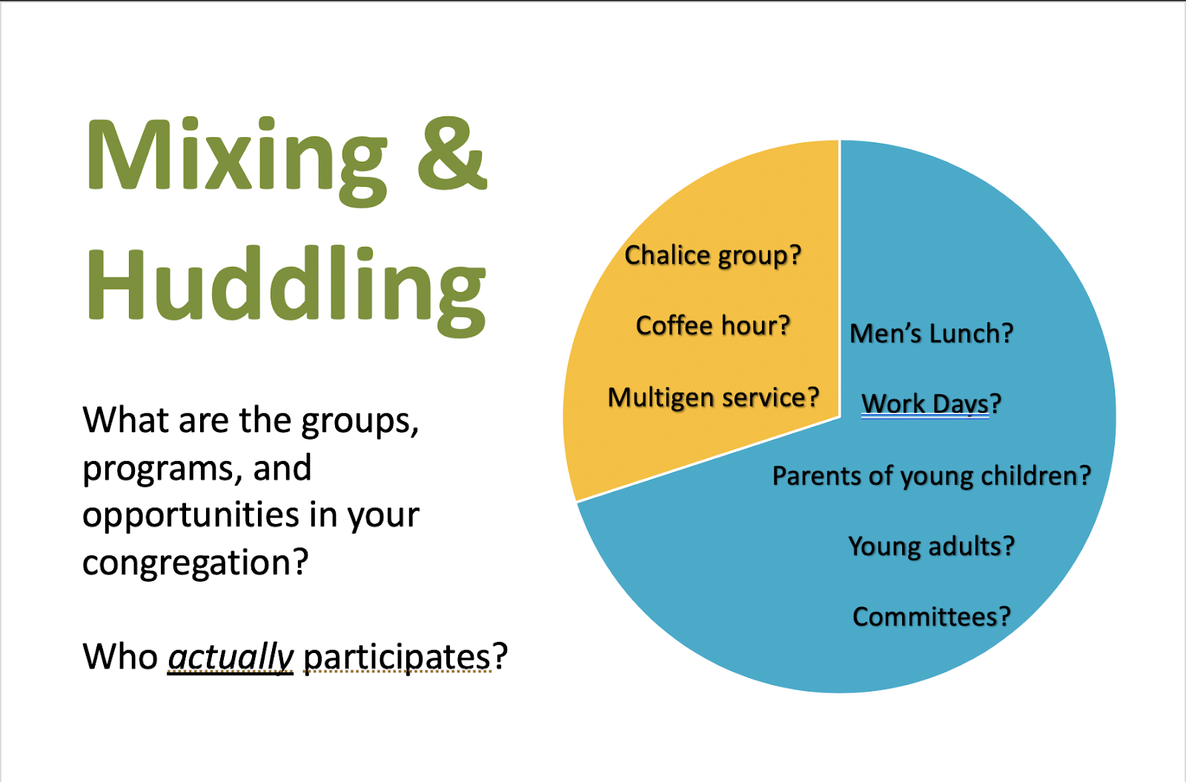

Annotate Your Pie Chart
- Circle the activities that address building the Beloved Community or doing Anti-Oppression work.
- Put a box around offerings devoted to Black, Indigenous & People of Color (BIPOC).
- Underline offerings that welcome other affinity groups.

Question for your Triad In-session Activity

While paying attention to those intentional learning opportunities that are working, what groups in your congregation are bypassing adult faith formation opportunities and why? (Guesses are fine.) Ask your group for any suggestions.

