Love in Action!
Google Jamboard Notes

Jamboard is a cloud-based app that enables visual collaboration between users in real-time.

Template for the Distilling Values Activity
Love in Action! Service - Core Values - Jamboard Template

Before the Service
- Make a Copy of the template
  - Open the link - Love in Action! Service - Core Values - Jamboard Template
  - Click the 3 dots near the “Share” button that are labeled “More Actions”
  - Select “Make a Copy”
  - Rename document to include your congregation/ministry name (instead of template)
- Set your sharing permissions to: “Anyone with the link” and “Editor”
  - Click “Share” button
  - At the bottom of the pop-up Click “Change to Anyone with a Link”
  - To the right, change “Viewer” to “Editor” by selecting it in the drop down
- Personalize your Jamboard
  - Add your congregation/ministry name to the board
  - Practice adding sticky notes, choosing colors, & moving them around
- Add the link to your Worship Script
  - Click “Share” button
  - Click “Copy Link”
  - Paste it into your Worship Script under the section “Distilling Values”

Sample Jamboard
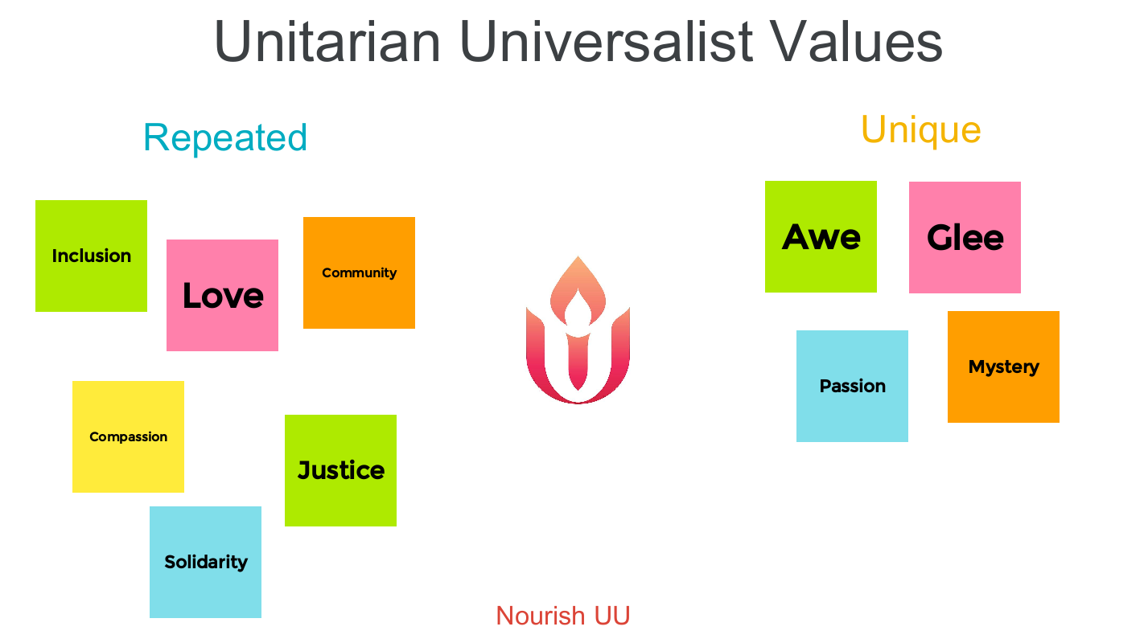

After the service
- Save image
  - Click the 3 dots near the Share button that are labeled “More Actions”
  - Select “Save frame as image”
- Share it!
  - Share it with the Article II Study Commission
  - Share it on social media
  - Share it with your congregational/ministry leaders

For an (optional) tutorial for how to use Jamboard overall: Jamboard Tutorial 2020

