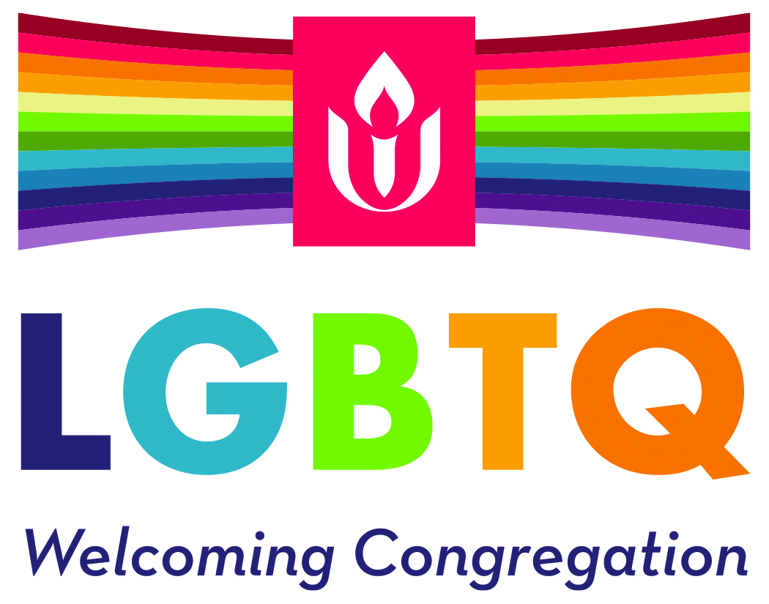

Renewing the Welcome Worksheet

- Congregation Name *
- Congregation ID *

- Address *
  - Street Address
  - Address Line 2
  - City/State
  - Province/Region
  - Postal/Zip Code
  - Country
- Year of initial Welcoming Congregation designation *
- Is this your first renewal? *

- Contact person’s name *
- Contact person’s email *
- Contact person’s phone

- Minister’s name (if applicable)
- Ministers’ email (if applicable)

- Congregational president’s name
- Congregational president’s email

- Year of most recent renewal (if applicable)
- Date of congregational vote for renewal *

- Summary of work done in service of renewing your Welcoming Congregation status:
- What LGBTQ-related educational work have you done since your first/most recent designation?*

- What impact do you think the educational work had on your congregation?*

- What congregational life (Sunday morning, programming, social occasions, bylaws, policies and procedures, facility, communications, etc), work have you done since you first/most recent designation? *

- Relate a recent story that illustrates you commitment to LGBTQ welcoming and inclusion inside your congregation: *
- What LGBTQ community outreach/social justice work have you done since you first/most recent designation? *

- How would you evaluate the strength of your relationships with LGBTQ community organizations/partners, either locally, state-wide, or nationally? [Bold the one that best describes your congregation.] *
  - Strong. We work with our LGBTQ community organizations/partners on issues of LGBTQ equality and acceptance at least 3 times a year.
  - Good. We work with our LGBTQ community organizations/partners on issues of LGBTQ equality and acceptance at least once a year.
  - We have connections with one or more LGBTQ community organizations/partners. We work with them on LGBTQ equality/acceptance when a special issue arises.
  - We have occasionally worked with one or more LGBTQ community organizations/partners but we have no ongoing connections.
  - We don’t have any relationships with LGBTQ community organizations/partners.

- What specific work have you done around transgender, bisexual, and queer identity and welcome? *

- Relate a recent story that illustrates your commitment to transgender, bisexual, and queer identity and welcome:*

- What is greatest area of challenge as a Welcoming Congregation *

- What is your greatest strength as a Welcoming Congregation? *

- What is your greatest strength as a Welcoming Congregation? *

- What steps have you taken and continue to take to identify and address areas where you can deepen your welcome of people of all races, ethnicities, economic status, abilities, ages, sexual orientations, and gender identities? *
