Love Reaches Out

A study guide of outreach and branding strategies for Unitarian Universalist congregations and communities

NOVEMBER 2015
Table of Contents
Introduction 3
Background 3
How to use this study guide 5
Leader facilitation tips 7
Session 1: The changing religious landscape 9
Opening 1: Introductions and how we will be together 10
Activity 1.2: Join our cause, not join our club 12
Closing 1 13
Handout 1A: Respectful Communication Guidelines 14
Handout 1B: Join our cause, not our club 15
Session 2: Who we are, what we do, and why it matters 17
Opening 2 18
Activity 2.1: Who we are – our congregation 18
Activity 2.2: Who we are - Unitarian Universalists 19
Activity 2.3: Communicating who we are 20
Closing 2 22
Handout 2A: We Are Unitarian Universalists 24
Handout 2B: UUA.org, Old and New 25
Handout 2C: Opportunities Abound 29
Session 3: Where to start: Sweet Spot and Entry Points 30
Opening 3 30
Activity 3.1: Where is your Sweet Spot? 31
Activity 3.2: Entry Points 33
Closing 3 35
Handout 3A: Throop UU Church Case Study 36
Handout 3B: Where is Your Sweet Spot? 38

Introduction
The purpose of this study guide is to allow congregations and other UU groups to explore the way religious practice is changing in the United States and how UUs can respond in their communities. To respond effectively, collectively and individually, UUs must get better at reaching out to new people and being heard through the ever-flowing stream of news and social media. One way that UUs can respond together is by offering events, programs and opportunities to introduce themselves to their communities. These create “Entry Points” for our faith tradition. Another way is through a shared UU “brand identity” in communications, which gives UU groups and individuals tools to shape how Unitarian Universalists are perceived. This study guide helps UU congregations and groups bring together outreach and branding strategies in practical ways that will allow them to further their mission and purpose amid the changing religious landscape.

Background
Recognizing the changing patterns in American religious practice, Unitarian Universalist Association (UUA) President Rev. Peter Morales released a paper in 2012 that called for Unitarian Universalists to consider ways that their congregations, and other faith communities, could adapt to these new realities. The Congregations and Beyond paper (uua.org/vision/beyond) kicked off a series of vibrant conversations around forms of community, social media and communications, styles of worship and dreams for the future of Unitarian Universalism.

One result of the Congregations and Beyond conversations has been greater UUA support for innovative and emerging ministries. These creative approaches to faith community explore new ways of expressing and advancing UU values and principles. Ranging from cooperative housing to small group ministries to alternative worshipping communities, emerging ministries have helped UUs engage people in reflection, connection, learning, and growth in new ways. A few of these groups were profiled in the Summer 2014 issue of UUWorld magazine.

Congregations and the UUA are supporting innovative approaches in a variety of ways. The 2014 UUA General Assembly delved into these ideas under a theme which shares its name with this study guide: “Love Reaches Out.” The Unitarian Universalist Association is embracing creative grassroots ideas through the Emerging Ministries system of support (uua.org/emerging). In partnership with the UU Ministers’ Association, the UUA is also training innovative leaders through the Beyond The Call: Entrepreneurial Ministry program. In addition to grants available from the UU Funding Program, many UUA districts and regions are financially supporting or endorsing alterative ministry groups. And local congregations across the Association are lending their weight to inspiring, creative ideas for how to live out their faithful purpose.

Another critical need that emerged from the Congregations and Beyond conversations was the need to better communicate the core of Unitarian Universalism in the world. This was clearly reflected in the multi-year Gathered Here appreciative inquiry process, which included thousands of individual UUs and local congregations, which demonstrated the yearning that UUs have to be known in the world for their good work. As a result, the UUA’s elected leaders began a process of understanding how UUs are actually perceived and how to promote a more honest and hopeful understanding. That process led to a new way of presenting Unitarian Universalism’s “brand.”

In February 2014, President Morales introduced a new visual look and feel for Unitarian Universalism that is intended to speak to the reality of current perceptions of religious institutions, including a new logo for the Association, and described the components of a comprehensive “brand identity” strategy designed to better tell our story (uua.org/branding). He noted that:
…the dramatic shifts in today’s religious landscape demanded that UUA leadership take an in-depth look at our strategic communications and how effectively our voice is breaking through the competing noise of our high-tech society. We examined our core values, our unique personality as a faith, and the impact Unitarian Universalists hope to make in the world. We asked UUs from across the country, of all ages with various levels of involvement in our faith, to answer three questions: Who are we? What do we do? And why it matters? From these conversations, and more, we began to form our brand identity for the future of our religious movement.

We look forward to conversations with you, in congregations, districts, regions, and affiliated organizations, about your own brand identity and how it fits into the new direction of the UUA. This is the beginning of a transformative journey to tell the story of Unitarian Universalism and inspire individuals to join that journey.

In the article “Into the Beyond” (UUWorld magazine Summer 2014), Rev. Dr. Terasa Cooley explains the need for outreach and branding:
Technology and culture are evolving in ways that present fantastic opportunities for us. We can seize these opportunities, but, as we have done many times before, we will have to change how we do church.

By exploring new models and expressions of Unitarian Universalism, and learning how to better reach out to new groups of people, our faith can thrive amidst the rapid changes of our time. The importance of this work is clear, and hopefully this guide will engage congregations and UU communities in turning fear into excitement as we move boldly into the future.

For more information
- “Emerging alternative groups at UUA’s growing edge,” UUWorld article, Summer 2014 - http://www.uuworld.org/articles/emerging-alternative-groups
- “Fired Up, General Assembly energized Unitarian Universalists with new models of ministry and outreach,” UUWorld article, Fall 2014 -http://www.uuworld.org/articles/ga-report-2014
- Beyond the Call: Entrepreneurial Ministry Training video - http://smallscreen.uua.org/videos/beyond-the-call-entrepreneurial-ministry

How to use this study guide
This guide consists of workshops and resources for three, ninety-minute sessions to serve as the starting point for the transformative journey that President Morales described. Here are a few suggestions for how to get the most out of this study guide:

- Find a format that fits - There are multiple pathways for engaging with the materials. The workshops can be done separately over time or combined into a day-long gathering. If the workshops are all held on a single day you can eliminate or revise the following components: Closing 1, Closing 2, Opening 2 and Opening 3.
- Take what you need – Learning goals for each session and activity are clearly defined so that facilitators can address each activity individually if they prefer. Some congregations may have already engaged with questions or programs that would make certain activities unnecessary, such as congregations who have recently rewritten their mission. However, beware of skipping activities! Every group has members with different levels of understanding, and the learning goals in the study guide build on one another as the group moves forward together. In the testing phase for this study guide, groups that completed all activities reported a better experience.
- Get the right people in the room – Make sure that the people attending the workshops are those who are most likely to follow through on outreach plans. This may be a cross-section of leaders in the congregation, a distinct group, or taskforce who is considering outreach.
- Stay grounded in support - It is likely that the leadership of the congregation or group will want to review the study guide to ensure that the full congregation is in support of the exploration that the guide asks. If the workshops will include multiple congregations or groups (highly recommended), it might be advisable to include a leader from each group. The study guide works for leaders who don’t have any knowledge of branding as well as those who have some knowledge.
- Consider your neighboring UU congregations - Another option for using this study guide is to gather several different congregations and/or other UU groups to work through the activities together. There are many ways that congregations or groups could learn from each other and help one another, especially in the Session 3 activities.
- Think virtual - Other formats could include the hybrid or “blended learning” model, which incorporates both online and in-person gatherings. For example, participants could meet in person for the first session and then complete the second and third sessions via an online webinar platform. There are also opportunities for “flipped” learning, in which participants can access all of the information online before a “live” in-person (or online) gathering and come prepared with an understanding of the concepts and goals. This requires facilitators to send out links to videos and handouts in advance of the session to provide more time for discussion while the group is together.

For more inspiration on virtual gatherings, read about the hybrid in-person/online “UU Leadership Institute” on the Central East Regional Group (CERG) website: http://www.cerguua.org/programs-74553/uulti-40609.html and/or listen to the Faith Development Office webinar “Outside In & Upside Down: Applying the ‘Flipped’" Classroom Concept to Faith Development” (March 2014) here: http://www.uua.org/re/teachers/webinars/293057.shtml.

Leader facilitation tips
Each session requires one or more facilitators. The text of this guide is written in the second person tense for the facilitator. Text that is recommended for facilitators to say aloud during the workshops is indented and italicized.

Accompanying the workshops, a visual slide deck formatted for PowerPoint with key question prompts (and other visual cues) is written in the second person tense for participants. Facilitators can show the slides during the workshop with a screen and projector or print out the handout versions and distribute to participants to follow along on their own. (If you are running the slides, note that they include animation, and the facilitator must click for each piece of the animation to phase in.) Slides are denoted in the guide by SLIDE next to the section of the activities they match. The italicized recommended instructions for each activity are included in the slides’ Notes section, visible through PowerPoint’s “Presentation” setting.

Facilitators should not be expected to serve as experts; rather, they are the helping the group together consider important questions and possibilities in a loving and supportive manner. This study guide is not intended to provide the “one right way” to engage discussions on outreach and branding. Nor are all UUA congregations expected to radically change everything they are doing overnight. This resource is descriptive, not prescriptive; groups should feel free to adapt the workshops and resources to fit the needs of their context.

Another important note is that these workshops are designed to help local groups and congregations take advantage of the research and insight that informs the UU brand identity, but are not the venue in which to debate the UUA’s branding process or the UUA logo. While no congregations are required to use any aspect of the UU brand identity, it was developed as a tool for them to leverage the good work they are doing in their communities. See the link below for some possible techniques for facilitating discussions.

An important and desired outcome is that congregations and UU groups who engage in the process will share what they are doing with others, offering ideas, inspiration and encouragement. Each congregation completing this study guide is encouraged to share their Entry Point projects (developed in Activity 3.2) and any other results from the workshops. Congregations can share these results by sharing them with the UUA’s Facebook page (facebook.com/theuua) or by emailing them to outreach@uua.org, so that UUA staff can share them online. More information about these venues for sharing will be communicated as they are developed. For more information, contact the UUA’s Outreach Office at outreach@uua.org
Preparation before each session
It is highly desirable for leaders to prepare themselves ahead of time by reviewing the content and videos. In advance of each session, it is recommended that facilitators:
- Review all materials needed for the session, make sure you have them on hand.
- Note where slides change in the workshop, if you are using the slides.
- Print copies of handouts for all participants.
- Download videos onto the computer hooked up to the projector. Videos from the UUA will be downloadable at the links listed. Videos posted to Vimeo or Youtube can be downloaded for personal use with the application ClipGrab (clipgrab.org).
- Test the computer, projector screen and any other equipment (consider recruiting someone to help with technical aspects if necessary).
Note that, in the spirit of “flipped learning,” it may be helpful to invite participants to review videos in advance of the workshop as well.

Sharing the Floor: Some Strategies for Effective Group Facilitation
http://www.uua.org/re/adults/151805.shtml

Session 1: The changing religious landscape

Time: 90 minutes
Goal: Understand how the American religious landscape is changing and how UU congregations can respond to that reality
Materials
- Session 1 slides
- Chalice, candle, and matches, or LED/battery operated candle
- Handouts 1A, Respectful Communication Guidelines; and 1B, Join our cause, not our club
- Laptop with videos and slides ready, projector and screen
  - Future of Faith: http://smallscreen.uua.org/videos/future-of-faith-unitarian-universalists-in-a-changing-time
  - Emerging Ministries: http://smallscreen.uua.org/videos/emerging-ministries

Preparation: If your room does not have Internet access, you can download the videos in advance from the links above. Just right-click on the URL below the screenshots and choose “Save Link As.” The mp4 video file will download to your computer.
Session at a Glance
Activity | Minutes
Opening 1: Introductions and how we will be together | 10
Activity 1: The changing religious landscape | 30
Activity 2: Join our cause, not join our club | 40
Closing 1 | 5

Opening 1: Introductions and how we will be together
Time: 10 minutes
SLIDE 1.0 Welcome participants to the session, and explain that over the next three sessions they will be exploring how UU congregations can succeed in creating religious communities that promote UU values and principles when religious practice is changing in America. Say something like:
We are all here because we care about this congregation and this community, and we know that the world is changing around us. Through the three sessions of this study guide, we will explore those changes and how UUs can respond in ways that promote their values and principles in the new American religious landscape. We will start by examining those changes and what they mean. We will consider what is most precious and important to us in our congregation, as well as how Unitarian Universalists in other congregations are developing a shared sense of identity. We will learn about how think from an outsider perspective, how to find the “Sweet Spot” for outreach in our community, and develop a plan for what our unique next steps will be. Thank you for taking this journey together, it shows how much passion and commitment are present here in our community.
SLIDE 1.0.1 Light the chalice and have someone read these chalice lighting words from Melissa Harris-Perry (from The Unitarian Universalist Pocket Guide):
“We are the certain and the seeking, the lifers and the newcomers, the beloved and the broken hearted, the insiders and the rejected, all of whom have found home in the extraordinary, yet intimate communities of Unitarian Universalism.”
SLIDE 1.0.2 Invite participants to introduce themselves by name and share one reason they are attending this workshop.
SLIDE 1.0.3 Distribute Handout 1A Respectful Communication Guidelines from the Kaleidoscope Institute and ask for a volunteer to read each statement. Invite brief comments and ask participants to voice or signal agreement.

Activity 1.1: The changing religious landscape
Time: 30 minutes
Goal: Understand the recent and dramatic changes to the American religious landscape
SLIDE 1.1.1 Introduce the video saying something like:
The first step to reaching out is to understand the world we live in. We will begin with a video called “The Future of Faith” by Carey McDonald, the Outreach Director for the UUA, which describes the way religious practices are changing in the United States and how these changes impact Unitarian Universalists. As you watch the video, be sure to think about whether the trends Carey describes match your experience and observations.

Play “Future of Faith – Unitarian Universalists in a Changing Time” (6:56) [http://smallscreen.uua.org/videos/future-of-faith-unitarian-universalists-in-a-changing-time].

SLIDE 1.1.2 Discussion questions
Ask participants to discuss each of the following questions. If your group is larger than 10-12 participants, you can break into smaller groups to discuss these questions for 10 minutes and then return to the larger groups and ask participants to share what they discussed in their smaller groups. Allow 20 minutes total for the discussion.
- How do these trends match what you are seeing or experiencing?
- In what ways has the congregation responded or adapted to these trends?
- How else could you imagine our congregation responding and adapting?

Finish the activity by summarizing some of the themes you have heard as the facilitator in the responses to the discussion questions.

Activity 1.2: Join our cause, not join our club
Time: 40 minutes
Goal: Given the changes in American religion, reframe what Unitarian Universalist faith communities offer.
Introduce the activity saying something like:
Since the world is changing, we need to pay attention to how Unitarian Universalists are known in the world. In this blog post, UUA Outreach Director Carey McDonald describes the need for a shift in the way we present ourselves as a faith community so that we speak to what people are actually looking for.

Distribute Handout 1B: Join our club, not join our cause.

SLIDE 1.2.1 Discussion questions
Ask participants to discuss each of the following questions. If your group is larger than 10-12 participants, you can break into smaller groups to discuss these questions for 10 minutes and then return to the larger groups and ask participants to share what they discussed in their smaller groups. Allow 20 minutes total or the discussion.
- If you did not grow up in this congregation, what drew you initially?
- What are the key things someone can expect to get out of participating in our congregation (the “what” and “why”)?
- How could our congregation describe the “why” and the “what,” rather than just the “who” in the way we talk about yourselves?

Finish the activity by summarizing some of the themes you have heard as the facilitator in the responses to the discussion questions.
SLIDE 1.2.2 Optional – Emerging ministries video
If your group has five extra minutes, consider showing the emerging ministries video (3:29). [https://uuacdn.s3.amazonaws.com/videos/emerging-ministries.mp4]
Introduce the video by saying something like:
We will close today by watching a third video that gives some great examples of UU faith communities who are successfully adapting to the changing religious landscape. While this congregation/group will likely have a different kind of response, it is helpful to see what is possible and get inspired.

Closing 1
Time: 5 minutes
Restate the goals for this session and the next session to remind participants where they are in the learning process.

- Session 1 – The world we live in
  - Goal: understand how the American religious landscape is changing, and how UU congregations can respond to that reality
- Session 2 – Who we are, what we do, why it matters
  - Goal: examine who we are as UUs in our congregations, as a faith movement, and how to communicate this to the wider world

Remind participants of the date and time of the next session.

SLIDE 1.3 Extinguish the chalice and read (or ask a volunteer to read) these closing words from Jim Key, Moderator of the Association (Southern Regional Assembly keynote address April 2014):
It is long past time for us, as Unitarian Universalists, to bravely move beyond our superficial differences and discomfort in talking about our beliefs and do the challenging, but important, work of identifying and deepening the core of our faith. Having done so, we will see that there are many more people who share our beliefs than we ever imagined…people hungry for a meaningful faith in these challenging, uncertain days of a young century. Let us finally resolve to truly become the religious beacon our heritage has equipped us to be. The time is now, the world is ready, and the hour is late.

Handout 1A: Respectful Communication Guidelines

R – take responsibility for what you say and feel without blaming others
E – use empathetic listening
S – be sensitive to differences in learning styles
P – ponder what you hear and feel before you speak
E – examine your own assumptions and perceptions
C – keep confidentiality
T – trust ambiguity because we are not here to debate who is right or wrong

Source: Kaleidoscope Institute [http://www.kscopeinstitute.org/respectful-communication-guidelines/]

Handout 1B: Join our cause, not our club
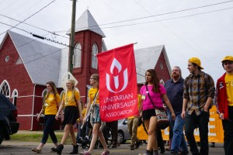
Growing Unitarian Universalism blog – September 23, 2015
We know that religion is changing in America, but in those changes there’s a hidden trend. Did you know that what attracts people to a congregation or religious community and what keeps them there are different things? What attracts people is the opportunity for meaning-making, and what retains them as members is the community and friendships they build. People don’t come because they are in search of friends or a community, per se, they come looking for spiritual deepening for themselves and their family and only then may they find a community which enriches the meaning-based experience and makes them want to come back.

This is clearly demonstrated through research. In his book “American Grace,” sociologist Robert Putnam digs through mountains of data to identify some key trends in American religious practice. Here’s a quote from his book: “Americans may select their congregations primarily because of theology and worship, but the social investment made within that congregation appears to be what keeps them there.” (pg 174).
You can see this dynamic at play within Unitarian Universalism, most recently in the multicultural ministries Sharing Project. This survey of UUs from marginalized groups (gender identity, race, ability, etc.) asked why respondents first decided to attend their congregation and then why they continued to attend. The top response for the decision to attend was “I wanted to deepen my spiritual life,” and the top response for staying was “I love the community of people”(page 15, or the 23rd page of the PDF).

Handout 1B: Join our cause, not our club (p. 2)
Ok, you say, fascinating point, but what am I supposed to do about it? Simple: when you talk about what your congregation offers, think “join our cause” instead of “join our club.” Show what your congregation does, how it helps people live better lives and make a better world, instead of only talking about what a great community you offer. If I had a dollar for every time I heard a congregation say “all are welcome” (including UU, UCC, Catholic, even conservative evangelical!), well, I’d have a lot of dollars but no idea what I would be welcome to spend them on. It’s great that you’re not turning people away, but what are you actually offering them? Seriously, “all are welcome” at the movie theater, but I’m still not going to the movies unless I know what’s playing.

The key to successful outreach amid the changing religious landscape, particularly with the unaffiliated or Spiritual But Not Religious sets, will likely be to speak to why people would want to show up in the first place, not just what can keep them there year after year. Describe what we offer for learning, yearning, and working for our values. We can’t assume people are already looking for a church on Sunday mornings, because in fact we’re competing for their time and attention against sleeping in, talking a walk, soccer practice, Facebook and brunch. We have to focus on what we DO as UUs, not just who we are.

To help you think “cause” over “club,” check out the values of the UU brand identity – boldness, compassion, reverence – that are geared towards the most active and authentic spiritual elements of our faith. They’re a departure from the pastoral, supportive, caring community connection values that we’ve often described in the past, but they’re well-positioned to help you get to the heart of our faith movement’s drive to advance our values in the world.

Session 2: Who we are, what we do, and why it matters
Time: 90 minutes
Goal: Examine who we are as Unitarian Universalists, both in our congregations and as a faith movement, and whether we are effectively communicating this to the wider world
Materials
- Session 2 slides
- Chalice, candle, and matches, or LED/battery operated candle
- Handouts 2A: We Are Unitarian Universalists; 2B: UUA.org, Old and New; and 2C: Opportunities Abound
- Newsprint, markers, and tape
- Sticky notes
- Pens and/or pencils
- Laptop with video and slides ready, projector and screen
  - Social Media and Membership: https://vimeo.com/63707371

Preparation: If your room does not have Internet access, you can download the video in advance from the link above using ClibGrab (see Leader Facilitation Tips, p. 7).
Session at a Glance
Activity | Minutes
Opening 2 | 5
Activity 2.1: Who we are – our congregation | 20
Activity 2.2: Who we are – Unitarian Universalists | 20
Activity 2.3: Communicating who we are | 40
Closing 2 | 5

Opening 2
Time: 5 minutes
SLIDE 2.0 Welcome participants to the session, both those who attended the first session as well as those who are new to the conversation.

SLIDE 2.0.1 Light the chalice. Read, or ask a volunteer to read these words from The UUA Brand Report:

We are Unitarian Universalists. We are brave, curious, and compassionate thinkers and doers. We are believers in what is good, what is right, and what is just. We have radical roots and a history as self-motivated spiritual people: we think for ourselves and actively object to what we believe is wrong. We have a track record of standing on the side of people, love, justice, and peace. Our faith has always been motivated by a desire to contribute to the greater good. We are a house without walls, a congregation without spiritual boundaries, and a movement towards a more action-oriented faith in yourself, your god(s), and your beliefs. Simply put, we are a guided path towards a better you and a better world.

Invite participants to re-introduce themselves if appropriate.

Activity 2.1: Who we are – our congregation
Time: 20 minutes
Goal: Be able to articulate your congregation’s core strengths and passions
[Note: if your congregation has recently (last three years) written a mission or vision, you can substitute this activity with a review of that vision or mission.]
SLIDE 2.1.1 Distribute sticky notes, 5-6 to each participant. Engage participants in an appreciative inquiry process, saying something like:
Think of a time when your congregation or group was being its “best self” or doing its best work. What are some of the adjectives you would use to describe that? Write each word on a sticky note and post in the designated place.

Ask participants to share ONE of their words and write this on newsprint. When all have shared, ask participants to post their sticky notes on the newsprint by the word closest in meaning to theirs. Spend a few minutes discussing the trends in the words.
- What trends do you see in the way we describe our community at its best?
- Is there a cohesive identity that you see emerging in these descriptions?

Activity 2.2: Who we are - Unitarian Universalists
Time: (20 minutes)
Goal: Learn about the emerging shared UU identity, developed to help UUs everywhere communicate more clearly and succinctly about who we are, what we do and why it matters.
SLIDE 2.2.1 Distribute Handout 2A “We Are Unitarian Universalists”. Say something like:
These statements of “who we are” came from Unitarian Universalists from across the country, of all ages, backgrounds, and experiences, who engaged in the conversation about who we are, what we value, and what we want to share.
Ask participants to form small groups and designate someone to take notes and someone to share their ideas with the larger group. Once groups have formed, introduce the “powerful questions” found on the handout and have participants discuss them for 15 minutes. Note that the exercise is an invitation to be creative about the ways a congregation or other UU faith community could imagine its ministry.

After 15 minutes, bring participants back to the larger group and ask for volunteers to share highlights from each small group discussion (15 minutes). Once all groups have shared, ask for observations – what commonalities were there among the groups? Differences? Something that surprised you? Something that inspired you? And what connections did you see between the larger faith identity and the specific identity you described for your congregation in the previous activity? (10 minutes)

SLIDE 2.2.2 Finish the activity by saying something like this about the UU brand identity to participants:

To help UUs better communicate who we are, what we do and why it matters, the UUA has worked with congregations and leaders to develop a UU brand identity. Using images, text and design to create a shared look and feel, the goal of the UU brand identity is to have an approach that can used by diverse UU groups to raise their profiles in the community. While no UU groups are required to use any part of the brand identity, it is hoped to represent the best of our shared values of boldness, compassion and reverence. The more UU congregations, groups and individuals who use the brand identity, the better our chances of breaking through the media noise with our message of healing and hope. Imagine a day when lengthy explanations and “elevator speeches” about Unitarian Universalism aren’t necessary anymore because our faith is known far and wide as a force for good in the world.

Activity 2.3: Communicating who we are
Time: 40 minutes
Goal: Understand how non-UUs view Unitarian Universalism, and how the UU brand identity helps frame an effective message for reaching outsiders

SLIDE 2.3.1 Introduce the activity by saying something like:
Now that we’ve had some discussion about how we see ourselves congregation and as a wider faith movement, we can consider whether that identity is being effectively conveyed to our community. The concept “it’s not what I say, it’s what you hear” can help us understand the perspective of people outside of our congregation. While this is never easy to step outside your own experience, one way to think about this is “putting on your outreach glasses” to try to observe our communities and communications from an outsider’s point of view.

Show each of the slides illustrating two similar web pages on UUA.org and distribute Handout 2B UUA.org Old and New. As you go through the slides, say something like:
SLIDE 2.3.1 Let’s use our “outreach glasses” to look at a case study. To put on your outreach glasses, all you have to do is imagine looking at this information for the first time with no prior knowledge or assumptions.

When we visit webpages, we quickly form assumptions based on what we see in the first few seconds on a page. In the examples I’m about to show you, you won’t be able to read all the text. That’s OK. No one reads a whole webpage before they react to what they’re seeing. Here we are just looking for first impressions.

SLIDES 2.3.2-5 Here, we see old versions of the LGBTQ Welcome and Equality and Young Adult Ministry pages on UUA.org.
- If you knew nothing about Unitarian Universalism, what impressions would you have visiting these old pages?
- In what ways do these page succeed or fail at communicating the best parts of UU identity?

SLIDES 2.3.6-9 Now, we see a new version of the same webpages on UUA.org.
- If you knew nothing about Unitarian Universalism, what impressions would you have visiting these new pages?
- In what ways do these pages succeed or fail at communicating the best parts of UU identity?

The New pages reflect a new site design and content that has been revamped to communicate better with visitors.

SLIDE 2.3.10 Discussion questions
Ask participants to discuss each of the following questions. Allow 10 minutes total or the discussion.
- Did putting on the “outreach glasses” help you notice things you wouldn’t have noticed otherwise? If so, how?
- How do we learn to observe from the outsider’s perspective? Why is this important?

SLIDE 2.3.11 Distribute Handout 2C: Opportunities Abound. Ask participants to read through the handout. Then ask participants to discuss each of the following questions. Allow 15 minutes total or the discussion.
- Which of these assets, challenges, opportunities and potential pitfalls have you heard before? Which are new?
- Are these also your congregation’s assets, challenges, opportunities, and potential pitfalls?
- Thinking about your “outreach glasses”, what might first-time visitors assume through what they observe on your congregation’s website, through social media, in building, at coffee hour, etc.?

SLIDE 2.3.12 Optional – Social Media and Membership video
If your group has seven extra minutes, consider this segment of the 2013 Minns Lecture with Peter Bowden: https://vimeo.com/63707371. Introduce the video by saying something like:
UU social media expert Peter Bowden reinforces the need for congregations to show up online, and advises that “church shoppers are pre-qualified members as long as the experience matches what they saw online”

Closing 2
Time: 5 minutes
Restate the goals for this session and the next session to remind participants where they are in the learning process.

- Session 2 – Who we are, what we do, why it matters
  - Goal: examine who we are as UUs in our congregations, as a faith movement, and how to communicate this to the wider world
- Session 3 – Where to start: Sweet Spots and Entry Points
  - Goal: develop a plan for getting started reaching out into the community while staying grounded in your core identity or mission

Remind participants of the date and time of the next session.

Ask participants to consider what it would mean to “answer the call” expressed by UUA Moderator Jim Key:
So my call to you today is to assess your websites and assess whether it conveys who we are, what we do, and why it matters? What about your order of service? And your adult faith development: are you using the Tapestry of Faith curricula? If you use lay leaders for some or all of your Sunday services, have then been trained to deliver excellence in their services?

SLIDE 2.4 Read, or ask a volunteer to read, these closing words from Jim Key (Regional Assembly keynote address April 2014):
I believe to my core that Unitarian Universalism can be the religion of the 21st century, because we have a broad, progressive theology that relies on reason, accepts science, respects the individual, celebrates community, seeks wisdom in all the world’s religions, and honors the Holy mystery of this magnificent creation of which we are a part.

Handout 2A: We Are Unitarian Universalists
Adapted from an exercise developed by Rev. Renee Ruchotzke, with quotes from the UUA Brand Report below.
Powerful Questions:
Imagine you are on the leadership team planting a new UU congregation or other type of faith community in your region.
- What is a need in your city, town, or neighborhood that your new UU faith community could address?
- How would you articulate your core purpose to the broader community, who may not know anything about UUism (3 action words or a “portable” phrase)?
- What actions (programs, services, etc.) would you offer in the broader community to “walk the talk” of that core purpose?

We are Unitarian Universalists.

We are brave, curious, and compassionate thinkers and doers. We are believers in what is good, what is right, and what is just.

We are diverse in faith, ethnicity, history and spirituality, but aligned in our desire to practice our faith and beliefs in tangible ways. We foster a respectful community hallmarked by action, love, and acceptance of all people.

We are the original conscientious objectors, radical thinkers, and self-motivated spiritual peoples throughout history. We have a track record of standing on the side of people, love, justice, and peace.

We have roots in radical thinking and compassion. Our faith has always been motivated by a desire to contribute to the greater good.

We are a house without walls, a congregation without spiritual boundaries, and a movement towards a more action-oriented faith in yourself, your god, and your beliefs.

Simply put, we are a guided path towards a better you and a better world.

Handout 2B: UUA.org, Old and New

Old UUA.org LGBTQ Welcome and Equality page excerpt
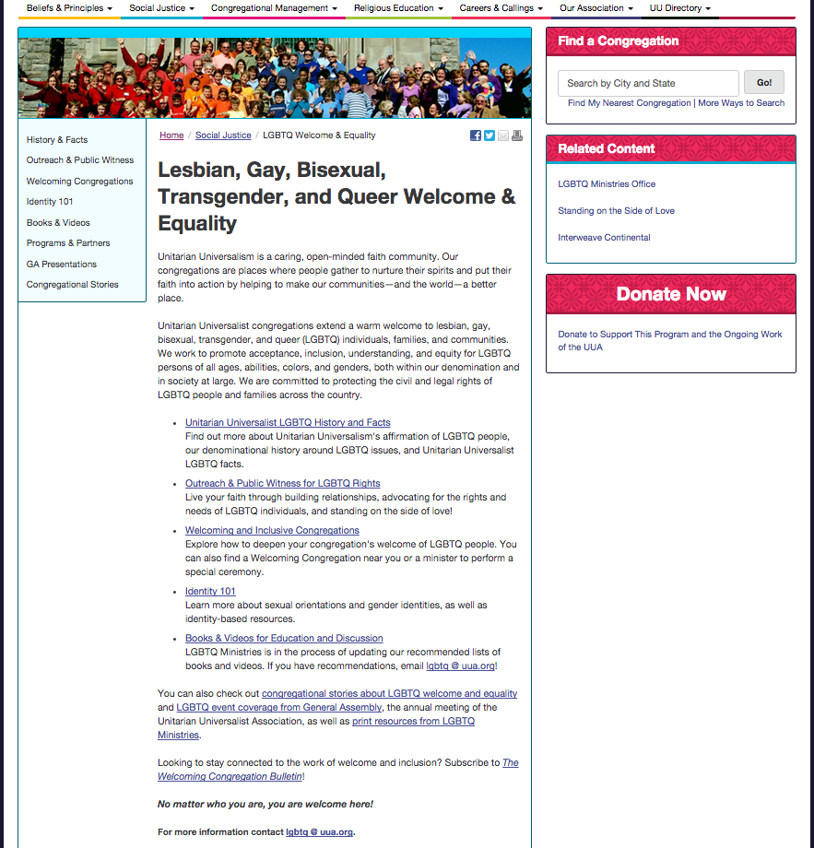

Handout 2B: UUA.org, Old and New (continued)
New UUA.org LGBTQ Justice page excerpt (uua.org/lgbtq)
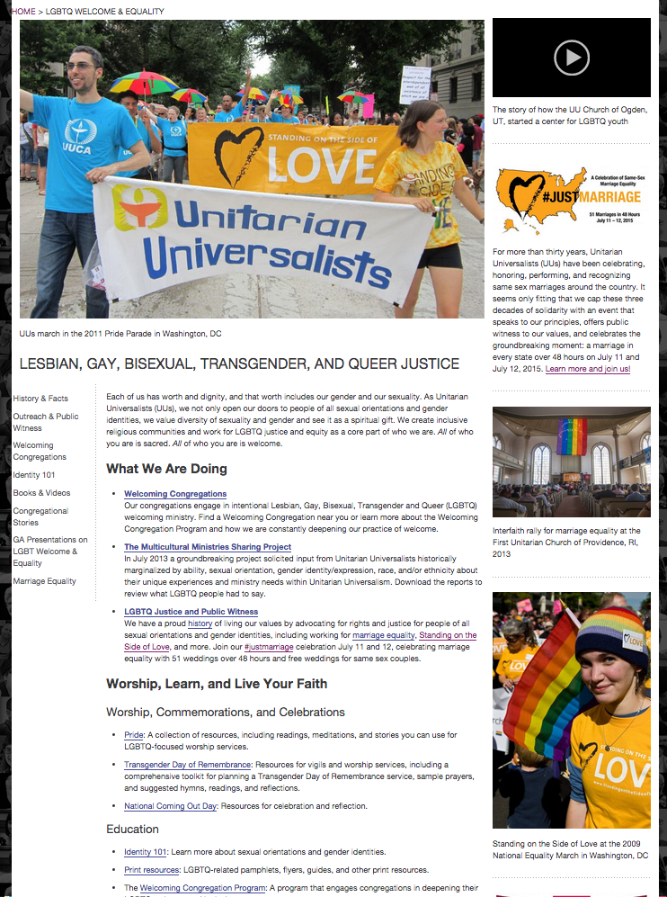
Handout 2B: UUA.org, Old and New (continued)
Old UUA.org Young Adults page excerpt
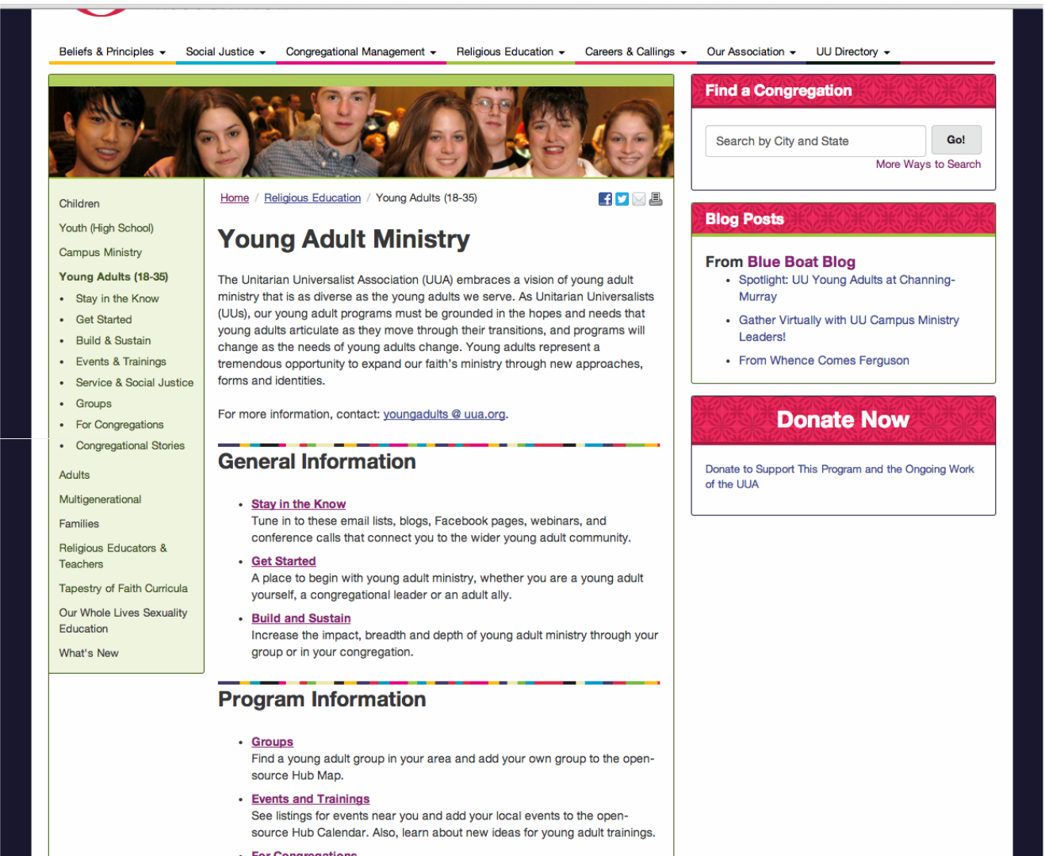

Opening paragraph text:
The Unitarian Universalist Association embraces a vision of young adult ministry that is as diverse as the young adults we serve. As Unitarian Universalists (UUs), our young adult programs must be grounded in the hopes and needs that young adults articulate for themselves as they move through their transitions, and programs will change as the needs of young adults change. Young adults represent a tremendous opportunity to expand our faith’s ministry through new approaches, forms and identities.

Handout 2B: UUA.org, Old and New (continued)
New UUA.org Young Adults page excerpt (uua.org/youngadults)

Handout 2C: Opportunities Abound
How are Unitarian Universalists actually perceived in the world? With a little help from Proverb Consulting in 2013, these assets, challenges, opportunities, and pitfalls were identified as to help Unitarian Universalists to think about our faith’s potential.
Assets to build on:
- Strong reputation for being progressive and inclusive
- UU beliefs resonate with emerging cultural values
- UU organizations are willing to make change and take risks
Challenges to consider:
- Traditionalist trappings
- “Silly” or “wacky” reputation
- Aging/declining membership lacks diversity
- Shrinking traditional funding base
- Lack of clarity to outsiders about beliefs
- Lack of consistency in being involved with congregations/communities
- Unclear “ask” and “promise” of what it means to be a UU
Opportunities we can take advantage of to spread our values:
- Rise of “spiritual but not religious” meshes with UU identity and beliefs
- Public desire for meaningful lives is high, even as more people are distrustful of or uninterested in traditional religion
- Untapped millennial audience is largest, most progressive and engaged, spiritually risk-taking generation ever
- New technologies allow us to reach more people than ever before
Potential Pitfalls – these could actively work against us in trying to reach new people:
- Openness to belief instead becomes “believe whatever you want”
- Trying to please all members all the time
- The nuanced, distinct UU point of view is lost in the 24/7 media culture
- Academic and cerebral tone
- Hesitance to push to action, more comfortable with just talking

Session 3: Where to start: Sweet Spot and Entry Points
Time: 90 minutes
Goal: Develop a plan for getting started with your congregation or group reaching out into the community while staying grounded in your core identity or mission.
Materials
- Session 3 slides
- Chalice, candle, and matches, or LED/battery operated candle
- Newsprint, markers, and tape
- Pens and/or pencils
- Sticky notes
- Handouts 3A: Throop UU Church Case Study; and 3B: Where is Your Sweet Spot?
- Laptop with slides ready, projector and screen

Session at a Glance
Activity | Minutes
Opening 3 | 5
Activity 3.1: Where is your Sweet Spot? | 40
Activity 3.2: Finding Entry Points | 40
Closing 3 | 5

Opening 3
Time: 5 minutes
SLIDE 3.0 Welcome participants to the session. Introduce the activity by saying something like:
Our final session will help us use the awareness and understanding we’ve gained in the first two sessions to develop a plan for reaching out into our community. We will start by looking at a congregation who has done this successfully, identify our “Sweet Spot” of who we are called to be in our community, and plan how develop programs an events that will be attractive to newcomers.

SLIDE 3.0.1 Light the chalice and read, or ask a volunteer to read, these words by Theodore Parker, Singing the Living Tradition # 683 (a nod to our history and heritage and its relationship to what we are doing today):
Be ours a religion which, like sunshine, goes everywhere:
Its temple, all space;
Its shrine, the good heart;
Its creed, all truth;
Its ritual, works of love;
Its profession of faith, divine living.

Activity 3.1: Where is your Sweet Spot?
Time: 40 minutes
Goal: Define the “Sweet Spot” between your congregation’s passion and the needs of your wider community as a foundation for outreach strategies
SLIDE 3.1.1 Distribute Handout 3A: Throop UU Church Case Study. Ask participants to read the story on their own (or ask for a volunteer to read it aloud). Then ask participants to discuss each of the following questions. Allow 10 minutes total or the brief discussion.
- How did the responses from community interviews shape the congregation’s choices?
- How might we engage the people in our own surrounding communities to ask similar questions?

SLIDE 3.1.2 Introduce the Sweet Spot by saying it is a structured process for thinking about outreach in the way that Throop UU Church thought about outreach: connecting the church’s core mission and purpose with a high-need area in the community.
Ask participants complete the following Sweet Spot exercise individually first, and then to get into small groups and share their thoughts and write.

Distribute Handout 3B: Where is Your Sweet Spot? (participants may choose to review Handout 2C: Opportunities Abound, if it is available).

Once participants have formed groups, narrate the activity as follows, with a few minutes in between each bullet point to allow participants to write down their answers:

The circle represents your congregation or group. Write down three answers for both of the following questions:
- What are three programs/events people get excited about or “show up for”?
- What are three occasions, programs or events when our congregation feels most connected to their Unitarian Universalist faith identity?

The square represents your wider community. Write down three answers for both of the following questions:
- What are the three most exciting places or events in our community?
- What are things about your community that truly break your heart?

The overlap between the circle and the square is your interpretation of your group’s Sweet Spot.

Break into groups of two or three participants. Give each group newsprint and markers. Ask each group to engage in the Sweet Spot exercise as described in the handout, keeping in mind the shared opportunities and challenges of Unitarian Universalists. After about 15 minutes, ask a volunteer from each small group to share their ideas. As space allows, post the newsprint from each group and invite those who would like a copy to take a photo or jot down notes.

Gather the whole group back together to briefly discuss what was came up in the small discussions. Note what similarities and themes are emerging.

Activity 3.2: Entry Points
Time: 40 minutes
Goal: Brainstorm and identify “Entry Point” projects that will allow your congregation or community to reach out through the Sweet Spot purpose
SLIDE 3.2.1 Ask participants to return to the groups of two or three that they used for the Sweet Spot activity. Say something like:
The Sweet Spot activity gave us a sense of where we are called to be as a congregation. Using all that we have learned in the last two sessions about how to reach out in the world, we are now going to brainstorm ways reach out with that Sweet Spot of purpose. We especially interested in events, ideas, and programs that go beyond the traditional Sunday morning structure (worship, religious education classes, coffee hour) because we are trying to reach out into the community.
Think of UUism as a spectrum of ways to be in relationship. We deepen our relationship and commitment over time as we get more involved. UU leaders are often those who are the most engaged, but right now we want to think about folks on the other side of the spectrum, those who share our values but do not identify as Unitarian Universalist. In the example of Throop UU Church, the community garden became an “Entry Point” to the congregation’s ministry. How can we create Entry Points for our faith community?

SLIDE 3.2.2 Share other examples of congregations that have used their Sweet Spot to create Entry Points. The following examples come from congregations who helped test this study guide:
Congregation | Sweet Spot | Entry Point
UU Church of Berkeley, CA | Families interested in community service and hunger | Community food drive
UU Church of Las Vegas, NV | Families interested in Our Whole Lives sexuality education | Be a voice in debate over public sex education, continue weekly family play group
First Universalist Church of Rochester, NY | Fans of jazz who want affordable opportunities to connect | Jazz Sunday services and community concerts

SLIDE 3.2.3 Ask groups to spend 15 minutes brainstorming outreach ideas that fit the sense of purpose identified through the Sweet Spot. Use the “friend test” – what would you be excited to tell your non-UU friend about?
Have groups share their top three most exciting ideas that they brainstormed. You will most likely have some wonderful, creative projects! Write these on the newsprint. As time allows, you can ask participants to vote for their favorite ideas (each participant may get 2-4 votes). While you may not make any decisions during this workshop about what Entry Point projects your congregation or community will take on, it is important to affirm the effort of brainstorming and clarify who will receive those ideas.
SLIDE 3.2.4 Finally, remind participants that new tools are available with the UUA to help with outreach, including website and email templates and new brochures.
SLIDE 3.2.5 You are encouraged to share your results of your brainstorm, or the Entry Point projects you choose, with the UUA and on social media. Congregations can email their results to outreach@uua.org, so that UUA staff can post them online.

Closing 3
Time: 5 minutes
SLIDE 3.3.1 Thank participants for attending the sessions. Extinguish the chalice and ask participants to join hands as they are comfortable doing so. Share this benediction by Rev. Erika Hewitt from Worship Web:
The hand in yours belongs to a person
whose heart is sometimes tender,
whose skin is sometimes thin,
whose eyes sometimes fill with tears,
whose laughter is a beautiful sound.
The hand that you hold belongs to a person who is seeking wholeness,
and knows that you are doing the same.
As you leave this sanctuary,
may your hearts remain open
may your voices stay strong
and may your hands remain outstretched.
SLIDE 3.3.2 Close with the final slide, and say something like:
Unitarian Universalist history is full of brave people who made bold and sometimes risky choices to reach out in love. The picture on the slide is from the stage of the UUA General Assembly on the morning that the US Supreme Court ruled in favor of same-sex marriage equality. All the same-sex couples who were present were invited on stage, demonstrating how Unitarian Universalists have helped change the world. In so many ways our communities are hurting today, and need our message of compassion and justice. Let us go forth in faith and make it so.

Handout 3A: Throop UU Church Case Study
By Rev. Tera Little
Throop Unitarian Universalist Church is an historic Universalist Church, founded in 1886. Their traditional church building sits on a busy street corner in downtown Pasadena, CA. Like many congregations of all denominations, we went through a period of decline for many years. The community hit a low point a few years ago. Struggling with rapidly declining membership and a beautiful building in need of much repair, with weeds quickly taking over the outside, the leaders considered closing the doors. Neighbors thought the church was abandoned.

During this time, one of the church members who was also active with a community group called “Transition Pasadena,” encouraged the Board to try something different. Transition Pasadena - a group dedicated to ending dependence on oil and encouraging local resiliency - needed a place to install a Learning Garden, based on permaculture principles. They thought Throop Church - with its 8000 square feet of thirsty lawn - would be the perfect canvas. The Board took a leap of faith that day. They voted YES to starting this project. To tearing out all that grass, living with mud and dirt for months, and trusting the consensus-based, collaborative process of the Transition group.
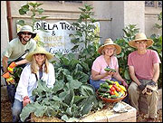
Three years later - and that decision has paid off. What was once a quiet corner is now alive and bustling - a fragrant, verdant piece of Eden in the midst of the urban core. There is a fruit tree guild, raised vegetable beds, herb gardens, native plants, and a swale that helps with storm water percolation. Plans are in process to create a Rainwater Harvesting Learning Project.

The garden planted seeds of new life for this historic church. Two years ago they hired a part-time minister. With the guidance of a Methodist minister whose profession was new-start churches, she conducted one-on-one interviews with city leaders, like the mayor, city council person, director of department of health, and more. It was important for the city to understand that there was new leadership and new direction at the church, and the church was reclaiming their investment in the City of Pasadena.

She asked three questions of these leaders:
- What are three areas of tension in Pasadena?
- What are your three hopes or goals for Pasadena?
- Who are three people I should talk with, and will you make the introduction?

These conversations sparked on-going relationships. The congregation offers free space for neighborhood meetings. The Mayor has spoken twice at large events sponsored by the church.

Throop is increasingly being seen as a go-to partner in the areas of sustainability and eco-spirituality. We are also part of an emerging clergy leadership group around the area of worker justice and living wage in Pasadena. Last year, Throop won a Green Award from the City of Pasadena, for our Learning Garden.

We strive to be a multi-generational congregation. Things we pay special attention to on Sunday morning:
  - Preaching a shorter sermon, about 12-13 minutes
  - Intentionally engaging younger people in worship leadership
  - Leading the congregation in body prayer, involving movement
  - Including five songs – diverse instruments, genres and styles of music
  - Having a family-friendly corner in the sanctuary where kids can move around.

We continually look for inspiration and guidance from the surrounding neighborhood. Our goal is for our ministries and programs to arise out of and respond to the needs of our neighbors. Our garden and eco-spirituality programs draw a wide range of people who are looking to meld their inner heart-work with their outward actions and activism.

Find out more in this UU World article: 'Learning Garden' sows connections between church and community

Handout 3B: Where is Your Sweet Spot?
Your Congregation or Group
Your Community
Your Sweet Spot

