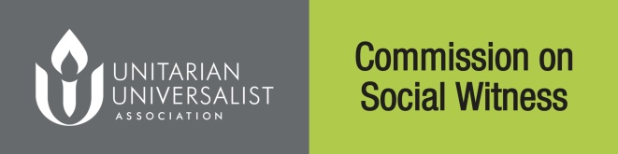
Comment Worksheet for
Congregational Study/Action Issue

“Corruption of Our Democracy”

This form for planning purposes only - comments must be submitted at www.uua.org/socialwitness by March 1, 2017 at 5:00 P.M. Pacific.

Submitting Congregation Information | Individual Completing Form
Name Of Congregation  Address  City State/Province  Postal/Zip Code  (Note: only one collected submission per congregation permitted) | Name Of Submitter  Address  City State/Province  Postal/Zip Code  Email  Position Or Role (If Any):
Source Of Comments Below (Mark Best Choice): | Rate Overall Impressions (circle number matching best judgment)
Denominational Affairs Committee  RE Program  Social Action/Justice Committee  Post-Sermon Discussion Or Open Meeting  Circle Study Group  Other  Estimated Number Of Individuals Involved: | How Aware Is Your Group Of The CSAI Process? | Not At All - A Lot  0 1 2 3 4
 | General Impression Of Draft Statement Of Conscience (SOC)? | Strongly Disliked - Strongly Liked  0 1 2 3 4
 | Is This SOC A Springboard To Action? | Not At All – Definitely  0 1 2 3 4
 | Does This SOC Help To Define UUism? | Not At All – Definitely  0 1 2 3 4

Essay/Free Responses

- How has your congregation engaged or how will you engage the issue?

- In studying the issue, what findings were most surprising or compelling?

- Please list useful resources or organizations not included in the Resource Guide. What specific actions would you recommend other congregations to take?
- Why is this an important issue for UUs?

- Please comment on the most interesting aspects of your congregation's study/action process.

- What concepts need to be included in the Statement of Conscience on this issue so that it is complete?

- Please list contact information for any potential individuals or groups (including yourself) whose experience with this topic (whether extensive or just recent) could contribute to a General Assembly panel discussion or workshop on this CSAI.

DEADLINE: March 1, 2017, by 5:00 p.m. Pacific Time
Submit responses at www.uua.org/sociawitness only.

