WORKSHOP 7: Leadership Styles

Introduction
Be the kind of leader you would follow. – Anonymous

This session describes formal leadership roles and different leadership styles, explores when they may be applicable and gives participants the opportunity to practice embodying different leadership styles.

Goals
This session will:
- Explain the formal leadership roles of process observer, facilitator and recorder
- Explain seven different leadership styles and how they relate to the seven principles
- Provide participants with practice for embodying different leadership styles.

Learning Objectives
Participants will:
- Understand the importance of formal leadership styles in a group setting
- Lean that they may need to adjust their leadership style to fit the context in which they are leading
- Explore ways to bring the seven principles alive through their leadership.

Workshop-at-a-Glance
ACTIVITY | MINUTES
Opening | 10
Activity 1: Formal Leadership Roles | 10
Activity 2: Leadership Styles and the Seven Principles | 15
Activity 3: Working with Others - Human Knot | 20
Closing | 5
Alternative Activity 1: Working with Others - Lilypad Leadership | 30
Alternative Activity 2: Working with Others - Meal Preparation | 60

Spiritual Preparation
Read Handout 2 Leadership Styles and reflect on times in the past when you have embodied some of these leadership styles. How did you know this type of leadership would be helpful? Are there particular styles that feel more comfortable for you to embody? Are there others that are more challenging for you to embody? Reflect on how the way you lead reflects your values.

Opening (10 minutes)

Materials for Activity
- Chalice, candle, lighter or LED/battery-operated candle
- Newsprint and markers
- Chalice lighting words: Worship Web A Character All Our Own by William Ellery Channing
- Each of us is meant to have a character all our own, to be what no other can exactly be, and do what no other can exactly do.
- Group covenant (from Workshop 2, Living in Covenant)
- Check in question:
Think of a time when a group you were part of had to make a decision or reach a goal. What role did you play or how did you act to help the group come to a decision or reach their goal?

Preparation for Activity
- Post the chalice lighting words on newsprint.
- Post the group covenant developed in Workshop 2, Living in Covenant.
- Post the check in question in the designated place.

Description of Activity
Welcome first-time participants. Invite participants and facilitators to go around the circle and say their names and briefly answer the check in question (in 3 or 4 sentences). Remind participants that check in is not a time for cross talk - clarifying questions can be asked if necessary. After everyone who wants to has had a chance to check in ask for a volunteer to light the chalice.

Including All Participants
Let participants know they have the right to pass or pass for now. For participants who have trouble being concise you can ask them “how would you sum up your experience in one sentence?” For participants who have trouble refraining from cross talk remind them of the group covenant and to be respectful of their peers’ time to share and the leaders’ time to facilitate.

Activity 1: Formal Leadership Roles (10 minutes)

Materials for Activity
- Handout 1: Formal Leadership Roles
- Newsprint
- Markers

Preparation for Activity
- Familiarize yourself with the handout so you can summarize the descriptions for the group.
- Make copies of handout for all participants.

Description of Activity
In this activity participants learn about the formal leadership roles of the recorder, facilitator, and process observer.

Pass out Handout 1 Formal Leadership Roles. Explain that in group discussions where there is a purpose and goal, assigning members of the group to serve as recorder, facilitator, and process observer can provide the group with direction, help them stay focused and reflect on how their time was spent. Provide a summary for the role of recorder then ask for volunteers to read the bullet points under General Hints For Recording In Full View.

Provide a summary for the facilitator role then ask for volunteers to read the bullet points under Getting Things Started and Facilitating During Discussion. Ask the group to name some personality traits or skills useful to being an effective facilitator. Ask for a volunteer to write down these personality traits or skills on newsprint, using the recorder tips they learned from the handout.

Provide a summary for the role of process observer and, if the group did Workshop 5: Active Listening, remind them that they practiced process observation in groups of three while practicing asking probing questions and paraphrasing. Tell the group that a process observer plays a vital role at the end of a meeting or discussion and ask for volunteers to read the numbered list under The Role of Process Observer.

Invite the group to close their eyes and say something like the following, reminding participants that raising their hand is optional:
Based on what you already know about yourself, your skills and personality, raise your hand if you think facilitating a group conversation would be easy for you, raise your hand if you think it would be challenging. Raise your hand if you think scribing would be easy for you, raise your hand if you think it would be challenging. Raise your hand if you think process observing would be easy for you, raise your hand if you think it would be challenging.

Without naming specific people, tell the group what you noticed. Were there varying comfort levels with each of the formal leadership roles? Tell participants that we may be naturally drawn to specific types of leadership roles based on our personalities and comfort levels and that even so, different situations may call us to be a different type of leader than we’re used to.

Tell the group that even if you are not assigned a formal leadership role, you can play a vital part in leading a group. Note that it is important to not only pay attention to the content of a conversation (what is said) but to the atmosphere (how people are feeling) of a conversation so that you can respond with an informal leadership role that can help move a group forward.

Activity 2: Leadership Styles and the Seven Principles (15 minutes)

Materials for Activity
- Handout 2 Leadership Styles
- Newsprint
- Markers

Preparation for Activity
- Familiarize yourself with the handout so you can summarize the descriptions for the group.
- Make copies of handout for all participants.

Description of Activity
In this activity participants learn about informal leadership roles and how they relate to the seven principles.

Pass out Handout 2 Leadership Styles and summarize the first two paragraphs, saying something like:
Even if you’re not in an official leadership role like facilitator, process observer or recorder, you can play an important part in a group or community. A leader does not have to be “in charge” to make an impact. As Unitarian Universalists we can be leaders just by lifting up our principles and values. On your handout there are seven leadership styles that represent some of the ways we as Unitarian Universalists can put our values into practice. Some of these styles may come easily to you, some may be more challenging. Everyone can practice “try on different hats” or practicing different leadership styles. Think of the colors associated with each leadership style as the color of hat you would be putting on if you embodied each leadership style.

Invite participants to read the roles aloud, going in a circle. Remind participants they have the right to pass. Ask if there are any questions about the leadership styles. Ask participants if there is a particular style or two they feel they’d be good at, or have already practiced, then ask if there are styles that seem challenging for them and why.

Activity 3: Working with Others - The Human Knot (20 minutes)

Materials for Activity
- Leader Resource 1 Leadership Hats
- Stapler
- Optional: red, orange, yellow, green, blue, indigo and purple markers

Preparation for Activity
- Print, cut and assemble leadership hats, enough for one per participant. You will not need the Recorder hat for this activity. On the Facilitator and Process Observer hats, the words should be facing out. For the leadership styles, the words should be facing in.
- Optional: mark each leadership style hat with the corresponding color as noted on Handout 2 Leadership Styles.
Place hats on a table or other surface so that the words for the leadership styles are facing away from participants.
Make sure you have an open space large enough for all participants to stand in a circle with their arms outstretched.
Optional: Review this YouTube video showing how the human knot game works.

Description of Activity
In this activity participants practice “trying on different hats” and embodying different leadership styles.

Ask for two volunteers to serve as process observer and facilitator and give them the corresponding hats. Invite the rest of the participants to choose a hat from the table and, without telling anyone, read the leadership style on the inside. Tell them that they are to embody the leadership role or style written on their hat while playing this game. Give participants a moment to review their role or style on their handouts if necessary.

Have participants stand in a very close circle, shoulder to shoulder. Then invite them to take the hands of two others in the circle. Participants may take hands across the circle or near their position, but may not hold both hands of the same person. When everyone is holding the hands of different people, tell participants the object of the game is to untangle the great, big knot they’ve created.

Remind participants to think about the leadership style they will be embodying and spend a moment in silence with this prompt:
Think silently to yourself about what strategies or behaviors you might use within your leadership style to help your team untangle this knot.

Instruct the process observer and facilitator that they have five minutes to help the group brainstorm and come up with ideas about how they plan to untangle the knot. After the team has brainstormed for four minutes, tell them they have one minute remaining and invite the process observer to share their observations.

Ask the participants to continue holding hands while they untangle the knot, so that everyone ends up standing in a simple circle again. Participants may end up facing into or out of the circle, but should not drop hands at any point. Some knots, however, may not be possible to resolve completely. You may wish to play the game more than once, as time allows.

When the group has completed the task or 10 minutes are up, whichever comes first, gather the group into a circle. If the group failed to untangle the knot, remind participants that sometimes success isn’t about achieving a predetermined goal, but about how a group works together to achieve said goal. Ask questions like:
Without revealing what your leadership style was, how did your group approach the challenge?
What was the most difficult part of untangling the knot?
Without revealing what your leadership style was, what strategies did you use to achieve your goal?

Then invite participants to guess what leadership styles their teammates were embodying. Invite participants to reveal their leadership styles if they were not guessed.

Conclude by saying something like:
Assuming a leadership style may be challenging if are not used to working in that fashion. However, it’s worth the challenge to practice these leadership styles and to notice when others are employing these leadership styles because they help us keep our seven principles in mind when in a leadership position.

Including All Participants
A participant who has mobility or balance issues can participate by sitting in a chair or wheelchair and having other participants maneuver around them. This game does involve close physical contact, and participants who are uncomfortable being touched may wish to opt out.

Closing (5 minutes)

Materials for Activity
- Taking it Home

Preparation for Activity
- Make copies of Taking It Home for each participant.

Description of Activity
Invite participants to gather in a circle. Thank everyone for their contributions to the group. Pass out Taking It Home and explain that it contains ideas for ways they can continue to explore workshop topics with family and friends.

You can offer that the group can continue a discussion about this session at a later date or in a closed Facebook group if your group has one. End the workshop with this body prayer by Annie Scott available on Worship Web.

It's important is to take time to be quiet, to be still,
so we can be in touch with the deepest and best part of ourselves—our inner voice—
often called prayer or meditation.
I invite you to join in a body prayer.
I will show you the motions—
then invite you to move through it with me once,
then we will all pray with our bodies in silence 3 times.
We begin with our hands in front of us in the prayer pose
to find our inner quiet
We raise our arms up high
to open ourselves to the Spirit of Life, God of Love,
We bring our hands to our hearts
to affirm the strength of our inner voice
We extend our hands out in front of us
to offer our kindness and respect to others.
We lift our hands out in front of us
to offer to others and the world all that we have to give.
We lift our hands high over our heads
reaching out to the world being open to all it might offer us.
We bring our hands down
gathering in the gifts and bringing them to our heart.
And returning to our stillness,
we bring our hands together in the prayer pose.
[repeat three times and end with a slow bow as a closing.]

Leader Reflection and Planning
As leaders working with youth in a Unitarian Universalist context, this workshop offered an opportunity to consider the importance of and practice formal leadership roles and leadership styles as Unitarian Universalists. What did you learn from this session on leadership styles? How did participants surprise you in the Working with Others activity? Did your understanding or ability to explain why leading with our values and principles in mind increase after preparing this session? What did you as co-leaders learn from your co-facilitator? Share your feedback and learnings from this session with the minister and religious educator.

Alternative Activity 1: Working with Others - Lilypad Leadership (30 minutes)
Adapted from Adventures in Peacemaking, by William J. Kreidler.

Materials for Activity
- Leader Resource 1 Leadership Hats
- Stapler
- Optional: red, orange, yellow, green, blue, indigo and purple markers
- Large room with no obstacles from one side to the other
- Six paper plates

Preparation for Activity
- Print, cut and assemble leadership hats, enough for one per participant. On the Facilitator, Process Observer and Recorder hats, the words should be facing out. For the leadership styles, the words should be facing in.
- Optional: mark each leadership style hat with the corresponding color as noted on Handout 2 Leadership Styles
- Place hats on a table or other surface so that the words for the leadership styles are facing away from participants

Description of Activity
In this activity participants practice “trying on different hats” and embodying different leadership styles.

Ask for three volunteers to serve as process observer, facilitator and recorder and give them the corresponding hats. Invite the rest of the participants to choose a hat from the table and, without telling anyone, read the leadership style on the inside. Tell them that they are to embody the leadership role or style written on their hat while playing this game. Give participants a moment to review their role or style on their handouts if necessary.

Ask participants to stand at one end of the room. Tell participants that there is a great, deep river flowing in front of them and the object of this game is to get every participant to the other side of the river by only stepping on the ‘lilypads’ (paper plates). Hand out the paper plates and give the following directions:
You must use the lilypads as stepping stones, but be careful because the river is flowing quickly. The lily pads have the power to hold anyone safely above the river. No one may touch the river. If someone falls off of a lily pad and into the river, they must start over. The lily pads must be used constantly or the group may lose them in the river’s current. That is, there must always be a foot on each pad. Lily pads that are carried away in the river’s current will be removed. The group may hold hands or find another way to stay connected to each other and the pads as they cross the river. At anytime a natural disaster may occur, making your trek across the river more difficult.

Remind participants to think about the leadership role or style they will be embodying and spend a moment in silence with this prompt:
Think silently to yourself about what strategies or behaviors you might use within your leadership role style to help your team get across this river.

Instruct the process observer, facilitator and recorder that they have five minutes to help the group brainstorm and come to a decision about how they plan to cross the river. After the team has brainstormed for four minutes, tell them they have one minute remaining and invite the process observer to share their observations.

Allow 15 minutes for participants to try to cross the river.

When the team has completed the task or 15 minutes is up, whichever comes first, gather the group into a circle. If they failed to cross the river, remind participants that sometimes success isn’t about achieving a predetermined goal, but about how a group works together to achieve said goal. Ask questions like:
Without revealing what your leadership style was, how did your group approach the challenge?
What was the most difficult part of crossing the river?
Without revealing what your leadership style was, what strategies did you use to achieve your goal?

Then invite participants to guess what leadership styles their teammates were embodying. Invite participants to reveal their leadership styles if they were not guessed.

Conclude by saying something like:
Assuming a leadership style may be challenging if are not used to working in that fashion. However, it’s worth the challenge to practice these leadership styles and to notice when others are employing these leadership styles because they help us keep our seven principles in mind when in a leadership position.

Including All Participants
This activity can be challenging, but not impossible for people with mobility issues. Ask participants with mobility issues how you can adapt this game for their success. Possibilities include providing more paper plate lily pads, shortening the distance of the river they must cross or asking for a partner to support them. Provide the group with consistent reminders to include all accessibility needs in their strategy and cooperation. Allow for more brainstorming time.

Alternative Activity 2: Working with Others - Meal Preparation (60 minutes)

Materials for Activity
- Leader Resource 1 Leadership Hats
- Stapler
- Optional: red, orange, yellow, green, blue, indigo and purple markers
- Kitchen and food

Preparation for Activity
- Print, cut and assemble leadership hats, enough for one per participant. On the Facilitator, Process Observer and Recorder hats, the words should be facing out. For the leadership styles, the words should be facing in.
- Optional: mark each leadership style hat with the corresponding color as noted on Handout 2 Leadership Styles
- Place hats on a table or other surface so that the words for the leadership styles are facing away from participants

Description of Activity
If you are doing this session at an overnight or weekend event, you may choose to conclude the session by preparing a meal together. In this activity participants practice “trying on different hats” and embodying different leadership styles.

Ask for three volunteers to serve as process observer, facilitator and recorder and give them the corresponding hats. Invite the rest of the participants to choose a hat from the table and, without telling anyone, read the leadership style on the inside. Tell them that they are to embody the leadership role or style written on their hat while preparing a meal together. Give participants a moment to review their role or style on their handouts if necessary.

Instruct participants that they are to prepare a meal using the food provided but before they do so the process observer, facilitator and recorder will have ten minutes to help the group brainstorm, come to a decision and map out a recipe for their meal.

Remind participants to think about the leadership role or style they will be embodying and spend a moment in silence with this prompt:
Think silently to yourself about what strategies or behaviors you might use within your leadership role style to help your team get across this river.

After the team has brainstormed for nine minutes, tell them they have one minute remaining and invite the process observer to share their observations.

Your role in the meal preparation is to ensure participants are using kitchen equipment correctly and safely. Try not to intervene in their decision making or preparation. If necessary, you may prompt the facilitator to ask probing questions about the efficacy of the group’s plan or prompt the process observer to make observations about the group’s progress.

When the team has completed the task, gather the group into a circle and ask questions like:
Without revealing what your leadership style was, how did your group approach the challenge?
What was the most difficult part of preparing this meal?
Without revealing what your leadership style was, what strategies did you use to achieve your goal?

Then invite participants to guess what leadership styles their teammates were embodying. Invite participants to reveal their leadership styles if they were not guessed.

Conclude by saying something like:
Assuming a leadership style may be challenging if are not used to working in that fashion. However, it’s worth the challenge to practice these leadership styles and to notice when others are employing these leadership styles because they help us keep our seven principles in mind when in a leadership position.

Handout 1 Formal Leadership Roles

The Role of the Recorder
- To write clearly and note what is decided
- To write key words as spoken
- To note who will do which tasks
- To ask for clarification as needed and follow up as necessary
- To ask speakers to slow down as needed

As the group’s recorder you provide an essential service: memory. This is usually accomplished in one of two ways: either by taking notes on a piece of paper or by scribing the flow of the meeting on a large sheet of newsprint, posted or held on an easel. Both styles have their advantages.

The accompanying example of a Meeting Summary Form is one way to organize yourself for the first method, which often involves rapid note-taking in the moment and then a later transcribing for distribution. It can be thorough and very helpful, but it’s essentially a private activity that one person conducts.

The process of recording in full view, usually on large newsprint with colored markers, is a very effective method for a group to follow and helps participants stay involved. It, too, often results in a later re-organization or distribution. However, the fact that everyone has seen the initial language written down as it was offered means that people are more immediately in touch with the flow of the meeting. Seeing their ideas up on the posted sheets reinforces that people are having an impact by being heard and valued.

General Hints for Recording in Full View:
- Think ahead and prepare your materials so that you don’t waste group time.
- Use two or three different color markers for varying aspects, themes, or portions.
- Identify clear wall space and have a helper in charge of posting the sheets.
- Put an appropriate heading on each sheet.
- Write big enough so that those farthest away can see; be generous with spacing.
- Repeat key words used by the speakers.
- Add upbeat graphics, such as stars, suns, smiley faces, etc.

Meeting Summary Form
Date of Meeting:

In attendance:
Roles:

Next Meeting Dates, Time & Location:

Meeting Objectives:

Issue I. Summary of Discussion & Decisions on the topic of:

Logistics: (Review of summary of previous meeting, Team member updates, meeting dates, place, etc.)

Miscellaneous follow-up to last meeting:

Issue II. Summary of Discussion & Decisions on the topic of:
Action Planning:

Issue III. Summary Discussion & Decisions on the topic of:
Other items:

Meeting Evaluation Summary:

Next Steps:

The Role of the Facilitator

- To keep the discussion focused
- To clarify (or ask for clarification) as necessary
- To help create and maintain a setting in which everyone can participate freely

Getting Things Started
Some discussions don’t need stimulating—they just get going. Often, however, the facilitator can play an important role to help the group get started. Some hints:

- Everyone should know what the discussion is about and the reason for having it. They should know what, if any, outcomes or outputs are expected, and the amount of time they have to accomplish this.
- Give participants room to be involved. It is important not to be too directive in your role as facilitator. The group should take responsibility for what happens.
- Use questions to stimulate and explore. It is often helpful to phrase questions in a positive manner. For instance, instead of asking, “Why won’t this plan work?” ask, “What problems might we have to overcome if we adopt this plan?” Use open-ended questions, not ones that simply require a yes or no response.
- Model desired behavior. Your own attitude and actions demonstrate to group members how they can participate—you set the tone.

Facilitating During Discussion
There are many things that a facilitator can do to help along a particular discussion. What you do will depend on your abilities, your style, and the particular group and situation. Some general hints:

- Equalize participation. Some may want to speak more than others, but you can prevent any person or small group from dominating. Be alert for the quieter members who can’t jump right in and draw them out.
- Keep on the subject. You can remind the group when the discussion strays and then offer questions or comments that provide focus.
- Be aware of pacing the group. Stay alert to time constraints and make adjustments or reminders as necessary. As the session draws to a close, you can point out what the group has accomplished, what is left to be done, and how much time is left.
- Clarify and support the recorder. Check to see that the recorder is keeping up accurately. Request examples or illustrations when a point is fuzzy, but do this in a nonthreatening fashion with questions such as, “I’m not sure I understand what you said. Could you give me an example?”
- Summarize as appropriate. When it’s time, you can pull together various parts of the discussion and restate them together. This might include what progress has been made and where you think the group is going. You might link ideas, identify patterns, or break something complex into simpler components.

The Role of the Process Observer

- Pay attention to the atmosphere of the group
- Take brief notes to relay to the group at the end of the session
- Lead a reflection on the session with your group
- Lead a check out

This role holds the group’s soul: process observing is ministry to the group. It is a vivid and too-often neglected opportunity to deepen the group’s intention for community building and learning together.

When you offer to do this, you are shifting into a very integral role. Be ready to participate and note any peculiarities, highlights, problems and tender moments. This doesn’t mean you can’t participate normally, but you’ve also got an eye out for meaningful things that might otherwise slip by unnoticed or be neglected.

Discipline yourself throughout the meeting to stay alert for the subtleties of the group, particularly experiences that might turn people away from the purpose of your gathering such as a putdown or intimidation. Watch for the shy people, the revealing comment that nobody follows up on or the joy not celebrated. It’s a good idea to take some brief notes to yourself as the process unfolds.

Near the end of the meeting, the facilitator should turn to you for a report. If this is not a regular part of your group meetings, remind the facilitator beforehand that you’ll need a few minutes at the end. You can conduct this review in at least three ways:

1. Comment on some, probably not all, of what you’ve noted. There may not be room for dialogue at this point, so offer to be available for follow-up talks after the meeting. Be sure to say good things about the group’s process.

2. Lead a group reflection of the meeting, to see what they noticed or if they had other feelings that would be important to include before closing. Be prepared to allow some time for this style of review; sometimes the most memorable piece of the meeting emerges here. These four general questions can be helpful in leading it:
What caught your attention at the meeting?
Where did you find yourself excited or pleased?
Where did you find the meeting bogged down or got difficult?
What was the significance of the meeting? (It was the meeting of/when…)
What did you notice about how we navigated cross-cultural differences and how attentive we were to anti-racist and anti-oppressive behavior and language?

3. Lead a check-out, which stands in contrast to a check-in. Go around the circle and give people a chance to comment on how they’re feeling about the meeting as it’s finished. This improves the odds that no one will go home unhappy, and you may find some unfinished business to be considered.

This way, by being willing to observe their process, group members get better attuned to how they can be productive on many levels at once, not just for business.

Handout 2 Leadership Styles
Developed by Jennica Davis-Hockett, Leadership Development Associate for the Office of Youth and Young Adult Ministries

Often times, when we hear the word “leader” we may automatically associate it with words like: boss; manager; authority figure or supervisor. But a leader is not always the person “in charge” of other people. As Unitarian Universalists we believe that there are many styles of leadership that reflect and lift up our principles and our values and that different situations call for different leadership styles.

The following leadership styles are some of the way we as Unitarian Universalists can put our values into practice. You may currently feel more competent and confident in one or a few of the following leadership styles. Some of these leadership styles may be challenging for you to embody, and that’s ok. No one can excel in every style of leadership, but everyone can practice and “try on different hats.” Think of the colors associated with each leadership style as the color of hat you would be putting on if you embodied each leadership style.

1. Empathic Leader
Color: Red for empathy, love and courage
Quote: Outstanding leaders go out of their way to boost the self-esteem of their personnel. If people believe in themselves, it’s amazing what they can accomplish. —Sam Walton

Empathic leaders ENCOURAGE and SUPPORT others and want to lift others up. They excel in SENSING FEELINGS AND MOODS and taking other people’s emotions into account when making decisions. They sense the potential in others and are able to ASSUME BEST INTENTIONS even in difficult situations. They thrive when GIVING AND RECEIVING FEEDBACK in a group setting. Empathic leaders CONSIDER THE ROLE OF PERSONAL RELATIONSHIPS in groups and can anticipate how personal relationships may impact decision-making. Empathic leadership is a useful style to embody the FIRST UU PRINCIPLE: The inherent worth and dignity of every person.

2. Justice Seeking Leader
Color: Orange for action, energy and thirst
Quote: Never doubt that a small group of thoughtful, concerned citizens can change world. Indeed it is the only thing that ever has. —Margaret Mead

Justice seeking leaders SET HIGH STANDARDS and expectations for a group and INSIST ON COMMON AGREEMENTS for the group to function. They are at once TASK ORIENTED and INTERESTED IN FAIRNESS for those they lead. They are PROBLEM SOLVERS who will work hard and thoroughly and want to FIND EQUITABLE MEANS to get a job done. They would rather TAKE ACTION, even if it is small and imperfect, rather than wait for the perfect moment. Justice Seeking leaders ADMIT ERRORS when necessary. Justice Seeking leadership is a useful style to embody the SECOND UU PRINCIPLE: Justice, equity and compassion in human relations.

3. Adaptive Leader
Color: Yellow for inclusion, imagination and enlightenment
Quote: A leader is best when people barely know he exists, when his work is done, his aim fulfilled, they will say: we did it ourselves. —Lao Tzu

Adaptive leaders know the importance of WELCOMING newcomers and new ideas in a group. They HELP PEOPLE FEEL VALUED as an integral part of a team. Adaptive leaders are dedicated to HELPING OTHERS FULFILL THEIR POTENTIAL and that’s how they implement change. They are INVESTED IN THE TRANSFORMATION of people and groups from something good to something great. Adaptive leaders are tolerant, accepting and flexible, but they are not pushovers. Because they are accepting of other’s ideas, being able to READJUST and SAYING YES, AND HOW? serves them well. Adaptive leadership is a useful style to embody the THIRD UU PRINCIPLE: Acceptance of one another and encouragement to spiritual growth in our congregations.

4. Curious Leader
Color: Green for learning, independence and growth
Quote: You gain strength, courage and confidence by every experience in which you really stop to look fear in the face. You must do the thing you think you cannot do. —Eleanor Roosevelt

Curious leaders love learning from others and sharing their own wisdom. They ASK FOR AND PROVIDE CLARIFICATION to clear up confusion and interpret ideas. While they are firm in their own values, they love to REEVALUATE or amend their ideas based on what they learn. Curious leaders value EDUCATION AND RESEARCH and will often SUMMARIZE conversations or decisions to ensure mutual understanding. They don’t want to miss an opportunity to LEARN FROM OTHERS. Curious leaders revel in complexity and usually DIG DEEPER if things seem too simple. Curious leadership is a useful style to embody the FOURTH UU PRINCIPLE: A free and responsible search for truth and meaning.

5. Listening Leader
Color: Blue for trust, respect and integrity
Quote: Speak in such a way that others love to listen to you. Listen in such a way that others love to speak to you. —Anonymous

Listening leaders often OBSERVE quietly until they notice that something has gone unsaid. Often in the background, they ASSIST OTHER LEADERS and OFFER SUPPORT in any way they can. They are adamant about ensuring a DIVERSITY OF VOICES is heard and excel at SUMMARIZING ideas in a group and SYNTHESIZING a lot of information. They appreciate efficiency but are even more interested in EXAMINING ALL SIDES before making a decision. Once a decision has been made, listeners are quick to jump into ACTION to support the leaders. Listener leadership is a useful style to embody the FIFTH UU PRINCIPLE: The right of conscience and the use of the democratic process within our congregations and in society at large.

6. Visionary Leader
Color: Indigo for insistence, intuition and faith
Quote: Where there is no vision, the people perish. —Proverbs 29:18

Visionary leaders focus on BIG PICTURE IDEAS and are not bogged down by logistical details. They HAVE A VISION of what their community or world could be and ideas of how to get there. They BUILD COMMON GROUND to achieve their goals. Visionary leaders are LOYAL TO LOFTY GOALS in line with their values and are especially focused on ADDRESSING BARRIERS to achieve those goals. They serve to FOCUS the group and help tie together what is currently happening with their overall purpose. They HOLD THEMSELVES AND OTHERS ACCOUNTABLE for championing causes with which they are associated. They are yearning for a future where peace, liberty and justice reign. Visionary leadership is a useful style to embody the SIXTH UU PRINCIPLE: The goal of world community with peace, liberty and justice for all.

7. Connecting Leader
Color: Purple for inspiration, magic and charisma
Quote: My own definition of leadership is this: The capacity and the will to rally men and women to a common purpose and the character which inspires confidence. —General Montgomery

The Connecting leader is often an INITIATOR who speaks up first, clearly states a problem they see and suggests ideas. They act as GATEKEEPER, helping everyone to participate in the group. They strive to HELP OTHERS TAKE OWNERSHIP of a project because they know the sum of the whole is greater than its parts and that something magic happens when people come together. They not only excel at connecting others and BUILDING RELATIONSHIPS, they can CONNECT DISPARATE IDEAS and help a group come to a CONCLUSION by working towards agreement within a group. Connecting leadership is a useful style to embody the SEVENTH UU PRINCIPLE: Respect for the interdependent web of all existence of which we are a part.

Leader Resource 1 Leadership Hats

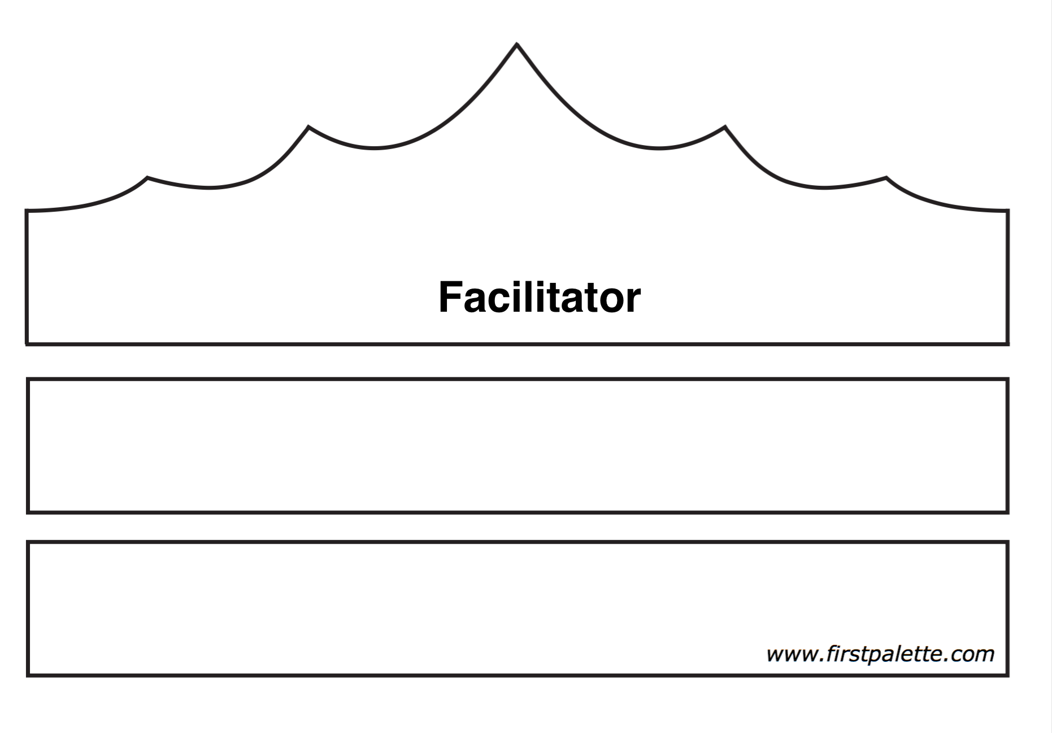

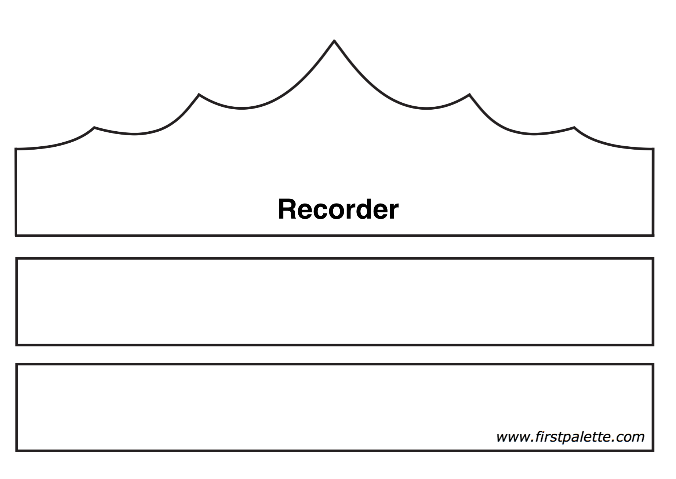

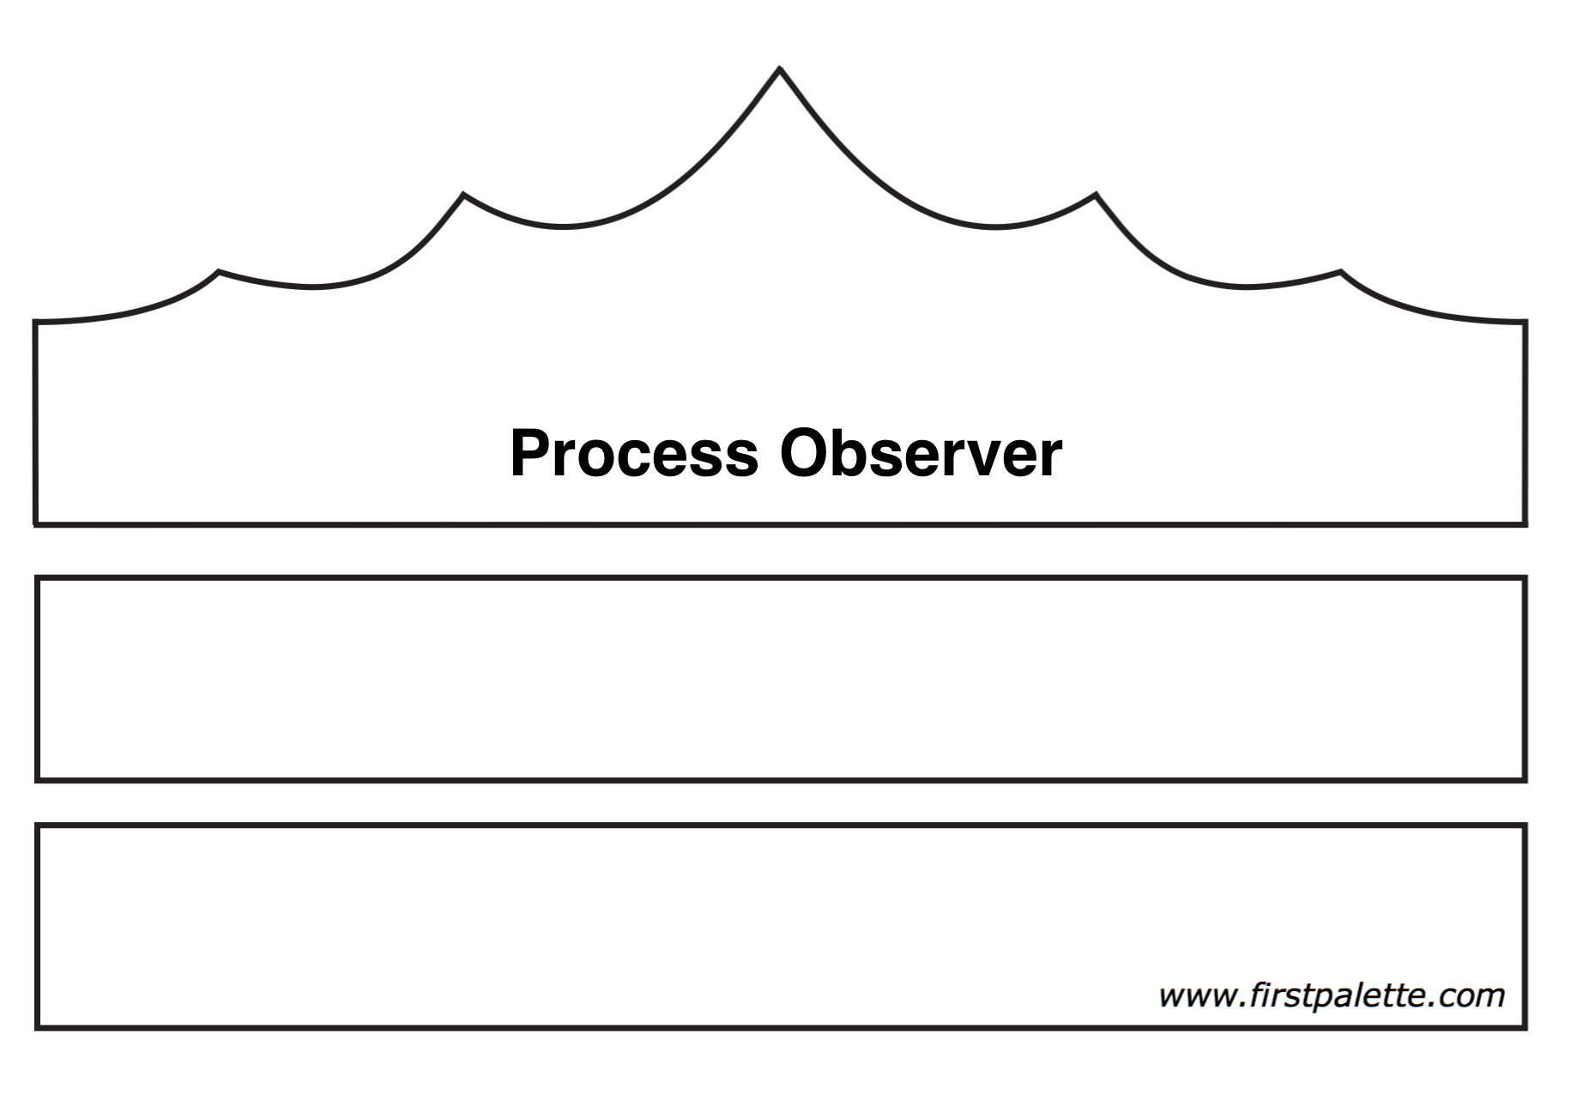

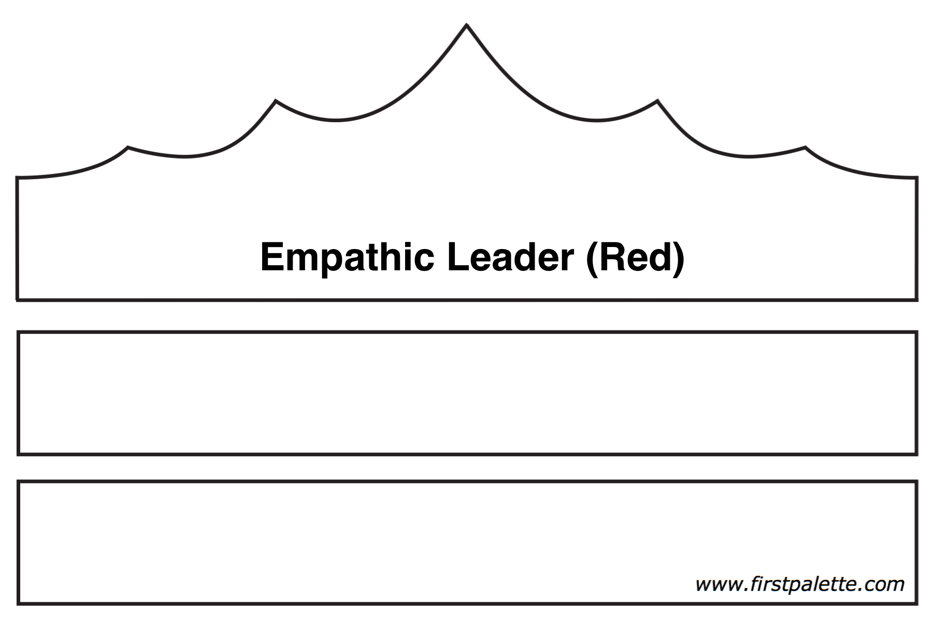

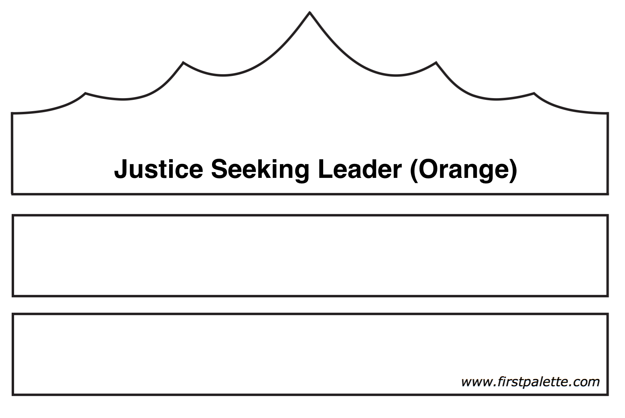

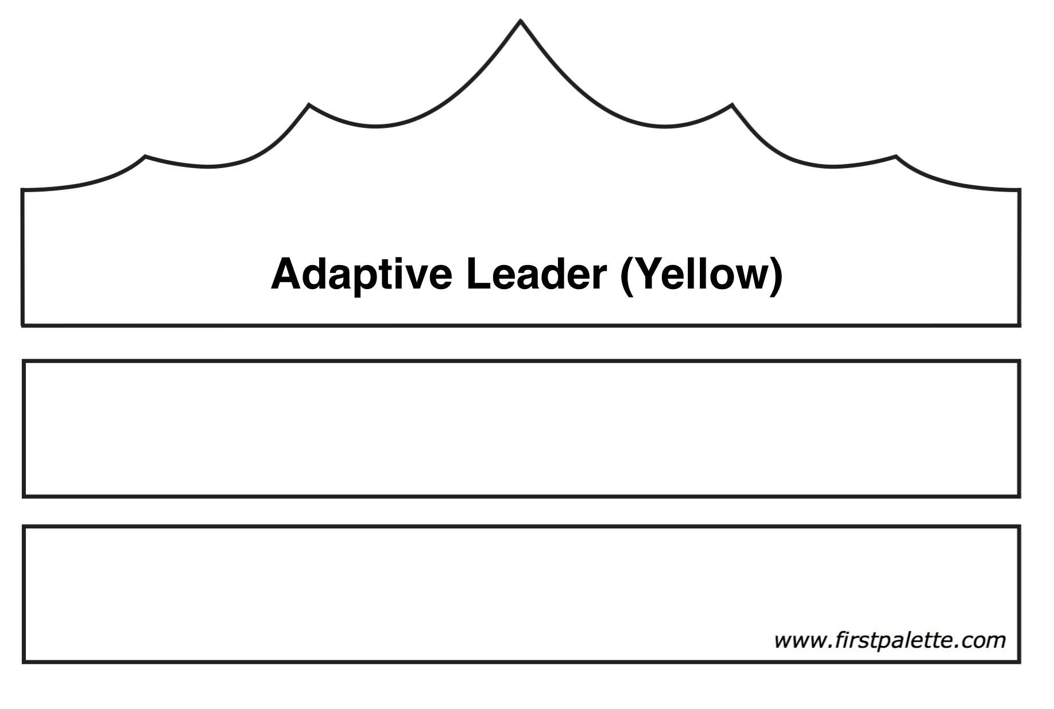

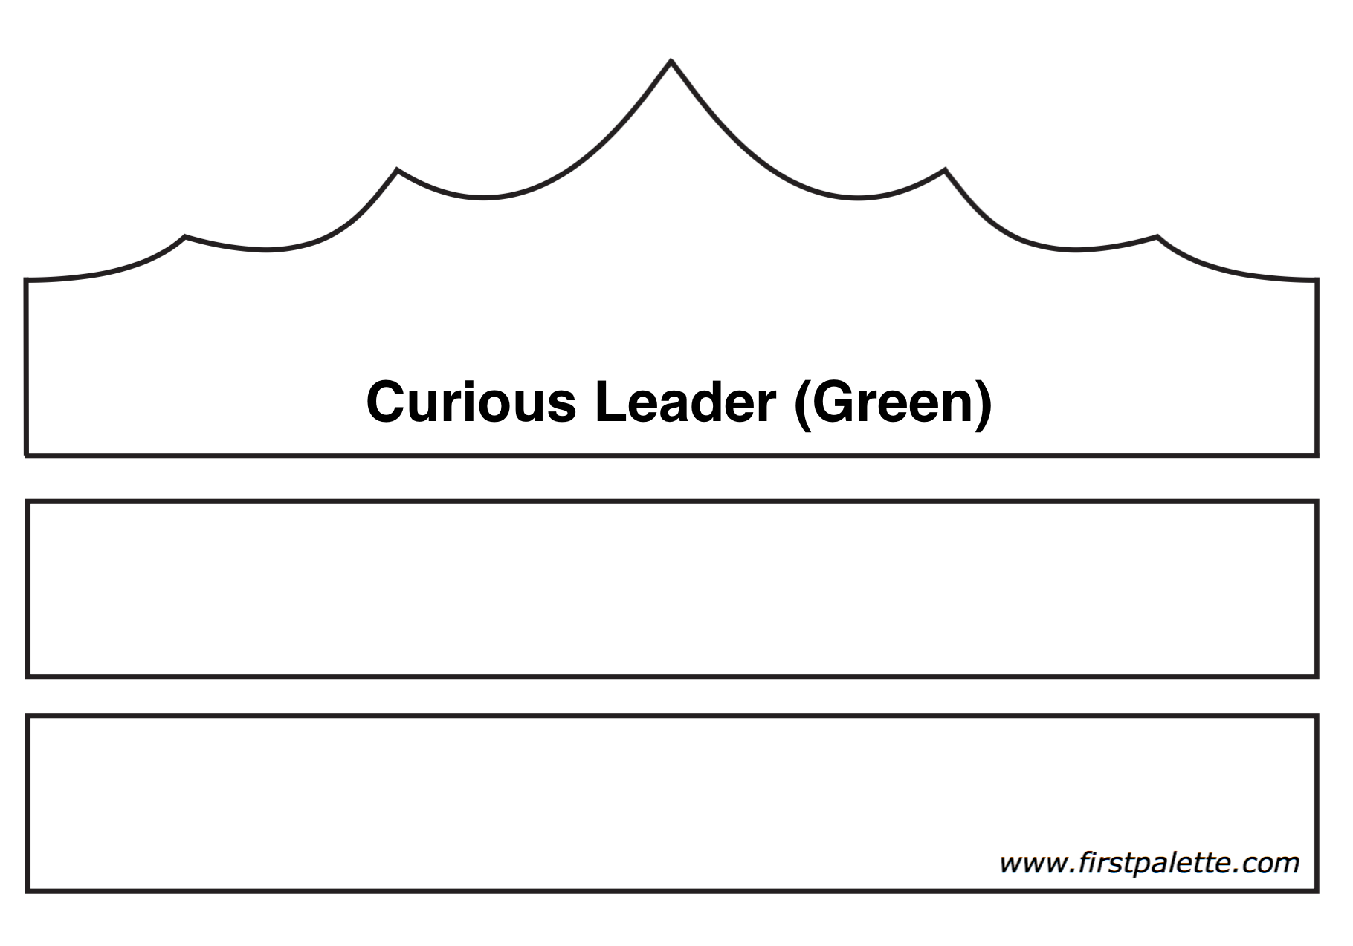

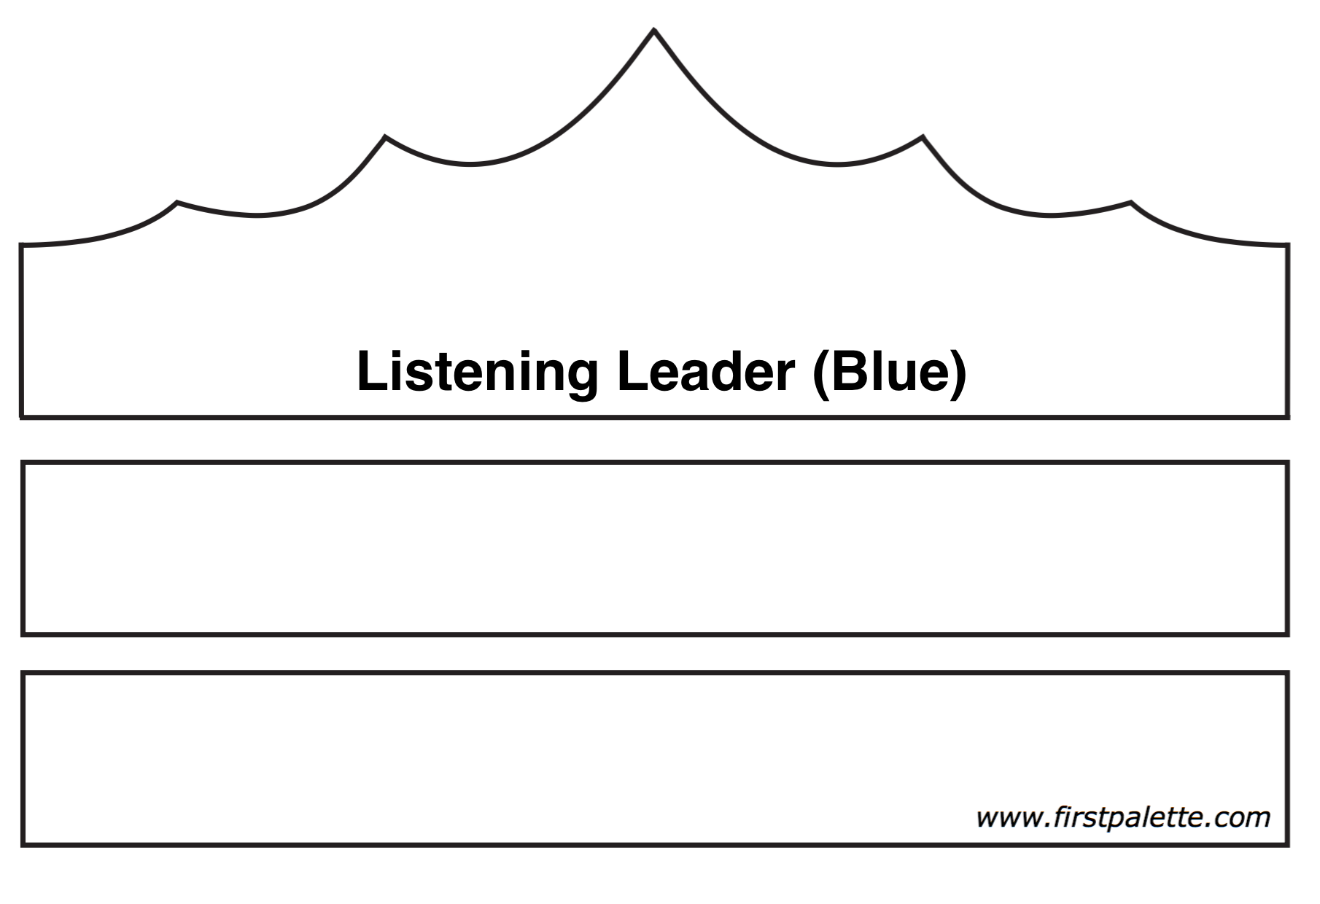

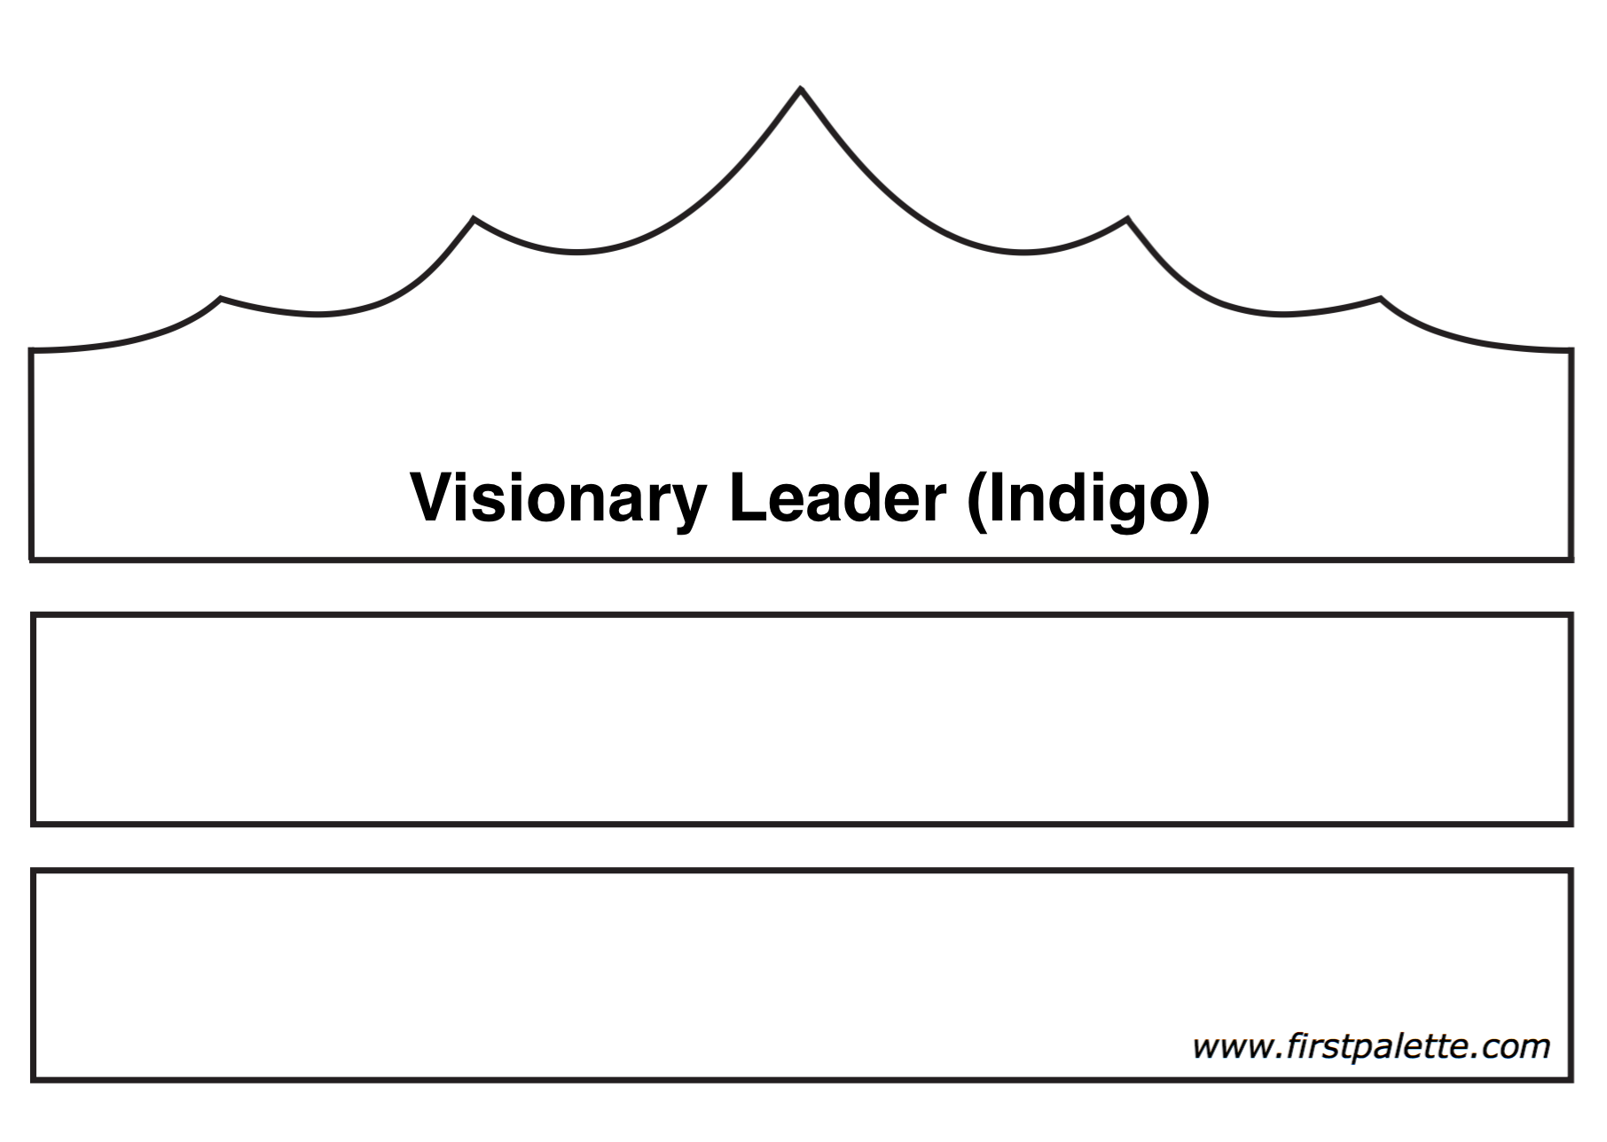

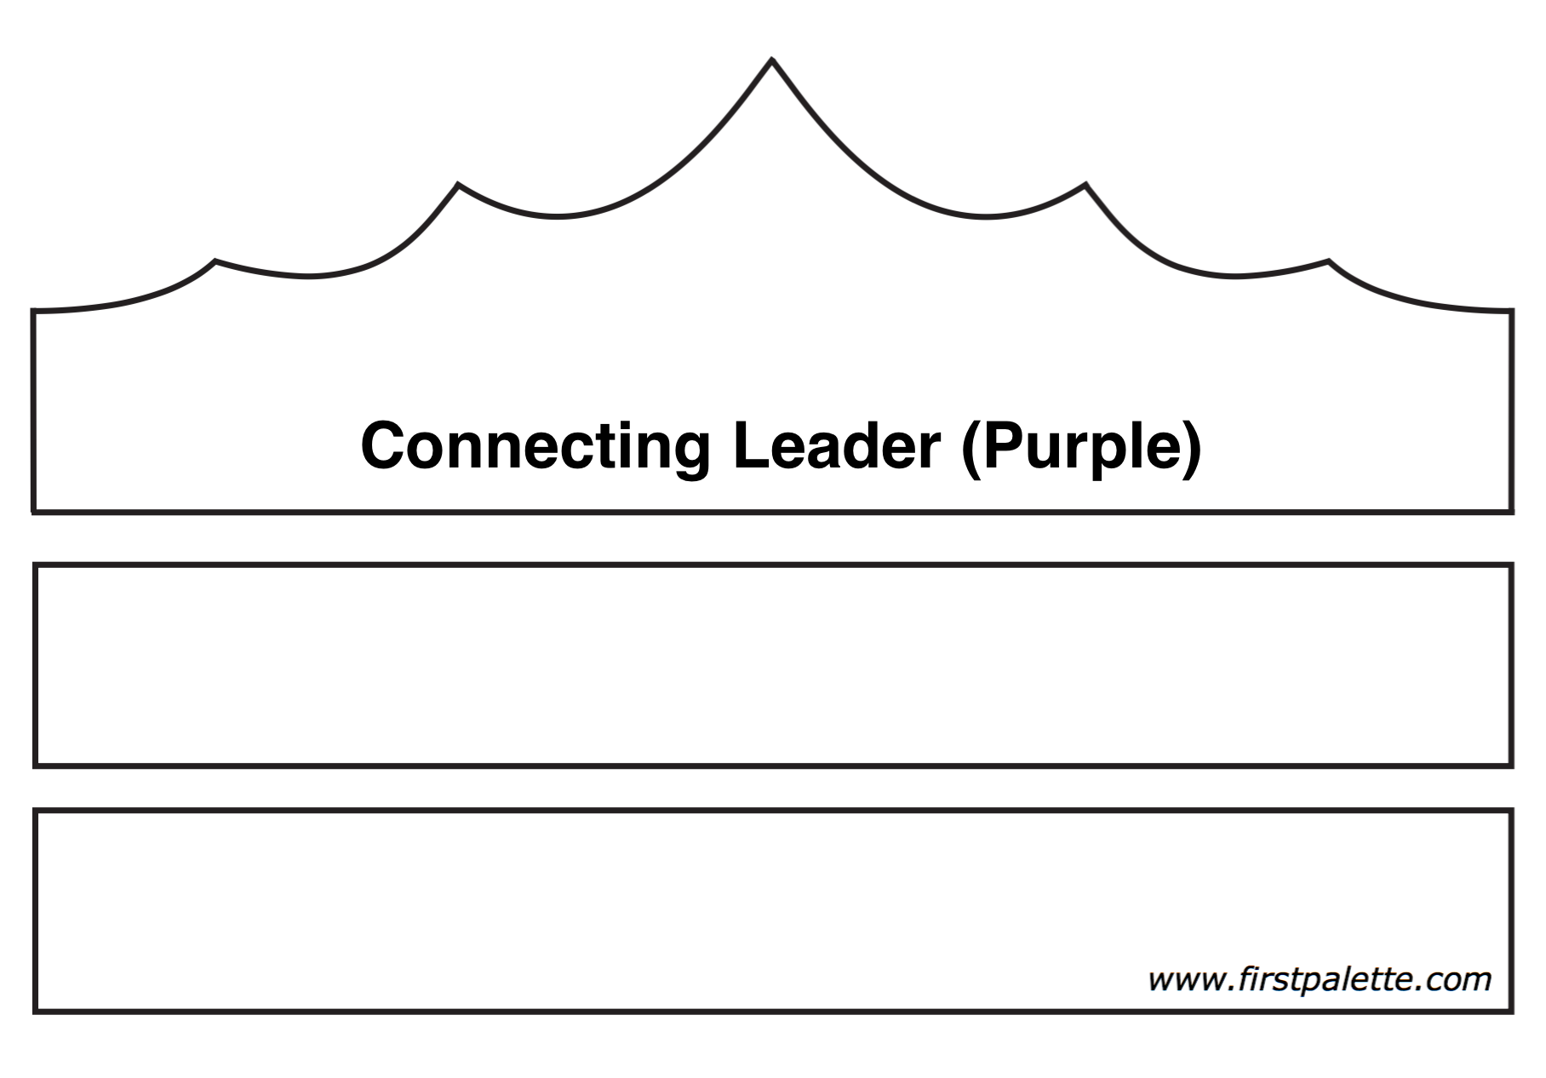

Taking It Home
Be the kind of leader you would follow. – Anonymous

IN TODAY’S SESSION… we learned about and practiced the formal leadership roles of process observer, facilitator and recorder. We also learned about and practiced seven different leadership styles and reflected on the importance of leadership as a reflection of our values and adjusting our leadership style to fit the context in which we are leading.

TRY ON OTHER HATS: Commit to practicing one of the seven leadership styles on Handout 2 Leadership Styles that may be challenging for you. Notice others in leadership positions and what style of leadership they are embodying.

LEARN FROM OTHERS: Do a search on the internet for leadership quotes and pick some favorites. Read an article by or about the authors of your favorite quotes and try to decipher what their leadership style is.

ENGAGE IN SPIRITUAL PRACTICE: Search “Seven Principles” on UUA.org. Choose one or more of the principles and read the reflection. Write your own reflection on how you can embody the principles.

Facilitator Feedback Form

We welcome your critique of this program, as well as your suggestions. Thank you for your feedback! Your input improves programs for all of our congregations.

You may choose to complete this feedback form online.

Otherwise, please forward your feedback to:
Office of Youth and Young Adult Ministries
youth@uua.org

OR

Office of Youth and Young Adult Ministries
Ministries and Faith Development
Unitarian Universalist Association
24 Farnsworth Street
Boston, MA 02210-1409

Workshops You Field Tested: *
☐ Workshop 1: Web of Youth Ministry
☐ Workshop 2: Living in Covenant
☐ Workshop 3: Meaning of Leadership Worship
☐ Workshop 4: Shared Leadership
☐ Workshop 5: Active Listening
☐ Workshop 6: Creating Inclusive Community
☐ Workshop 7: Leadership Styles
☐ Workshop 8: Building Multigenerational Connections
☐ Workshop 9: Conflict Resolution and Transformation

Number of Participants: * ___________________

Age Range: * ___________________

Did you work with (a) co-facilitator(s)? *
☐ Yes ☐ No

Congregation: * ________________________________________________

Overall, what was your experience with this program?

What specifically did you find most helpful or useful about this program?

In what ways could this program be changed or improved (please be specific)?

Did you enrich the program with any resources that you would recommend to others?

What impact, if any, do you think this program will have on your life going forward?

What impact, if any, do you think this program will have on your congregation going forward?

Your Name: ________________________________________________

Your Email: * ________________________________________________

Participant Feedback Form

We welcome your critique of this program, as well as your suggestions. Thank you for your feedback! Your input improves programs for all of our congregations.

You may choose to complete this feedback form online.

Otherwise, please forward your feedback to:
Office of Youth and Young Adult Ministries
youth@uua.org

OR

Office of Youth and Young Adult Ministries
Ministries and Faith Development
Unitarian Universalist Association
24 Farnsworth Street
Boston, MA 02210-1409

Workshops You Participated In: *
☐ Workshop 1: Web of Youth Ministry
☐ Workshop 2: Living in Covenant
☐ Workshop 3: Meaning of Leadership Worship
☐ Workshop 4: Shared Leadership
☐ Workshop 5: Active Listening
☐ Workshop 6: Creating Inclusive Community
☐ Workshop 7: Leadership Styles
☐ Workshop 8: Building Multigenerational Connections
☐ Workshop 9: Conflict Resolution and Transformation

Your Age: * ___________________

Congregation: * ________________________________________________

Overall, what was your experience with this program?

What specifically did you find most helpful or useful about this program?

In what ways could this program be changed or improved (please be specific)?

Did you enrich the program with any resources that you would recommend to others?

What impact, if any, do you think this program will have on your life going forward?

What impact, if any, do you think this program will have on your congregation going forward?

Your Name: ________________________________________________

Your Email: * ________________________________________________

